Improvement after traumatic brain injury achieved by coordination dynamics therapy

Giselher Schalow¹

Abstract
In 6 patients 13 to 47 years old, who suffered traumatic brain injury 2 to 7 years ago, central nervous system (CNS) functioning, including motor, vegetative and higher mental functions, could partly be restored by applying coordination dynamic therapy for 3 months. The repair was quantified by the improvement of walking, jumping and hand function and the direct measurement of the coordination dynamics of coordinated arm, leg and trunk movements. The CNS organization (the coordination dynamics) improved by 69% from 29 to 69 s⁻² within 3 months of therapy. The mean coordination dynamics achieved (5.9) were slightly higher than those in a population of untrained healthy physiotherapists (coordination dynamics = 5.1 ± 1.2). The author's value of coordination dynamics is mostly between 3 and 4 (best value 2.5). It is discussed that longer therapy times are needed in neu-rorehabilitation, since there is indication that during longer therapy times also new nerve cells are built outside the hippocampus, for example in the spinal cord.
Key-words: Brain injury — Coordination dynamics — Coordination dynamic therapy — Coordination dynamics recording method —
Repair quantification - Neurogenesis - Neurotherapy

Introduction
We have reviewed in 31 case reports (5) and learned that different central nervous system (CNS) lesions, including stroke, brain injury and spinal cord lesions, can partly be cured by coordination dynamic therapy. The coordination dynamic ther-apy rests on several new developments and concepts in understanding the integrative functions of the human CNS: in recent 10 to 15 years, coordination dynamics has helped to describe CNS self-organi-zation, which is taking place by relative phase and frequency coordination of the firings of CNS neu-rons (5), neurogenesis in the adult CNS (1) and inte-grative storing and functioning of the CNS that all explain the huge plasticity of the human CNS in
¹ Kaskein Kuntoutuskeskus, PL 37, FIN-54801 Savitaipale, Finland; Coordination Dynamic Therapy Centre, Avenida del Parque. Edif. Benal Beach, Local 2, E-29630 Benalmadena-Costa (Malaga), Spain.
re-learning motor, vegetative and higher mental func-tions (5). In a recent article I could show that a pop-ulation of stroke patients relearned arm, leg and trunk movements on the paretic side within 3 months of coordination dynamic therapy (8). When the ther-apy lasted longer, more functions were relearned. The coordination dynamics of stroke patients improved by 70%. In this paper it will be shown that in 6 patients with a traumatic brain injury 2 to 7 years earlier the CNS functioning could be improved sub-stantially by coordination dynamic therapy. Their coordination dynamics improved within 3 months by 69%.
Methods
Coordination dynamic therapy is a learning method. In severe CNS lesions restoration of phys-iologic functioning is possible if the relearning is

Electromyogr. din Neurophysiol., 2002, 42, 195-203.
195

integrative, coordinated and efficient. The reorgani-zation of the pathologically functioning CNS by relearning can be achieved by: (I) The use of special instruments (like the special coordination dynamic therapy device) for relearning of the lost phase and frequency coordination between the firings of neu-rons and the lost coordination between the move-ments of arms, legs and trunk (possibly more of a functional reorganization). (II) The exercise of automatisms, postures and old learned movements, which are only little changed by the lesion (possibly more of a structural reorganization) (5-8).
Instructive training, interpersonal coordination and co-movements are used to enhance physiologic movements in the patient (5, 8). The movements which are often performed during coordination dynamic therapy include creeping, crawling, postures, uprighting, jumping on springboard, walking, run-ning and exercising on the special coordination dynamic therapy device in the lying, sitting and standing position. For further details of the coordi nation dynamic therapy see (5-8).
The progress in the repair of the CNS can be seen in the patient's behaviour and is quantified by measuring the improvement of movements like walk-ing, jumping and hand movements and by measur-ing the coordination dynamics (Δ(df/dt)/f, variation of the time derivative of the frequency f), when turn-ing on a special coordination therapy device (6-8). Always the best value (often after 10 min of turning) is taken for 1 min, because it is possible to turn more arrythmically but not more rhythmically. Larger arrhythmicity can be seen on the computer display on-line and can be felt by the patient as a "stutter" of the turning. For further explanations of the method see (5-8).
Results
Traumatic brain injury recovery in 6 patients
Six patients suffered a traumatic brain injury at the age between 13 to 47 (mean = 30) years, 4 in a car accident, one in a motorcycle accident, and one as a result of surgery to remove an astrocytoma. They underwent coordination dynamic therapy for 3 months 2 to 7 years after the brain injury with at least 4 hours therapy per day, 5.5 times per week.
The relearning in physiologic CNS functioning was quantified by the improvement of movements like walking, jumping and hand grip power (Fig. 3) and by measuring the coordination dynamics at the begin-ning and at the end of the therapy (Figs. 1, 2). It can be seen from Fig. 1 that in 4 cases the frequency of turning increased and the variation of the frequency reduced, which means that the patients relearned to turn more rhythmically at a low dynamic level. The coordination dynamics (variation of the time deriv-ative of frequency Δ(df/dt)/f) reduced strongly (lower traces), indicating that also at a higher dynamic level the rhythmicity improved. The increase of turning frequency and the reduction of Δ(df/dt)/f indicate that the lesioned CNS could generate better coordi-nated movements at a higher speed.
For the 6 patients the mean frequency for for-ward turning increased from f = 0.91 ±0.21 Hz to f = 1.43 + 0.15 (mean ± s.d.) and the coordination between arm and leg movements Δ(df/dt)/f improved, i.e. decreased, by 69 ± 12% (range 50-81%) from 23 to 5.9s⁻¹ within 3 months of therapy.
Even though the coordination dynamics in one of the 6 patients (Fig. 1C, D) were unusually very good at the beginning of the therapy (Δ(df/dt)/f = 6.9) and nearly as good as in a normal untrained population of physiotherapists (Δ(df/dt)/f - 5.1, see below), the improvement was still 50% during therapy.
The largest value of improvement of the coordi-nation dynamics was with 81% quite much larger than the lowest value (50%). The largest value of the coordination dynamics before treatment (Δ(df/dt)/f = 43.1) was (not shown in Fig. 1) very much larger (approximately 6 times) than the lowest value (Δ(df/dt)/f = 6.9). The mean of the improvements of the coordination dynamics with therapy may there-fore be a more reliable value to characterize the improvement of CNS organization (functioning) than the improvement of the mean coordination dynam-ics, because the improvement in single patients reflects the history and the individuality of CNS functioning.
In the first patient of Fig. 1 Δ(df/dt)/f changed according to pace (P) and trot gait coordination (K). The intermediate coordinations seemed to be more difficult to perform (higher variation or transiently lower frequency of turning). In the other patients the difference between the easy (pace and trot gait) and difficult (intermediate) coordinations were not so pronounced. But when watching the coordina-

196

Coordination dynamics
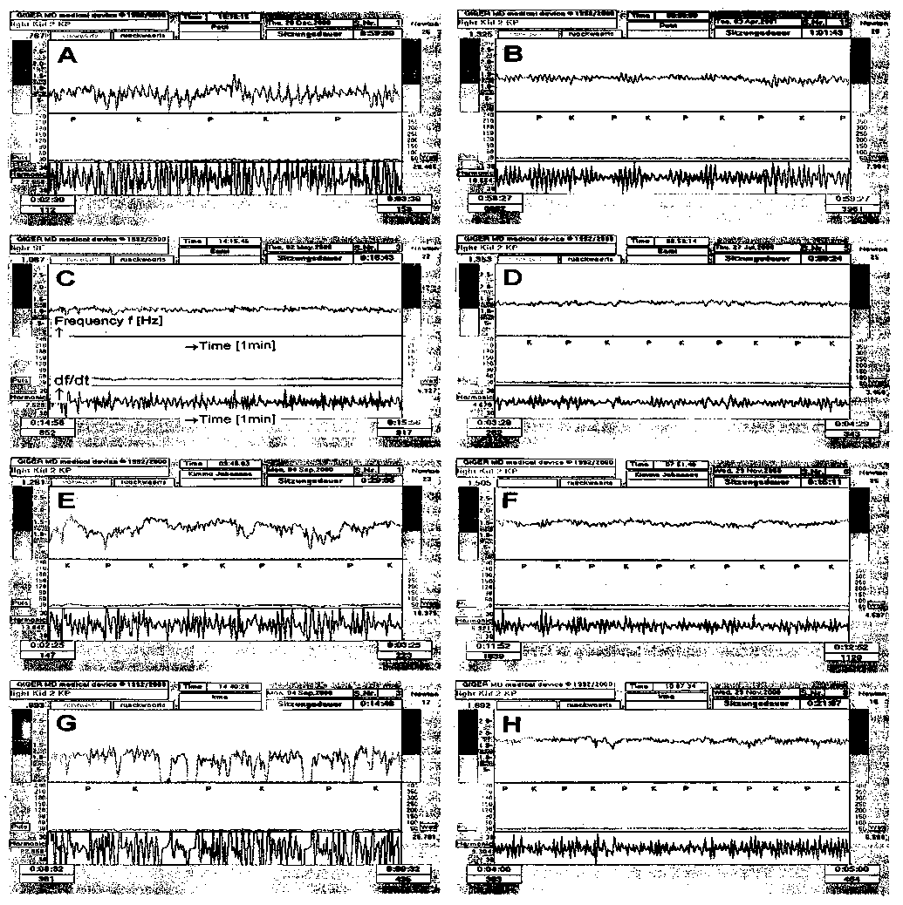
Fig. 1. - Coordination dynamic recordings for forward turning of 4 patients with traumatic brain injury at the beginning of therapy (A, C, E, G) and after 3 months of therapy (B. D. F, H). Ordinate, f (upper trace) and df/dt (lower trace). Abcissa, time coordinate (Imin from left to right) calibrated by the pace (P) and trot gait (K) coordinations. Note that the amplitude of variation of frequency (Δf) and its time derivative (Δdf/dt) reduced and the frequency of turning increased in all 4 patients.
197
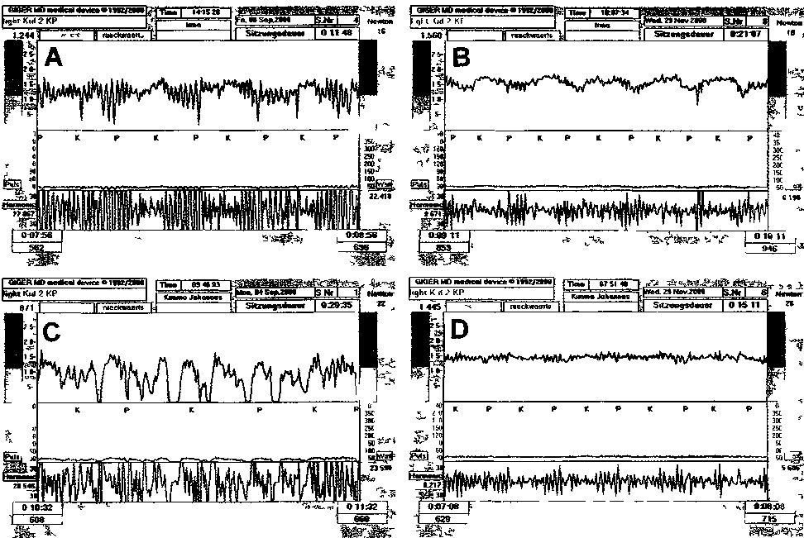

Fig 2 Coordination dynamic recordings for backward turning of 2 patients with traumatic brain injury at the beginning of therapy (A, C) and after 3 months of therapy (B, D) Ordmate, f (upper trace) and df/dt (lower trace) Abcissa time coordinate (1mm from left to right) calibrated by the pace (P) and trot gait (K) coordinations Note that the amplitude of variation of frequency (Δ f) and its time derivative (Δ df/dt) reduced and the frequency of turning increased in the 2 patients

tion dynamics of a patient on-line, one can see that the organization of the CNS is changing all the time
For backward turning also the coordination dynamics improved substantially in the shown two cases (Fig. 2) the coordination dynamics improved within 3 months by 72 and 76%
The indirect measurements of CNS organization by the improvement of movements also showed sub-stantial progress in all patients In Fig 3 the improve-ments of walking, jumping and hand grip power of the 4th patient (Fig. 1G, H) are shown This patient relearned to freely walk faster (Fig. 3A) with a bet-ter performance, to jump longer on springboard (Fig. 3B) and to turn on the device longer without fixation of the paretic hand (increase of hand grip power, Fig. 3C)
In most patients muscle power, balance, walking speed, function of the bad hand, general condition and self confidence became better if present, hyper-sahvation and agressivity reduced In two of the 3 patients with speech problems the speech improved
Coordination dynamics of physiotherapists
In 6 healthy physiotherapists the coordination dynamics were measured Their age was between 21 and 33 and they were untrained with respect to exer-cising on the special coordination dynamic therapy device Their automatic lower frequency of turning was 1.15 ± 0.09Hz (corresponding to a walking speed of approximately 4km/h). Their coordination

198

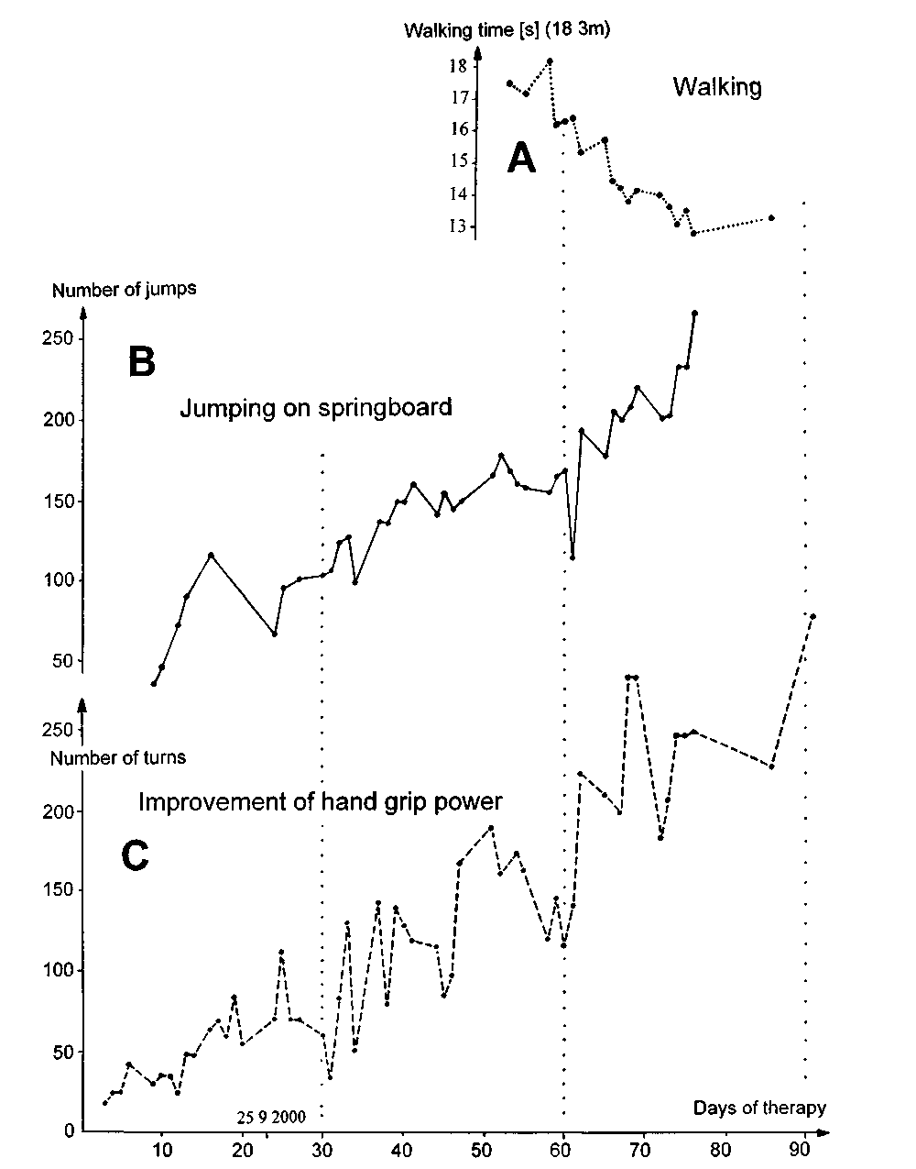
Fig 3 - Improvement of walking (A), jumping (B) and hand grip power (C, number of turns without fixation of the right paretic hand) in d patient (after astrocytoma operation) perfoi mmg coordination dynamic thei apy for 3 months.

199

dynamics for forward turning were Δ(df/dt)/f = 5.1 ±1.2 (range 3.7 to 6.3) for forward turning. When the author exercised intermittently with a high con-centration for a few hours, he could reach a value of Δ(df/dt)/f = 2.5 for forward and backward turning (frequency of turning = 1Hz). With no special efforts his coordination dynamics lied between 3 and 4.
Discussion
Coordination dynamics improvement in patients who
suffered stroke or traumatic brain injury
In 6 patients with traumatic brain injury the coor-dination dynamics could be improved by 69%. In 4 stroke patients, who obtained the same therapy, that means coordination dynamic therapy for 3 months, the coordination dynamics improved by 70% (8). Pooling the original data of the stroke and brain injury patients together, the coordination dynamics in stroke and brain lesion (10 patients) improved by 69 ± 12% (range 50 to 87) if the patients obtained intensive coordinaton dynamic therapy for 3 months.
More substantial relearning with longer therapy times (neurogenesis after 5 months of therapy?)
I measured in stroke patients that when the coor-dination dynamic therapy lasted much longer, then the recovery was much better (8). A musician even relearned hand and finger functions and could play violin again when the coordination dynamic therapy of moderate intensity lasted longer than 4 years.
In two patients with traumatic brain injury further substantial recovery was achieved when the therapy lasted longer (at least 6 months). The movements became better and the coordination dynamics fur-ther improved. In two children with cerebral palsy and two patients with spinal cord lesion a substan-tial rather sudden further improvement occurred after very approximately 5 months of continuous intensive coordination dynamic therapy. As if some-thing was growing in the lesioned CNS which needed 5 months.
A now 39-year-old patient suffered severe poliomyelitis sub Th10 ate the age of one year (com-plete paralysis of the lower body), but also arm func-
tions were impaired. After 36 years (at an age of 37) coordination dynamic therapy was started. After 3 months of coordination dynamic therapy, the patient could move a bit the legs (with gravity eliminated). After 7.5 months of therapy the patient could stand a bit and walk two steps backwards when supported. After 2 years of therapy she got more leg and trunk functions and the legs started to grow (the patient is getting taller). Menisci were built, which she had not before. This therapy-induced growth includes also a neurogenesis of motoneurons, since it is believed that poliomyelitis destroys the motoneurons. It seems therefore that neurogenesis in the adult CNS is at least induced if coordination dynamic therapy lasts longer than 5 months. Therefore longer therapy times are needed for patient with severe CNS lesions. Ther-apy times between 6 and 12 months minimum are needed, depending on the severity of the CNS lesion.
Electromyographic indication for neurogenesis of motoneurons
In the above mentioned poliomyelitis patient elec-tromyography (EMG) was performed of the leg mus-cle quadriceps femoris in comparison to the arm muscle biceps brachii to see also by electromyo-graphical means the improvement of CNS function-ing (Figs. 4, 5). After 3 months of therapy most likely a few α₃-motoneurons (S-type muscle action poten-tials have a very low amplitude, (4)) were activated when the patient turned on the special coordination dynamic therapy device (Fig. 4A). After 7.5 months of therapy the EMG-activity in the quadriceps femoris muscle further increased (Fig. 4B, C, D). The amplitudes and the duration of the action potentials of the motor units point toward the activation of FF muscle fibres, which are activated by a₁-motoneu-rons. From frog experiments it is known, that the thick fast conducting axons regenerate fastest (2, 3). The additional rather sudden appearance of action potentials of the FF-type (fast-fatigue, ATPase-type IIB) with ongoing therapy (Fig. 5A) indicates a regeneration process. This argument is supported by the observation that the proximal leg muscles (closer to the CNS) were reinnervated before the more dis-tal muscles (more distant from the CNS). But in the process of restoration of spinal cord functions in patients with a spinal cord lesion also mostly the

200

EMG

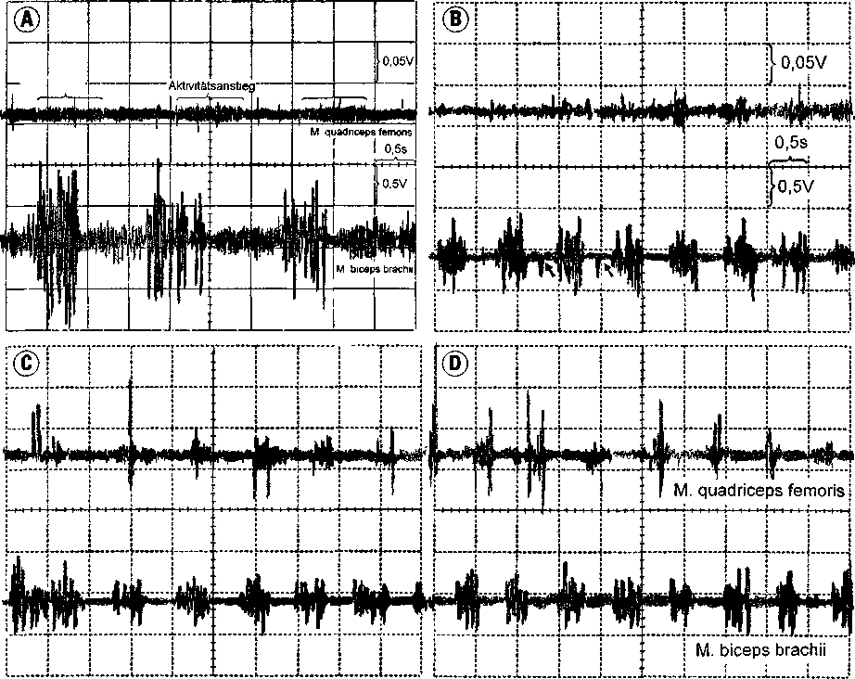

Fig. 4. - Electromyography (EMG) of a reactivated muscle (quadriceps femoris dexter) after poliomyelitis in comparison to a muscle which was only little affected by poliomyelitis (biceps brachii dexter) after 3 (A) and 7.5 (B, C, D) months of coordination dynamic therapy during rhythmic activation when turning fast on the special coordination dynamic therapy device. In A low amplitude activity can just be seen, upper trace, which is probably generated by type S muscle fibres activated by α₃-motoneurons, which survived poliomyelitis. In B, C, D, rhythmic activity of also the musculus quadriceps femoris can clearly be seen, when turning fast on the special coordination dynamic therapy device. The dynamically activated FF-type muscle fibres, innervated by α₁-motoneurons (identified by the large action potential amplitude and the short duration (see Fig. 5A)). were firing irregularly as can be seen from the irregular EMG-activity of the quadriceps femoris in B. C. D. But also in the biceps brachii muscle the rhythmic firing was not physiologic; in B, two irregular action potential are marked with small arrows.

proximal muscles start to work before the distal mus-cles (work is in progress).
The recording of muscle action potentials of long duration point further towards the building of new motor units (Fig. 5B). The irregularity of appearance of muscle action potentials in the formally plegic muscles (Fig. 4B, C, D) indicates further the building of new synapses in the spinal cord, since newly built synapses fire first irregularly. The EMG findings sup-
port regeneration of the CNS and reinnervation of the leg muscles in the poliomyelitis patient.
Adult neurogenesis, cell proliferation, motor learning and function
The clinical and the EMG findings in the poliomyelitis patient are only an indirect indication

201

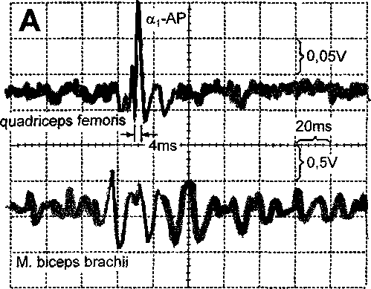
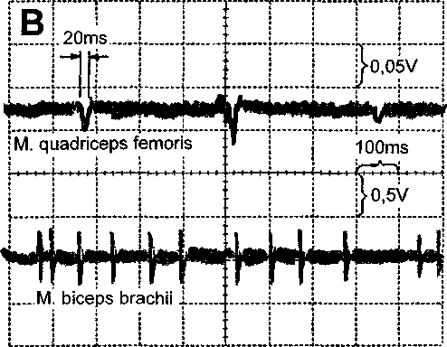
Fig. 5. - EMG from a reactivated muscle following severe poliomyelitis 36 earlier ago (m. quadriceps femoris) during non-rhythmical activation. In the recording in A, upper trace, a muscle action potential is marked with α₁-AP. which has a comparably high amplitude and is of short duration (4ms). which originates probably from a FF-unit (ATPase-type IIB) activated by an α₁-motoneuron. There is therefore electromyographic indication for reinnervation of the musculus quadriceps femoris by the fast growing and reinnervating α₁-motoneurons. In B muscle action potentials of long duration (20ms) indicate that new motor units are in the process of building, because motor endplates in the building process fire irregularly and the many irregularly firing motor endplates of the motor unit will give rise to a motor unit action potential of long duration. Note that the muscle action potentials of the quadriceps femoris have a much smaller ampli-tude than those of the biceps brachii, because the preamplifica-tion is different.
for the building of new motoneurons and probably other neurons in the CNS. The biochemical and anatomical findings of neurogenesis are a direct indi-cation for neurogenesis (1). But this does not prove that these new nerve cells are working with respect to functional aspects. When working on motor end-plates of slow muscle fibres in the frog I could mor-phologically find healthy looking synapses which were not functioning as measured electrophysiolog-ically in the process of innervation of slow muscle fibres (3). When applying coordination dynamic therapy to patients, it seems that at the beginning of therapy there is some progress taking place which may come from some newly built CNS neurons which were already present in the CNS, but were not functionally used.
I have measured in frog morphogenesis that many motoneuron axons were growing into the pyriformis muscle, but only a part of them established stable functioning synapses and survived (3).
There are reports that motor learning enhances adult neurogenesis and cell proliferation in the hip-pocampal formation of rats and mice (9-11). Some conclusions on adult neurogenesis are summarized and compared to strategies used in neurorehabilita-tion of patients:
1. Proliferation and survival of newly formed neu-rons can be affected by training methods in mice and rats (in the hippocampal formation), espe-cially in cases of suboptimal CNS functioning due to non-use. Non-moving has to be avoided in CNS lesioned patients.
2. The survival rate of labeled neurons was more than two times longer in animals which had learned the hippocampus-dependent task than in those learn-ing a similar but hippocampus-independent task. With respect to applicability to humans, this prob-ably means that a lesioned part of the CNS has also to be activated during therapy to be repaired.
3. It is important to distinguish between effects on the formation of new neurons and effects on their subsequent survival. New neurons may be more sensitive than more mature neurons to the effects of activity, and it is possible that the period of maximum sensibility may begin shortly after the neuron is formed. Long continuous motor learn-ing is probably needed for patients to induce neu-rogenesis and make use of it.

202

4. Voluntary exercise of mice in a treadmill increased cell proliferation, cell survival and net neurogenesis. Motor learning may be a specific stimulus for epigenic neurogesis. This is what the practical experience with the patients suggests: for a success in reorganization to be achieved there must be more than just reorganization of the lesioned CNS. New neurons are needed if some critical parts (for example connecting parts) of the neuronal networks are destroyed. Free and treadmill running was used in patients, if possible, for the reorganization of the lesioned CNS.
5. Activity alone is not an adequate stimulus for adult hippocampal neurogenesis. This argument is fully in line of the coordination dynamic therapy and is of immense consequence for the methods applied in neurorehabilitation. It is of importance what methods are used for an efficient supervised learning and re-learning and what neuronal net-work parts are activated during the exercise.
6. Involvement of the hippocampal formation in learning: Direct association between hippocam-pus-dependent learning and neurons generated in the adult hippocampal formation.
7. Stressful experiences known to increase levels of adrenal steroids and hippocampal glutamate release, diminish the proliferation of granule cell precursors in the dentate gyrus of adult tree shrews and marmorset monkeys. Continually diminished production of new cells resulting from chronic stress or corticosterone treatment may contribute to performance decrements in hip-pocampus-dependent tasks under some condi-tions. Performance decrements were also observed in some patients when they experienced stress.
2. miledi, R., parker, I. and schalow, G.: Calcium transients in normal and denervated slow muscle fibres of the frog. J. Physiol. 318: 191-206, 1981.
3. schalow, G.: Elektrophysiologische und morphologische Untersuchungen zur Differenzierung der Tonusfasern des Frosches. Inauguraldissertation. Universitat des Saarlandes (1983).
4. schalow, G., blanc, Y, jeltsch, W. and zach, G.A.: Elec-tromyographic identification of spinal oscillator patterns and recouplings in a patient with incomplete spinal cord lesion: Oscillator formation training as a method to improve motor activities. Gen. Plnsiol. Biophys. 15. Suppl. 1: 121-220, 1996.
5. schalow. G. and zach, G.A.: Reorganization of the Human CNS. Neurophysiologic measurements on the coordination dynamics of the lesioned human brain and spinal cord. Theory for modern neurorehabilitation (31 case reports). Gen. Physiol Biophys. 19 (Suppl. 1): 1-244,2000.
6. schalow. G.: On-line measurement of human CNS organi-zation. Electromyogr. Clin. Neurophysiol. 41: 225-242, 2001.
7. schalow, G.: Time axis calibration in human CNS organization for judging dysfunction. Electromyogr. Clin. Neuro-physiol. 41:485-505.2001.
8. schalow, G.: Stroke recovery induced by coordination dynamic therapy and quantified by the coordination dynamic recording method. Electromyogr Clin. Neurophysiol. 42: 85-104, 2002.
9. praag van. H.. k.empermann, G., gage, H.: Running increases cell proliferation and neurogenesis in the adult mouse dentate gyrus. Nature Neurosci. 2(3): 266-270, 1999.
10. gould, E.. beylin, A., tanapat, P., reeves, A., shors, T.J.: Learning enhances adult neurogenesis in the hippocampal formation. Nature Neurosci. 2(3): 260-265, 1999.
11. greenolgh, W.T.. cohen, N.J.. jlrasko, J.M.: New neurons in old brains: learning to survive? Nature Neurosci. 2(3): 203-205, 1999.

References
1. eriksson, P.S., perfilieva, E.. bjork-eriksson. T.,
alborn, A.M., nordborg, C, peterson D.A. and gage, F.H.: Neurogenesis in the adult human hippocampus. Nature Medicine 4: 1313-1317, 1998.
Address reprint requests to:
Giselher Schalow
Dr.med.habil. Dr.rer.nat., Dipl.Ing.
Untere Kirchmatte 6
CH-6207 Nottwil
Switzerland

203

