Non-drug induced spasticity reduction achieved by coordination dynamic therapy in CNS injury

Giselher Schalow

Abstract
In two patients with severe central nervous system (CNS) lesions it could be demonstrated that spasticity reduction can be achieved by the coordination dynamic therapy method without administration of spasmolytic drugs. The reduction of spasticity in the short- and long-term memory was measured with the coordination dynamic recording method. When performing rhythmic coordinated movements, the mainly extensor spasticity reduced in the first case in the short-term memory within 35min of assisted exercising by approximately 68% (easy treatable case). In the second case spasticity reduced in the short-term memory within 58min oj exercising by 15 up to 28% and in the long-term memory within 6 months bv 16% (difficult treatable case) as judged by the improvement of the coordination dynamics when exercising on the special coordination dynamic therapy device. Reduction of spasticity without administration of drugs could be achieved in all of the more than 100 patients undergoing coordination dynamic therapy.
Key-words: CNS injury - Neurotherapy - Coordination dynamic therapy - Coordination dynamic recording method -Spasticity reduction - Spasticity quantification.

Introduction
Neuroretherapy management is frequently hin-dered by different kinds of spasticity. Also in the everyday life spasticity is mostly not beneficial for the central nervous system (CNS) functioning. Dif-ferent kinds of spasmolytic drugs have been used to reduce spasticity, including Botulinum toxin. For low doses, spasmolytic drugs are administered orally, pumps are used for high doses.
Such drugs are not very beneficial for the patient since they only treat the symptoms, rather than the underlying cause of spasticity, and they are associated with quite a lot of side effects. While blocking the neuromuscular junction or the input to the motoneu-ron with these drugs also the volitional power reduces with the reduction of spasticity. But the real cause for spasticity is the pathologically functioning CNS due to lesion or malformation. Causative therapy has
therefore to restore physiologic functioning of the CNS again. The lesioned CNS has to be reorganized in the way that false organizations of the CNS become depressed and physiologic functions improve.
Based on measurements of relative phase and fre-quency coordination between the firings of neurons in the human nervous system and its partial loss after CNS lesions (4-12), the coordination dynamic therapy was developed (13-17). This therapy method reduces or eliminates spasticity and enhances strongly physiologic neuronal network re-organization at the same time. When applying the mainly movement ther-apy spasticity reduces and movements, vegetative and higher mental functions do improve substantially, until the CNS lesion gets partly cured. Therefore spasmolytic drugs are not needed any more.
In more than 100 patients undergoing coordina-tion dynamic therapy, the dose of spasmolytica could be reduced or their administration stopped. Mostly

Electromyogr. clin. Neurophysiol, 2002, 42, 281-293.
281

the patients discontinued their drugs themselves as soon as realizing that spasticity had reduced during the therapy.
In this paper, I report about spasticity reduction in the short- and long-term memory in a patient with a hypoxic CNS lesion and in a patient with a rostral spinal cord lesion including bleeding, achieved through coordination dynamic therapy. Both patients presented with severe spasticity and were given up by the school medicine. The spasticity reduction was measured and quantified with the coordination dynamic recording method.
Method
Spasticity is experienced as a non-physiologic activation of skeletal or smooth muscles. Most often extensor spasticity occurs; legs go into an extended position when activated (Fig. IB). Also smooth mus-cles of the urinary bladder can be spastic.
In the concept of coordination dynamics, the dif-ferent kinds of spasticity or other kinds of patho-logic CNS organization (such as rigidity or cogwheel phenomenon) can be decribed by attractors (13) in the same way as physiologic movements. Neuronal network states and attractors can be represented as a ball (network state) which is rolling (attracted) into a well (attractor) in a potential landscape of differ-ently sized wells. By coordination dynamic therapy, i.e. by relearning relative phase and frequency coor-dination among CNS neuron firing, the pathologic attractors (like spasticity) have to be made less prominent (smaller and shallow) and the physiologic attractors (like walking, running and crawling) have to be made more prominent (deeper and wider). The whole potential landscape for CNS organization has to be changed in the way that the CNS organizational states use much more physiologic than pathophysio-logic attractors. Therefore reduction of spasticity is not so much a theoretical problem but an immense practical problem. For example, how to exercise a physiologic movement like walking if the legs are so much extended that only the big toes are touching the ground: for walking it is the heels that have to touch the ground, especially when the stepping automatism is to be induced.
With the special coordination dynamic therapy device it seems always possible to start coordination
dynamics therapy and reduce spasticity. This will be shown and illustrated in the first case report.
Mostly, spasticity hinders physiologic movements. When measuring the arrhythmicity between coordi-nated arm and leg movements with the coordination dynamic recording method, spasticity and spasticity reduction can be quantified through improvement of rhythmic coordinated movements. But there are patients with very bad coordination dynamics (when, for instance, the arms move very uncoordinatedly) but they have nearly no spasticity. It is therefore not possible to distinguish always what part of the bad coordination dynamics (high value of Δ(df/dt)/f) originates from spasticity and what part originates from uncoordinated movements. Also with the reduc-tion of spasticity often the volitional power increases, giving the patient more power to counteract spastic-ity to exercise more rhythmically. But whatever the splitting of coordination dynamics may be, the improvement of the coordination dynamics quanti-fies improvement of CNS organization, of which the patient will benefit in any case.
Spasticity may be a physiologic CNS organiza-tional state or activation which is changed patho-physiologically by a lesion or by malfunctioning with the consequence of pathological muscle activation. In patients we can see that when the supraspinal con-trol to one leg is impaired in the spinal cord, the CNS recruits the stepping automatism for help. A patient may walk therefore on one side rather physiologically while using the stepping automatism recognisably on the other side, as indicated by a pronounced higher lifting of the corresponding knee. Due to the CNS lesion the movement pattern (walking) and the automatism (stepping) may be altered. For the upright position we need the antigravity muscle fibres (S) and the antigravity activation. But because of the CNS lesion this activation for the upright position of the trunk may be overemphasised and pathologically changed and can be the cause for extensor spasticity. Also phylogenetically old patterns may partly be recruited and activated by the CNS neuronal net-works, when the CNS is lesioned (18).
Results
It will be shown now in two case reports that spasticity can be reduced substantially in the short-

282

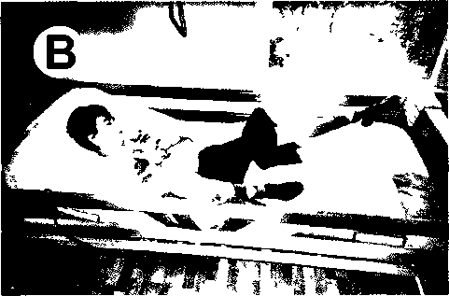
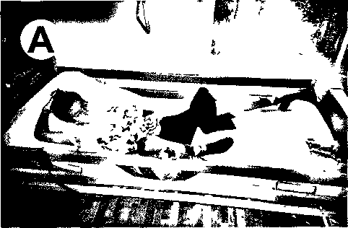

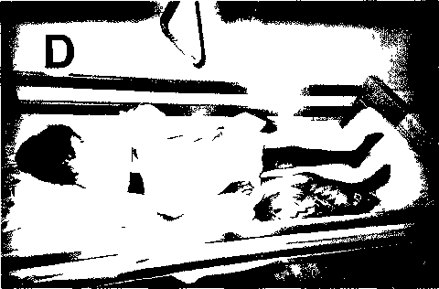
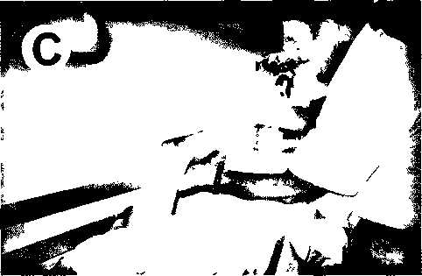

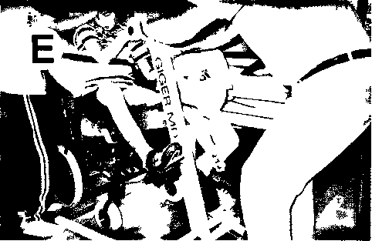
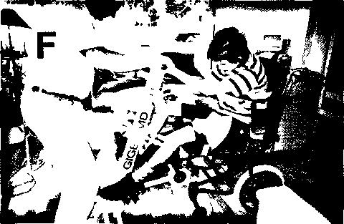

Fig 1 Spasticity reduction in the short-term memory in a patient with CNS lesion due to hypoxia with very severe extensor spasticity in the left leg, flexor spasticity in the right leg and hand spasticity. A. The typical position when the 14-year-old Anna is lying in bed, probably 20 hours per day: Extensor spasticity in the left leg, flexor spasticity in the right leg, right arm mostly lifted up, hand spasticity B. Extreme extensor spasticity in the left leg when touching the left leg. C. No extensor spasticity in the left leg during deep sleep. D. Possible positioning of the patient during deep sleep, when there is no spasticity present. E. Exercising with the patient, when only one leg is moving. The hands were mostly fixed to the handles. Note that the left spastic leg is a bit flexed after a 2000 to 3000 turnings. F Exeicising with the patient, when both legs are moving after reduction of spasticity in the long-term memory. Note that the trunk stability and the expression in the face is better in comparison with E.
283

and long-term memory without drugs, and that it can be quantified by the coordination dynamic recording method.

Case report 1: Reduction of very severe spasticity in the short and long-term memory without drugs, when the patient could not exercise by himself.

Clinical picture of spasticity reduction

The now 14 years old Anna suffered severe hypoxia when in an accident, during playing her tra- chea broke and the parents attempted to venti1ate her unsuccessfu11y (paratrachea11y). When a trachea1 tubus was inserted by the emergency staff and proper venti1ation was possib1e, she had a1ready suffered severe hypoxia. Now, 9 months after the accident, Anna cannot wa1k, cannot stand, cannot sit, cannot speak and is not a1ways conscious (vigi1ant coma). Anna has been given up by the schoo1 medicine and has been kept ~t a place where she gets care and one hour conventiona1 physiotherapy per week! The par- ents wou1d 1ike to take her home, but one of the main prob1ems is the extreme1y strong extensor spas- ticity of the 1eft 1eg, which they cannot handle. The girl received at the beginning seventy mg Baclofen per day (later on 30mg) which had efficient1y no effect on her ~xtensor spasticity.
During ho1idays, the parents to ok Anna home so that the author cou1d have a try to see whether it was possib1e to reduce her very strong spasticity to give them SÜlle hope for the future. It wi11 be shown here that substantia1 reduction of spasticity cou1d be achieved in the short-term and in the long term memory within 3 days without additiona1 drugs by using the specia1 coordination dynamic therapy device. During the first two days of therapy Anna was "mounted" in the specia1 coordination dynamic therapy device (Fig. lE), except the spastic 1eft 1eg, and the author turned the device approximately 4000 times in the morning and 4000 times in the after- noon. During the turning the spasticity reduced in the short-term memory, which ,could be felt by the author (reduction of resistance) and was quantified with the coordination dynamic recording method on the third day of therapy (Figs. 2, 3). On the third day the spasticity had reduced that much in the long- term memory that Anna could be placed in the morn- ing with both legs (and arms) in the device (Fig. 1F).
A full turning was not possible and the author turned only partially forward and backwards (Fig. 2) until the extensor spasticity reduced so much in the left leg that full turning became possible (Fig. 3A). Subse-quently, spasticity decreased quickly further as could be felt by the author and quantified by the coordi-nation dynamic recordings (Figs. 2, 3). Because the coordinated arm and leg movements were symmetri-cal on the third day of therapy (both legs were placed in the device), the posture became more upright, the hypersalivation present reduced more strongly and the higher mental functions (judged upon by the appearance of the face and the glance of the eyes and her becoming more conscious) improved in the short-term memory. The flexor spasticity in the right leg did not affect very much the exercises. Because Anna's CNS functions improved very much in the short-term memory every day and kept improving day after day (long-term memory), it is very likely that her CNS functions can be improved substantially with coordination dynamic therapy for at least 6 months. Fig. 1A shows Anna lying in bed. The left leg is in extensor spasticity position. The right leg is in flexor spasticity position; the right arm shows upwards. Being in this position most of the time, Anna's tendons will get shorter, especially the Achilles tendon (tendo calcaneus) of the left leg. When touching her left leg, independent of the site, even stronger spasticity was induced for (Fig. 1B) for 5 to 10s. Anna is a cooperative patient (when seemingly conscious) but she cannot bend her left leg on volition. No manual induction of flexion was possible. A mechanical flexion with power would probably cause the knee joint to break. Taking Anna into the arms (emotional stimulation) did not help at all or only very little. Father, mother, author and sister then helped Anna into the standing position. By holding the body (emotional input), the hands (get afferent input to the palms), closing the legs (synchronized afferent input to both legs to induce co-movement or co-activation between the legs) and asking Anna to stand (instructive learning) may have helped a tiny bit, but not really. Still, she was stand-ing on her toes on the left side and the right leg was still quite much flexed. A real standing with the sup-port of 3 to 4 persons was not possible. When taking Anna's hands spasticity reduced in the hands and the fingers. The hand spasticity was therefore not the main problem. But it was not possible to bend

284

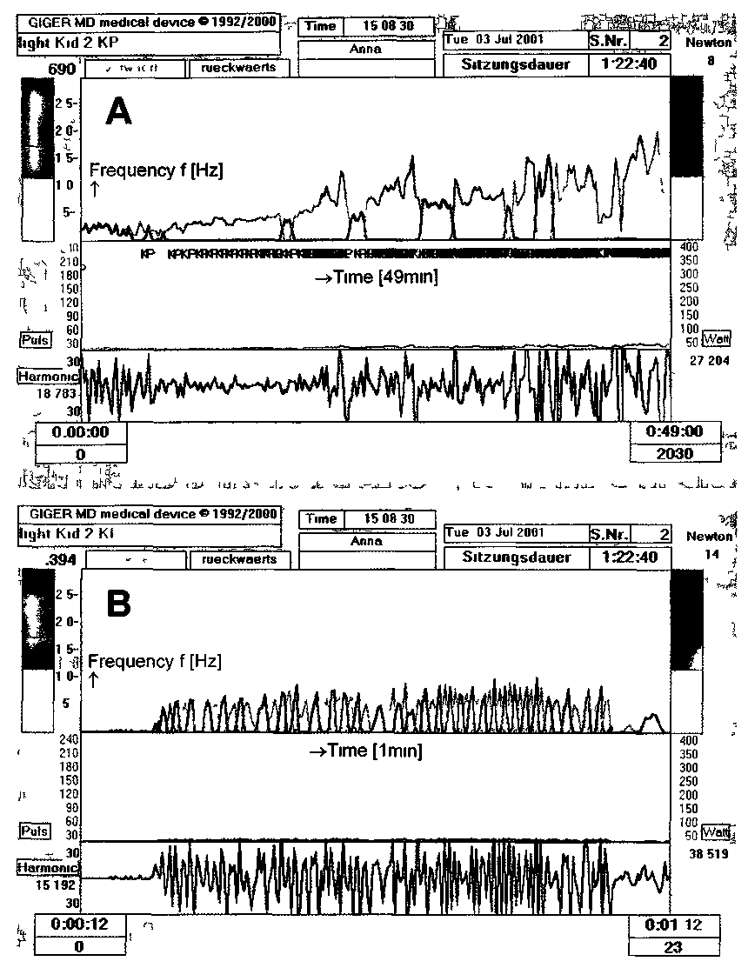
Fig 2 - Spasticity reduction in the short-term memory without drugs in a patient with a severe CNS lesion due to hypoxia. A. Spasticity reduction during 49 min quantified by the coordination dynamics recording method by using the frequency (upper) trace. Ordinate frequency of turning (Hz), abscissa time (49min from left to right). Note that at the beginning only partial forward and backward move ments were possible and then alter spasticity reduction forward and backward turning became possible with increasing frequency (as a sign of spasticity reduction). B. Initial segment of A time stretched (0min and 12s to 1min and 12s) Ordinate of upper trace frequency [Hz] abscissa time (1min from left to right). Note that the peak frequency of forward (grey) and backward turning (blue) is increasing from left to right indicating spasticity reduction.
285

the left knee. Two reasons that the left leg could not be flexed are: (1) The tendons were already too short, so that no flexion was possible not any more or (2) the extensor spasticity was really that strong that the used means were too inefficient to reduce substantially the spasticity. No diagnostic was possible because the leg was always in the extended position.
Anna was therefore positioned in her wheelchair in front of the device to perform coordinated move-ments with the two arms and the right leg to reduce spasticity in general and especially spasticity in the left leg. And indeed after 2000 to 3000 turns the exten-sor spasticity reduced a bit in the left leg, because the left knee started to slightly bend (Fig. 1E). Mostly it was the author who turned the device, the father supported Anna's trunk and the mother held her left leg. No real diagnostic about knee flexion was still possible. But may-be, during sleep, the spasticity would reduce and diagnostic would be possible.
And actually, in the late evening, when Anna was sleeping deeply, no spasticity (no extensor spasticity of the left leg, no flexor spasticity in the right leg, no uptaking of the right arm, no hand spasticity) were present any more. Probably the reticular formation did not activate those neuronal networks which gen-erated the spasticity. Now the author could bend Anna's hip, knee and ankle joints (Fig. 1C). The ten-dons of the left leg were a bit shortened, especially the left Achilles tendon, but not that much that it would mechanically prevent standing or walking. Then the mother and the author positioned Anna in a more natural symmetrical position during sleep to prevent further shortening of Anna's tendons dur-ing the night (Fig. 1D). In the morning, when Anna's sleep was more shallow, the spasticity partly reoc-curred and the flexor spasticity in the right leg was stronger than the extensor spasticity in the left leg.
On the second day of therapy (5 hours therapy per day) the exercise on the special coordination dynamic therapy device was continued, while leaving the left leg out. But in the afternoon also the left leg was fixed in the device and a bit forward and back-ward movement became possible with both legs. Then after forward and backward moving, the spas-ticity reduced that much that full turning including the left leg became possible. With further turning the spasticity reduced further. The symmetrical exer-cising induced more trunk stability, so that her sit-ting needed less support. Anna's look and face
expression improved. Her face became beautiful. The reduction of spasticity lasted for about 3 hours. On the third day Anna was fixed with both legs imme-diately (like in Fig. 1F) and after some forward and backward moving, full turning became possible and Anna's spasticity reduced more strongly than on the previous day. Her vigilance went up in the short-term memory and her higher mental functions, judged upon by her more concentrated looking, also improved.
When it became possible to position Anna nicely when she was sleeping deeply at night and when it became possible to bend her left leg, the mother asked the author why neurologists at the University hospital had not told her that it was possible to bring Anna's left leg to bend.
Spasticity reduction quantified by the coordination dynamic recording method
Since the coordination dynamics were recorded on the third day when the author helped Anna to exercise on the special coordination dynamic therapy device (Anna could not exercise by herself), it became possible to quantify Anna's reduction of spasticity in the short-term memory.
In Fig. 2A, upper trace, an overview of the reduc-tion of spasticity can be seen. It is known that spas-ticity is velocity dependent. When moving a spastic leg faster on volition or passively, then after a threshold for spasticity the spasticity increases. The possible increase of the turning frequency without an increase of coordination dynamics, when the author helped the patient to exercise on the special coordination dynamic therapy device, showed therefore that spas-ticity reduced. When turning too fast on the device, spasticity increase was felt as usual as an increase of resistance, when the extended leg (in this case exten-sor spasticity) had to be bend. The consequently more arrhythmic turning was measured and quanti-fied by the device as a larger frequency variation (Fig. 3 upper trace) and an increase of the coordi-nation dynamics (Fig. 3, lower trace).
When starting the exercising on the device on the third day, only forward and backward moving was possible (Fig. 2B). The spasticity reduced, because the transient turning frequency (Fig. 2B (upper trace)) and the amplitude of turning went up. When

286

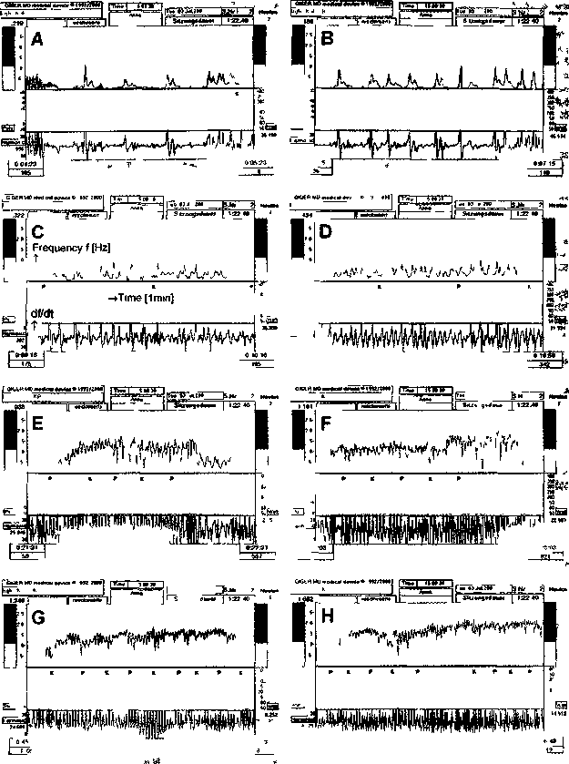
Fig 3 - Spasticity reduction m the short-term memory A to H time-stretched segments of Fig 2A Ordmate upper trace frequency (f) and lower trace coordination dynamics (Δ(df/dt)/f) abscissa time (1mm from left to right) The frequency of turning increased from B to H from f = 0 189 to 1 66Hz (by = 778%) and the coordination dynamics improved (decreased) from 45.5 to 15.0 (by = 68%) in the short-term memory within 46min. A. It just becomes possible to assist Anna (a patient with a hypoxic CNS lesion) to turn on the special coordination dynamic therapy device. On the left side of the upper trace forward and backward moving can be seen on the right side first continuous turning. B. Arrhythmic turning with stops in between mainly due to extensor spasticity in the left leg. When the extended leg had to bend spasticity hindered strongly the turning and the frequency went down Mean frequency f = 0.189Hz. C. After 9min of turning the turning becomes continuous, the frequency does not reach the zero-line any more, mean frequency of turning = 0.317. D. After 15.50 min the turning becomes further rhythmic the variation of the frequency reduced, mean frequency = 0.429Hz. E. After 21- 27min spasticity reduction allowed a still faster turning. When the author changed the frequency of turning from 0.5Hz (slow walking frequency) to 1.5Hz (slow jogging frequency) additional spasticity increase appeared with a delay of approximately 12s and the turning was nearly blocked, the moving nearly stopped when the leg with extensor spasticity had to be flexed. F. After only slowly turning was possible a faster turning became possible again with the reduction of spasticity (f = 1Hz). A further increase of turning induced again velocity dependent spasticity, the turning was nearly blocked and the turning nearly stopped Patient’s spasticity reduced in the short-teim memory (higher frequency of turning was possible) but was partly still present. G. A mean frequency of turning of f = 1.342 was possible indicating a further reduction of extensor spasticity in the short term memory. Note that the frequency reduction was greater for pace (P) and trot gait coordinations (K) than for the intermediate coordinations indicating that extensor spasticity may come more from the bramstem or the spinal cord. H. After 46-50 mm of exercising on the special cooidmation dynamic therapy device extensor spasticity was reduced so much that nearly a running frequency of turning was possible (f = 1.66Hz) In E, F, H a few P and K calibrations are missing.
287

spasticity reduced that much that it did not block the turning any more full turning became gradually possible (Fig. 3A, upper trace). With further turning, the frequency of turning went up from 0.189Hz (Fig. 3B) to 1.66Hz (Fig. 3H, upper trace) and the arrhythmicity of turning (coordination dynamics) reduced from 45.5 (Fig. 3B) to 14.5 (Fig. 3H) by 68%, indicating that spasticity had reduced strongly. When spasticity reduced, the author tried to test whether there was still further substantial spasticity present in the CNS of Anna by turning still faster on the device. After increasing the turning frequency for a few sec-onds, spasticity increased strongly after a delay of a few seconds (Fig. 3E, F), as felt by an increase of the resistance of turning when the left leg had to be bent: the turning frequency reduced strongly. When turn-ing then transiently slowly, the additionally increased spasticity reduced again. With further turning, the frequency of turning could be further increased, indi-cating a further spasticity reduction (Fig. 3G, H).
In conclusion, within three days of coordination dynamic therapy, spasticity reduced in the 14-year-old Anna in the short- (in every therapy session) and long-term memory (reduced spasticity before the therapy session after 3 days). Her trunk stability, hypersalivation and her higher mental function had improved in the short-term memory during each ther-apy session. If Anna got coordination dynamic ther-apy for a year, her CNS functions, including spastic-ity, movements, trunk control, hypersalivation and vigilance could most likely substantially be improved.
Case report 2: Reduction of very severe spasticity in the short and long-term memory without drugs in a patient able to exercise by himself.
In the first case report, the patient could not exer-cise by himself, but she may have helped a bit with her own volitional power when the author assisted her on the special coordination dynamic therapy device. In the second case, the patient had already learned to turn by himself on the special coordina-tion dynamic therapy device. His spasticity reduced during his exercising. Also, this second patient has been given up by the school medicine.
Clinical picture
The now 37-year-old patient had an accident dur-ing riding a bicycle and suffered a spinal cord lesion
sub C4/C5 and partly sub C2. Due to hemorrhage probably the brainstem functions were also impaired, because the patient had an unusually strong spastic-ity in arms and legs (in spite of a spasmolytic having been administered), and his breathing was impaired. Two years after the accident coordination dynamic therapy was started. Three months of coordination dynamic therapy resulted in a reduction of the drug from a high doses (120mg Baclofen per day) to zero. After 5 months of little progress (apart from the with-drawal of the spasmolytic), the patient's movements made a step forward. He was able to turn 4500 times per day by himself in the sitting position, while before the sudden change he only managed 1000 turns. At the beginning of therapy he only managed to per-form a few turns by himself in the lying position. The sitting position became possible because of the reduction of pain and hypersensitivity in the sacral range, especially in the sacral skin. Probably, the pain subsided because of a better processing of the affer-ent input in the neuronal networks as a result of the improvement of CNS organization. After 16 months of coordination dynamic therapy the patient can turn 12,000 times by himself in the sitting position, and can creep a bit when supported.
The coordination dynamics are compared now after 10 and 16 months of therapy; no drugs have been administered any more for at least 6 months. In Fig. 4 the coordination dynamics after 10 months of therapy are compared with those after 16 months of therapy. After 10 months of therapy the overall recording of turning (58min) is shown in Fig. 4A (mean frequency = 0.289Hz). The frequency of turn-ing increased from 0.0Hz to approx. 0.39 Hz and the coordination dynamics improved (reduced) from 46 to 33 (28%) (Fig. 4B-D). The increase of the turn-ing frequency and the decrease (improvement) of the coordination dynamics were mainly due to the reduc-tion of spasticity in the short-term memory. After 16 months of therapy the frequency of turning increased during 58min of turning from 0.18 to 0.68Hz (mean frequency = 0.476Hz, Fig. 4E) and the coordination dynamics decreased from 32.7 to 27.7 (15%) (Fig. 4E-H). The increase of the turning frequency and the decrease of the coordination dynamics during a therapy session (Fig. 4A, E) were mainly due to the reduction of spasticity in the short-term memory whereas the increase of the turn-ing frequency and the decrease of the coordination

288

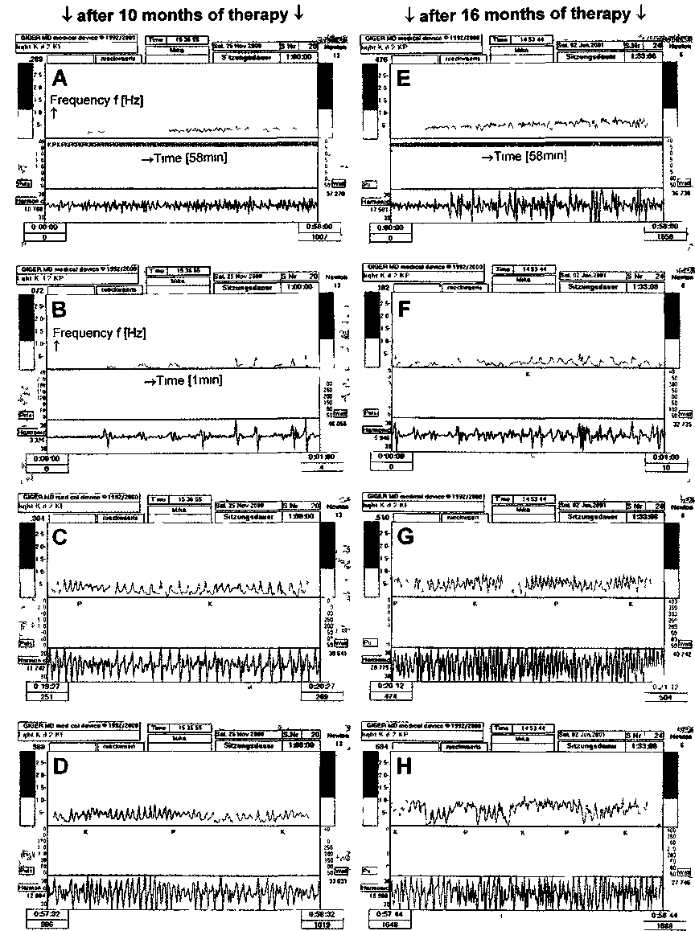
Fig 4 - Spasticity reduction in a 37-year-old patient with a spinal cord and brain stem lesion after 10 (A, B, C, D) and 16 (E, F, G, H) months of coordination dynamic therapy with no drugs administered. Ordinate of upper traces, frequency (f [Hz]); ordinate of lower traces coordination dynamics (Δ(df/dt)/f[s⁻²]). Abscissa time A,B, whole recording of frequency and coordination dynamics (58min), recordings of 1 min at the beginning (B, F) after 20 (C, G) and after 58min (D, H). Note that the frequency increases in the overall traces A and B and from B to D (from 0.072 to 0.388Hz) and from F to H (from 0.182 to 0.684Hz).
289

dynamics after 58min of turning between 10 and 16 months of therapy from 0.39 to f = 0.68Hz (74%) and from 33 to Δ(df/dt)/f = 27.7 (16%) respectively (Fig. 4D, H) were mainly due to the reduction of spasticity in the long-term memory. A bit of increase of volitional power will have contributed.
The frequency traces in Fig. 4D, G show that the patient could turn better for pace (P) and trot gait (K) coordinations than for the intermediate coordi-nations, which may indicate that the main problems concerning repair are sited supraspinally.
It can be seen in Fig. 4H that the frequency of turning reduced strongly for the intermediate coor-dinations (between pace (P) and trot gait (K) coor-dinations). This is because the patient tried to turn as quickly as possible. When he turned a bit too quickly additional spasticity occurred after a few seconds. When turning a bit slower again than the additional spasticity subsided. In this case additional spasticity occurred for the difficult intermediate coordinations. This additional spasticity increase when moving spastic arms or legs too fast was also experienced by the author, when he assisted Anna to exercise (see above, Fig. 3E, F).
In this case the measured coordination dynamics, seen as the coordination dynamic trace (lower traces), seem to show only little spasticity reduction, because the patient was turning too slowly (especially at the beginning of the therapy session), indicating too good coordination dynamics. The frequency of turning should be around 1Hz, which could not be achieved by the patient.
In conclusion, within further 6 months of coordi-nation dynamic therapy spasticity in this 37-year-old patient reduced by at least 16% in the long-term mem-ory, as measured by the reduction of the coordination dynamics. When using the frequency increase for the evaluation of spasticity reduction, the improvement would be 74%. His hand and finger functions improved a bit so that he can work a bit better (he develops computer programs).
Spasticity reduction without drugs in more than 100 patients
When patients with a CNS lesion come for a consultation to see whether coordination dynamic therapy can help them, it is nearly always possible to
show them that coordination dynamic therapy, administered during the consultation time (~ 90min), can reduce their spasticity. The hand spasticity an'd the adductor spasticity of the legs mostly reduces when exercising 2000 to 3000 times on the special coordination dynamic therapy device. Especially the substantial spasticity reduction in the hand convinces the patients that coordination dynamic therapy can improve their CNS functioning. In a stroke patient and in a patient with a traumatic brain lesion it even happened that in the short-term memory the impaired vision improved transiently and the lost ability to write came back in the short-term memory. In all patients treated with coordination dynamic therapy spasticity could be reduced in the long-term memory. The main problem in neurotherapy is there-fore not how to reduce spasticity (this problem can be solved without using drugs) but how to win back lost volitional power in arms, legs and trunk muscles and to improve vegetative and higher mental functions.
Discussion
No need for spasmolytic drugs to treat CNS lesions
It has been shown in this paper that in two patients with CNS lesion very strong (mainly extensor) spas-ticity could be significant reduced by the coordina-tion dynamic therapy method. In the 14-year-old Anna with a hypoxic CNS lesion, spasticity reduced while having 40mg Baclofen (after the accident 80mg) per day administered. In the 37-year-old patient with rostral spinal cord and brainstem lesions, severe spasticity reduced during coordination dynamic ther-apy with no drugs administered. In more than 100 patients, the author treated himself or supervised the treatment of, spasticity could be reduced with-out spasmolytic drugs or while reducing the drug doses, by only coordination dynamic therapy. It is concluded therefore that spasmolytic drugs are not necessary and not helpful when treating CNS lesions by coordination dynamic therapy. Since spasmolytics do not work sufficiently for severe spasticity, they reduce the volitional power in the patient and have side effects, it is concluded that school medicine should give up the usage of spasmolytics in the treat-ment of CNS lesion and replace this pharmaco-ther-apy by an adequate learning therapy.

290

Loss of plasticity
* In animal experiments it has been shown that the irjotor cells of the spinal cord, located in the cir-cumference of the motor horn are more resistant to ischemia than those at the centre (3). The motoneu-rons are closer to the arterial end of the capillaries, and the interneurons are closer to the venous end. When blood supply gets impaired the peripheral cells use up the oxygen first, and the central cells are sub-jected to low oxygen levels. It may therefore happen that monosynaptic reflexes and rigidity are present, whereas plasticity in the spinal cord (and supraspinal levels) gets lost because of the loss of interneurons of neuronal networks (1, 2).
But spasticity (and rigidity) reduced in the short-term memory in nearly all patients treated by the method mentioned. The severity of the CNS lesion became fully apparent during adequate treatment
only. Further experience with the coordination dynamic therapy indicates that new nerve cells may be build throughout the adult CNS. Therefore pre-treatment diagnostic is not sufficient to evaluate the patient's outcome.
Botulinum toxin
In the 14-year-old Anna the extreme extensor spasticity could be partly blocked by injecting Bot-ulinum toxin into certain extensors muscles of the left leg to block neuromuscular junctions for a few months. First, Botulinum toxin is a strong toxin and little is known about long-term side effects. Second, reducing or blocking the activation of muscles is treating symptoms rather than the cause underlying the illness, namely the pathologic organization of the CNS. Third, when administering the toxin, the

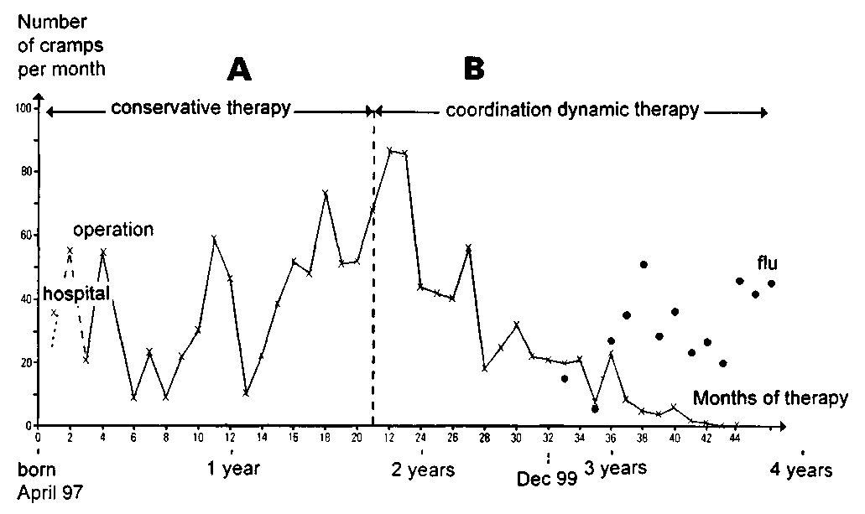
Fig. 5. - Reduction of affect cramps with loss of consciousness and hypoxia in a patient with myelomeningocele (spina bifida) and brain injury (hydrocephalus) during 2 years of moderately intensive coordination dynamics therapy (no drugs were administered). With the Bobath-therapy the amount of cramps increased (A), during coordination dynamic therapy the amount of severe affect cramps (with loss of conciousness and severe hypoxia) reduced until, at an age of 3.5 years, no severe cramps were occurring any more. Between 3.5 and 4 years of age only light cramps were occurring (no loss of consciousness, only hypoxia, no hand cramps), xxx = heavy cramps, ••• = light cramps.
291

trunk stability would not improve, hypersalivation would not stop, higher mental functions would not improve and cramps would still occur. When apply-ing coordination dynamic therapy to Anna, there is hope that the parents get her daughter back, but there is no hope that this may happen when admin-istering Botulinum toxin.
What is spasticity
It is still unclear what is spasticity. Formally it is a pathologic organization of the lesioned CNS and can be described within the concept of coordination dynamics by an attractor (see above). But where does spasticity come from in terms of CNS organization? One possibility is, that spasticity is a network state which became pathologic due to the CNS lesion and this network state can even be a reactivated phylo-genetically old network state, not any more used by the physiologically functioning CNS.
The positioning of Anna (Fig. 1A, B) can be explained by extensor spasticity in left leg, flexor spasticity in the right leg and co-movement or co-positioning of the right arm with the right flexed leg. But her positioning was similar to that of a healthy person lying or sleeping in bed. Anna's positioning may have therefore been a behavioral state of an attractor for physiologic sleeping, which was made pathologic by the lesion in the way that the extended leg was changed into extensor spasticity and the flexed leg changed into flexor spasticity. If we therefore could reduce spasticity (and this is possible) then Anna will mainly be in a physiologic position when lying in bed.
spasmolytic drugs are needed to reduce spasticity. Spasmolytic drugs are only hindering the repair of the pathologically functioning CNS, because the trite CNS functioning is altered by the drugs.
Ethics
It has been shown that CNS lesion can partly be cured when applying coordination dynamic therapy (16, 17). In severe brain lesion, the brain may even destroy itself, if adequate therapy is not given. If the 14-year-old Anna got coordination dynamic therapy, her motor, vegetative and higher mental functions would probably improve. When after two to three hours after the treatment the improvement of CNS functioning subsided from the short-term memory, cramps occurred (may be induced by pain attacks), which looked much worse than the positions Anna is taking in Fig. 1A, B. For this condition, the school medicine offers pain treatment. In Fig. 5 it is shown that affect cramps can be cured by coordination dynamic therapy without administration of drugs, even though it may take a long time (in this case of myelomeningocele it took 2 years).
A traumatic and/or hypoxic CNS lesion is an organic lesion and can partly structurally and func-tionally be repaired.
If patients like Anna with severe CNS lesion do not get adequate available treatment and diagnostic and are kept instead in places until they die, their human dignity gets violated.

Spasticity quantification
Spasticity can be reduced by different kinds of movements and can be substantially reduced, when the patient exercises on the special coordination dynamic therapy device. When exercising on the device, spasticity reduction can be measured. It is unclear so far whether spasticity reduction can be better quantified by the frequency of turning or the coordination dynamics. There are still several uncer-tainties concerning spasticity evaluation. But the substantial step forward is that spasticity can be reduced or eliminated, it can be quantified, and no
References
1. gelfan, S., tarlov, I.M.: Differential vulnerability of spinal cord structures to anoxia. J. Neurophysiol 18: 170-188, 1955.
2. gelfan, S., tarlov, I.M.: Interneurons and rigidity of spinal origin. J. Physiol. 146: 594-617, 1959.
3. krogh, E.: The effect of acute hypoxia on the motor cells of the spinal cord. Acta Physiol. Scand. 20: 263-292, 1950.
4. schalow, G.: Conduction velocities and nerve fibre diameters of touch, pain, urinary bladder and anal canal afferents and a and γ-motoneurons in human dorsal sacral nerve roots. Electromyogr. Clin. Neurophysiol. 31: 265-296, 1991.
5. schalow, G: Oscillatory firing of single human sphincteric (α₂ and α₃-motoneurons reflexly activated for the continence of urinary bladder and rectum. Restoration of bladder function in paraplegia. Electromyogr. Clin. Neurophysiol. 31: 323-355, 1991.

292

6. schalow, G.: Impulse patterns of single encoding sites of human secondary muscle spindle afferents. Electromyogr.
- din. Neurophysio.l 33:451-464. 1993.
7. schalow, G: Recruitment of motoneurons in the occasional
- firing mode in paraplegics. Electromyogr. Clin. Neurophysiol.
33:401-408, 1993.
8. schalow, G.: Spinal oscillators in man under normal and pathologic conditions. Electromyogr. Clin. Neurophysiol. 33: 409-426, 1993.
9. schalow, G.: Phase-correlated adequate afferent action potentials as a drive of human spinal oscillators. Electromyogr. Clin. Neurophysiol. 33: 465-476, 1993.
10. schalow, G.: Action potential patterns of intrafusal γ and parasympathetic motoneurons, secondary muscle spindle afferents and an oscillatory firing α₂-motoneuron, and the phase relations among them in humans. Electromyogr Clin. Neurophysiol. 33: 477-503, 1993.
11. schalow, G, bersch, U.. michel, D., koch. H.G: Detrusor-sphincteric dyssynergia in humans with spinal cord lesions may be caused by a loss of stable phase relations between and within oscillatory firing neuronal networks. J. Auton. Nerv. Syst 52: 181-202, 1995.
12. schalow, G.. blanc, Y, jeltsch, W., zach, G.A.: Elec-tromyographic identification of spinal oscillator patterns and recouplings in a patient with incomplete spinal cord lesion: Oscillator formation training as a method to improve motor activities. Gen. Physiol Biophys. 15, Suppl. 1: 121-220, 1996.
13. schalow, G., zach, G.A.: Reorganization of the Human CNS, Neuroplrysiologic measurements on the coordination
dynamics of the lesioned human brain and spinal cord. Theory for modern neurorehabilitation (31 case reports). Gen. Physiol Bioplns 19 (Suppl. 1): 1-244,2000.
14. schalow, G: On-line measurement of human CNS organization. Electromyogr. Clin. Neurophvsiol 41: 225-242, 2001.
15. schalow, G.: Time axis calibration in human CNS organi-zation for judging dysfunction. Electromyogr. Clin. Neuro-physiol., 41: 485-505. 2001.
16. schalow, G.: Stroke recovery induced by coordination dynamic therapy and quantified by the coordination dynamic recording method. Electromyogr. Clin. Neurophysio. 42: 85-104, 2002.
17. schalow, G.: Improvement after traumatic brain injury achieved by coordination dynamic therapy. Electromyogr. Clin. Neitropln-siol, 2002. in press.
18. bobath B. (1985): Abnormal Postural Reflex Activity Caused by Brain Lesions. William Heinemann Medical Books Limited, London.
Address reprint requests to:
Giselher Schalow
Dr.med.habil.Dr.rer.nat.. Dipl. Ing.
Untere Kirchmatte 6
CH-6207 Nottwil
Switzerland
Institution:
Coordination Dynamic Therapy Centre,
Avenida del Parque, Edif. Benal Beach, Local 2,
E-29630 Benalmadena-Costa (Malaga), Spain

293

