Recovery from spinal cord injury achieved by 3 months of coordination dynamic therapy

Giselher Schalow¹

Summary
Coordination dynamic therapy was applied to 18 patients (average age 31 years) after a spinal cord injury between C4/5 and L4/5; the therapy was administered on average 5 years after the injury for a minimum of 3 months. All complete spinal cord lesions became incomplete, i.e. motor functions improved below the lesion level, including trunk stability and arm, hand and leg functions. The organization of the CNS, quantified by the coordination dynamics between arm and leg movements, improved by 42% for forward and by 49% for backward moving when exercising on a special coordination dynamic therapy device. The improvements of the coordination dynamics were 53%, 32% and 48% for lesions in the cervical, thoracic, and lumbar range, respectively. The plasticity for spinal cord lesions was thus higher when the intumescence was lesioned. Since the coordination dynamics did not change substantially prior to coordination dynamic therapy, did further improve with continued therapy, and worsened when the therapy was terminated, it is concluded that the improvement of CNS functioning above and below the spinal cord lesion level was due to the therapy. Since in stroke and traumatic brain lesion the CNS functioning further improved if the therapy was continued over longer time periods beyond 3 months, it is suggested that spinal cord lesions can partly be cured if coordination dynamic therapy is administered for 1 to 2 years.
Key-words: Spinal cord injury - Neurotherapy — Coordination dynamics therapy — Coordination dynamics recording method — Repair quantification - Neurogenesis.

Introduction
I previous reports, I could show that in stroke and traumatic brain injury the lesioned brain could partly be repaired when administering coordination dynamic therapy for 3 months (23, 24). Further ther-apy resulted in further repair. Improvements of cen-tral nervous system (CNS) functioning could be quantified by improvements of movements and by measuring the improvement (70%) of the coordina-tion dynamics between arm and leg movements (21, 22). Probably, the repair of brain lesions were mainly due to functional reorganization.
¹ Kaskein Kuntoutuskeskus, PL 37. FIN-54801 Savilaipale. Finland; Coordination Dynamic Therapy Centre. Avenida del Parque, Edif Benal Beach, Local 2. E-29630 Benalmadena-Costa (Malaga), Spain.
In spinal cord lesions on the other hand, there is probably also quite much structural repair necessary, since connecting tracts in addition to the grey mat-ter are substantially destroyed. Further, in cervical spinal cord lesions motoneurons are destroyed which innervate hand and finger functions and in lum-bosacral spinal cord lesions motoneurons are destroyed which innervate leg muscles. A partial cure of the spinal cord lesion will therefore most likely also include the building of new nerve cells includ-ing motoneurons and their functional integration in the neuronal networks of the CNS. It will be shown in this report that spinal cord repair can already be stimulated by 3 months of coordination dynamic therapy. For a partial cure of a spinal cord injury however, much longer therapy times are needed. The coordination dynamic therapy is a learning method, and learning needs time.

Electromyogr. din. Neurophysiol, 2002, 42, 367-376.
367

This progress in neurotherapy is due to develop-ments in human neurophysiology achieved in recent 18 years. The coordination dynamic therapy is based on author's own measurements using the single-nerve fibre action potential recording method of natural impulse patterns of single neurones in the human nervous system. In these measurements, it could be found that the self-organization of neuronal networks of the human spinal cord takes place by relative phase and frequency coordination (8-10, 13, 14, 16-20). The theory of the coordination dynamic therapy is in accordance with recent developments in human neurosciences including neurogenesis (2) and coor-dination dynamics (4).
Method
Upon a spinal cord lesion, neuronal network parts and connections (tracts) become destroyed and the relative phase and frequency coordination between neurons, neuron assemblies and neuronal network parts for the self-organization of the central nervous system (CNS) get impaired (11, 12, 15, 20). To partly cure the lesion the relative phase and fre-quency coordination has to be restored by learning. At key functional spinal cord sites new neurons have to be built. In a patient with a cervical spinal cord lesion hand and finger functions can only become substantially repaired if new motoneurones are gen-
erated or if properties of neurones are changed as there must be motoneurons, which bring the infor-mation from the CNS to the muscles.
A partial cure of the pathologically functioning CNS, due to the spinal cord lesion, by relearning is achieved through: (1) The use of special instruments (like the special coordination dynamic therapy device) for relearning of the lost phase and frequency coor-dination between the firings of neurones, neurone assemblies (for example, spinal oscillators) and neu-ronal network parts by exercising the lost coordina-tion between the movements of arms, legs and trunk (probably, more of a functional reorganization). (2) The exercise of automatisms, postures and old learned movements which have been only little changed by the lesion (probably, more of a structural reorganization).
The movements which are often used for repair in coordination dynamic therapy in patients with spinal cord lesion are illustrated in Fig. 1. Fig. 1A, B, C shows how phase and frequency coordination is relearned by exercising on a special coordination dynamic therapy device in the sitting, lying and standing position. In A, a patient with a C4/C5 lesion is shown while training additionally hand and finger functions, and in B, additionally trunk stability is exercised by additional rotational trunk movements. In the standing position (antigravity muscles are sub-stantially activated) movements have to be supported (C). Quite a variability of coordinated arm and leg

Fig. 1. - Different movements included in the performance of coordination dynamic therapy. A, B. 21-year-old tetraplegic patient with a complete spinal cord lesion sub C4/C5 exercising in the sitting (A) and lying position (B) on the special coordination dynamic therapy device. In A, the hands are not fixed allowing the exercising and measuring of hand and finger functions (see Fig. 2Ab). In B, the hands are fixed. C. 33-year-old paraplegic patient with a spinal cord lesion sub Th6 exercising on the special coordination dynamic therapy device in the standing position. The position of the feet had to be supported (author on the right side). D. Measuring of coordination dynamics. The "young and dynamic" patients with scoliosis are supervising each other to turn more rhythmically when watching the coordination dynamic traces on the display. The 6-year-old Katharina watches the counter of turnings (notice the concentrated face) and has her moving hands in the field of vision for biological feed-back. E. Same patient as in D, demonstrating different kinds of coordinated movements on the device. F. 25-year-old tetraplegic patient with a spinal cord lesion sub C5 during creeping exercise for train-ing those neuronal networks which are activating arm and trunk muscles. The therapist is creeping in interpersonal coordination. For quantification of improvement in creeping, see Fig. 2Aa. Notice that hand and finger function are not exercised as in A. G. 33-year-old paraplegic patient, lesion sub Th6 crawling in interpersonal coordination with the author; the movement is quantified in Fig. 2C. H. 28-year-old tetraplegic patient with a spinal cord lesion sub C7 during exercising uprighting. I. Same patient as in H during jumping on springboard. One therapist (author) is supporting the feet and the other one the trunk. Notice that the forefoot of the patient is not touching the springboard, to prevent induction of extensor spasticity. K. Same patient as in A, B during treadmill walking. Therapists are supporting feet and leg movements (author on the right). By pressing the feet to the ground the movement induced re-afferent input is enhanced. When pressing preferentially the heel when the foot touches the ground and when pushing the forefoot at the lift-off phase, the stepping automatism is stimulated. L. 7-year-old paraplegic patient with a spinal cord lesion sub TM2/L2 during walking with sticks; the walking is quantified in Fig. 2E. M. 29-year-old patient during climbing staircases, quantified in Fig. 2F. Patient is moving in pace gait coordination (arm and leg on each side are moving in synchrony).
368

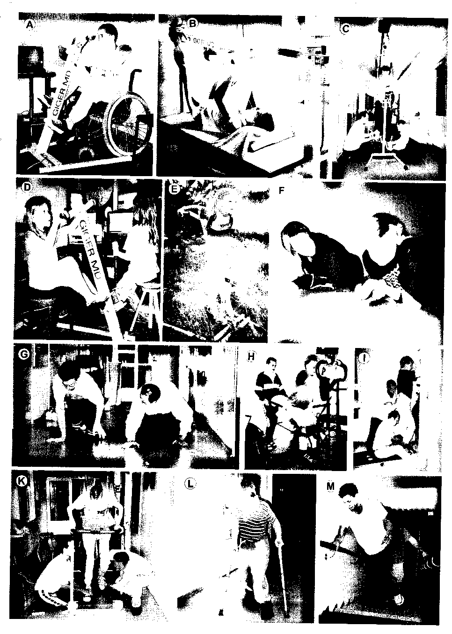

movements is possible with this device (Fig. 1E). The improvement of CNS organization, i.e. improvement of the coordination dynamics, can easily be measured on-line and non-invasively as shown in Fig. 1D by "young and dynamic" therapists.
In Fig. 1F to M, the exercising of automatisms and old learned movements like creeping, crawling, uprighting, jumping, walking and climbing staircases are shown. When walking with support on a tread-mill, it is of importance to induce and support the stepping automatism if only little leg functions are present. Therapists have to get a feeling for the patient's nervous system and have to support it in the way that the best performance of walking is achieved. In accordance with the induction of neu-rogenesis (3, 5, 7) those neuronal network parts have to be substantially activated where neurogenesis and functional reorganization have to be induced. In other words, for spinal cord lesions the patients have to sub-stantially exercise also leg functions (see Fig. 1G to M), best in coordination with arm movements. Fin-ger and hand functions of patients with cervical spinal cord lesions (Fig. 1F) can be trained on a spe-cial coordination dynamic therapy device (Fig. 1A). For stroke patients, Berta Bobath emphasized already 23 years ago that the impaired body side has to be included in the exercising (1). Instructive training, interpersonal (social) coordination and co-move-ments are used to enhance physiologic movements in the patient.
Results
Eighteen patients who suffered spinal cord injury underwent coordination dynamic therapy for at least 3 months. The injuries were due to car accidents (5), working accidents (4), jumping into the water (header, 4), motor-cycle accidents (2), playing ice hockey (1), a parachute accident (1) and erroneous surgery (1). The average age of the patients was 31 years (range 7 to 55), their accident happened on the average 5 years ago (range 1 to 23 years), and the lesion level was between C4/5 and L4/5. In all patients the motor functions improved. In rostral spinal cord injuries (cervical range) mainly trunk stability and arm and hand functions improved. In more caudal lesion levels (thoracic and lumbar range) trunk stability, leg and foot functions improved.
The progress achieved was measured by the improvement of movements and was measured by the improvement of the organization of the lesioned CNS, i.e. by measuring coordination dynamics.
Recovery from spinal cord injury quantified by improvement of movements
Movements performed during 4 to 5 hours ther-apy per day were quantified and protocolled. The movements to quantify the progress were mostly speed of creeping (Figs. IF, 2Aa), crawling (Figs. 1G, 2B, C) and climbing staircases (Figs. 1M, 2F) and the number of jumps when jumping on springboard in anti-phase (Fig. II, 2D). The improvement of hand and finger functions was quantified by the number of turnings without hand fixation when exercising on a special coordination dynamic therapy device (Figs. 1A, 2Ab). Typical good movement improvements are shown in Fig. 2. Additional quan-tified movements were speed of walking with sticks (Fig. 1L, 2E), duration of supported or not sup-ported walking on the treadmill and number of uprightings (Fig. 1H).
In Fig. 2Aa, a typical improvement of creeping is shown. With ongoing therapy the patient needed less time for creeping 7.2m. At the beginning this patient with a complete spinal cord lesion sub C5 needed approximately 65ms and at the end 22ms. This patient thus relearned to creep faster, that means that arm power and trunk stability improved. Since he also learned to turn longer on the special coordination dynamic therapy device without hand fixation (Fig. 2Ab), also hand and finger functions improved. During 3 months of therapy the patient did not relearn to crawl again. But the relearning of creeping was already of practical consequence.
In Fig. 2B, C, the improvement of crawling of two patients with a clinically complete spinal cord lesion sub Th5/9 and Th6 is shown. The crawling times for 7m shortened from 40 to 8s and from 61 to 9s. In both cases the curves show 2 rather linear dependencies. After an initial strong reduction of the crawling times, the times reduced then only slowly, as if underlied by two different mechanisms of improvement. Both patients could also creep.
In Fig. 2D, the number of anti-phase jumps of the longest series is plotted against the therapy time

370

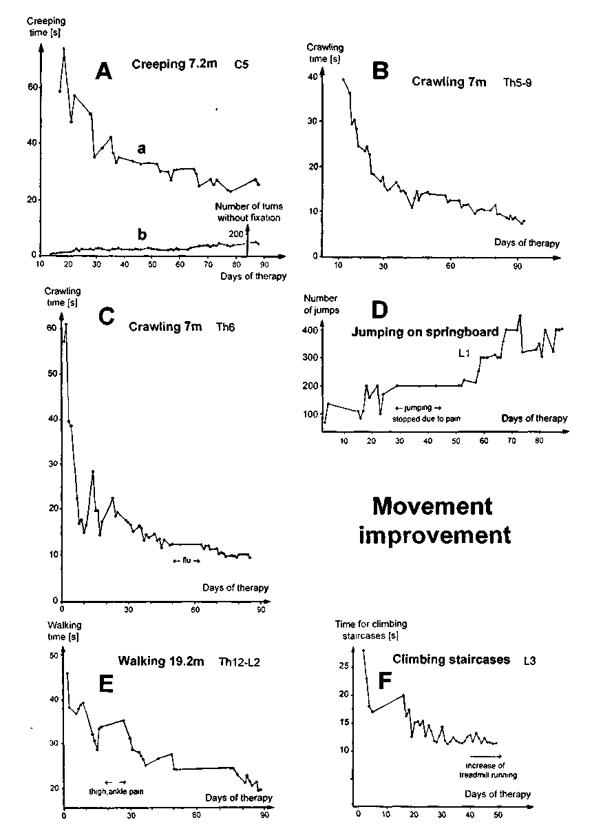
Fig. 2. - Movement improvements of creeping, crawling, jumping on springboard, walking with sticks and climbing staircases are quantified in terms of time (Aa, B, C, E, F). Improvement of hand and finger functions are quantified by the number of turnings on the special coordination dynamic therapy device (Ab). The jumping is quantified by the number of jumps (D). Notice that the curves for crawling in B,C seem to comprise two components. Notice that pain (D,E) and a flu (C) seem to hinder the progress.
371

of a patient with a complete spinal cord lesion sub L1. With ongoing therapy this patient could jump longer on springboard, indicating that his leg and foot functions improved. Especially the triceps surae and the gluteus maximus muscles became stronger. When the patient had to stop jumping transiently because of pain (Fig. 2D), also the number of jumps per series transiently stopped to increase.
The improvement of walking with sticks is shown in Fig. 2E. Within 3 months of therapy the time needed to cover 19.2m reduced from 46 to 19s, indi-cating improvement of leg and foot functions. Tran-sient pain in ankle and thigh stopped the improve-ment transiently.
In Fig. 2F, the faster climbing of staircases of a patient with a spinal cord lesion sub L3 is shown. The patient was holding the handrail with his left hand. When holding it with the right hand during climbing (Fig. 1M) a very similar curve was obtained. Alternating support with the left and right hand made a continuous rhythmic movement possible. In the latter case, the climbing of staircases was similar to running.
Spinal cord repair quantified by improvement of coordination dynamics
Measuring coordination dynamics in patients with a spinal cord lesion is of importance for two reasons. Firstly, it can be measured whether a spinal cord lesion is complete or incomplete and secondly, changes of CNS functioning can be quantified.
Diagnosis of complete and incomplete spinal cord lesion
When a spinal cord lesion between the cervical intumescence (the site where rhythmic stereotyped arm movements are located) and lumbosacral intu-mescence (network location of stereotyped leg move-ments) is complete, the patient can turn on the spe-cial coordination dynamic therapy device with a certain rhythmicity so as to only make arms and hands do the work with the legs only moving pas-sively. When the spinal cord lesion becomes incom-plete or is incomplete, then some leg muscles work in coordination with the arm muscles when exercising
on the special coordination dynamic therapy device. With the change between easy and difficult coordi-nations (dictated by the device), the quality of rhyth-micity (the size of the amplitude of Δ(df/dt)/f) will change. Fig. 3A, B and Fig. 3D, E show two patients with a spinal cord lesion in the cervical and thoracic range, who became incomplete during 3 months of coordination dynamic therapy. In Figs. 3A, D (lower traces), the coordination dynamics (Δ(df/dt)/f), do not show changing coordination dynamics. But 3 months later (Figs. 3B, E) the coordination dynamics show rhythmic changes due to the ongoing changes of the coordination between arm and leg movements when exercising on a special coordination dynamic therapy device. The spinal cord lesion became incomplete.
Improvement of coordination dynamics within 3 months
The coordination dynamics were measured in all patients at the beginning of the coordination dynamic therapy, at the end of the therapy after 3 months, and 3 to 6 months later, when the patients mostly came for a check-up. The coordination dynamics (Δ(df/dt)/f) for forward turning of 3 patients with a cervical, a thoracic and a lumbar spinal cord lesion are shown in the lower traces of Fig. 3. In the first patient with a cervical spinal cord lesion sub C4/5 (Fig. 3A, B) the coordination dynamics improved from 10.3 to 3.8 (by 63%). In the second patient with a thoracic spinal cord lesion sub Th 5/8 (Fig. 3D, E) the coordination dynamics improved from 8.1 to 4.8 (by 41%). In the third patient with a spinal cord lesion sub L1 (Fig. 3G, H) the coordination dynam-ics improved from 5.4 to 2,2 (by 59%). For all spinal cord lesions (including cervical, thoracic and lum-bar lesions) the coordination dynamics improved by 42 ± 16% (mean ± s.d.) for forward turning and by 49 ± 17% for backward turning within 3 months of therapy.
Changes of coordination dynamics after the 3 months of therapy: improvement with further therapy and worsening with no therapy
Apart from patients who just completed therapy and those who did not come for a check-up

372

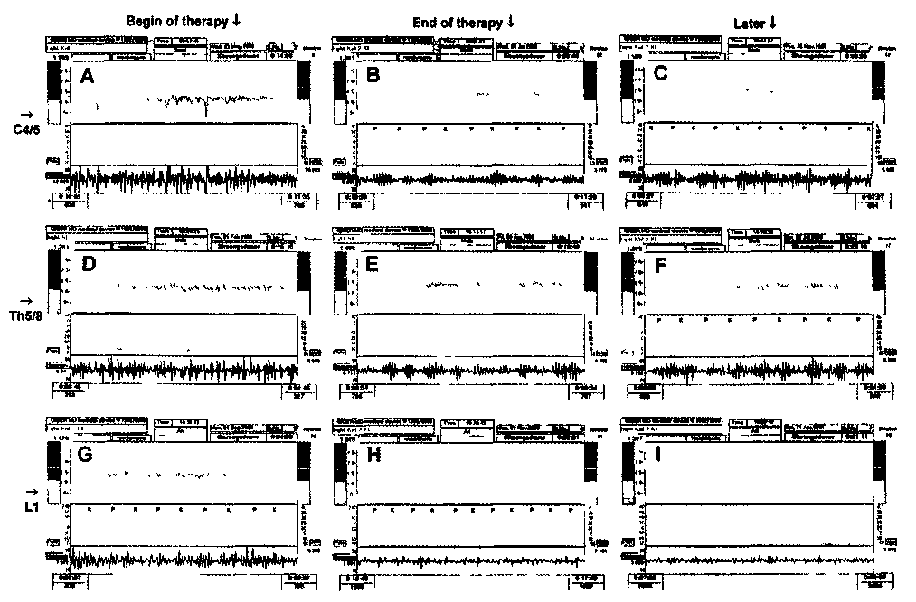

Fig 3 - Coordination dynamics of 3 patient with spinal cord lesions sub C4/C5 (A, B. C), sub Th518 (D, E, F) and LI (G, H, I) at the begin of therapy (A, D, G), at the end of 3 months of coordination dynamic therapy (B. E H), and 3 to 5 months later (C, F, I) Notice that coordination dynamics (lower trace = Δ(df/dt)/f) = blue) improve from A, D G (begin of treatment) to B. E, H (end of treatment), the arrhythrmcity becomes smaller for each patient Later after treatment, the coordination dynamics became worse when the therapy had been stopped (C, F), and became further improved when the therapy was continued (I) Some pace (P) and trot gait coordinations (K) are indicated. Upper trace (yellow) = frequency of turning

(5 patients), the coordination dynamics improved in
all patients (7) by very approximately 15% over 3 months if the therapy was continued more or less intensively or the coordination dynamics became worse in all patients (5) by very approximately 14% over 3 months if the therapy was stopped after 3 months of therapy (Fig. 4A)
When the patient with the cervical spinal cord lesion (Fig. 3B) stopped therapy his coordination dynamics increased (became worse, Fig. 3C) from 3.8 to 5.9 (by 20% in 4 months compared to the base-line value of coordination dynamics (10.3, Fig. 3A)). When the patient with the thoracic spinal cord lesion (Fig. 3E) stopped exercising, his coordination dynamics increased within 3 months (Fig. 3F) from 4.8 to 6.4 (by 20%). When the patient with the lum-
bar spinal cord lesion (Fig. 3H) continued coordi-nation dynamic therapy his coordination dynamics further reduced (improved, Fig. 31) from 2.2 to 1.9 (by 6% within 5 months).
Most patients came a few months before the start of coordination dynamic therapy for a consultation, whether it might be of interest for them to undergo coordination dynamic therapy to improve their CNS functioning. During the consultations their coordi-nation dynamics were always measured. By com-paring coordination dynamics measured at the con-sultation with those measured as the baseline value at the beginning of therapy it was found that they weie rather similar. This means that coordination dynamics did not change very much if no coordina-tion dynamic therapy was administered.

373

Altogether this means, that the improvement of coordination dynamics (i.e. the improvement of CNS organization) in patients with a spinal cord lesion was due to the coordination dynamic therapy. Sec-ondly, when the coordination dynamic therapy was continued the CNS functioning further improved. Thirdly, when the therapy was stopped completely the achieved coordination dynamics worsened, indicating that the improved CNS organization in those patients was partly lost again. Therefore, to keep the achieved level of improved CNS organization a certain amount of further therapy seems to be necessary.
Results achieved in some patients in whom the coordination dynamic therapy was first continued, then only continued with little effort and subsequently continued intensively again, seemed to suggest that very approximately one hour of intensive coordina-tion dynamic therapy per day six times per week is necessary to keep the achieved level of repair if the patients use wheelchair. Those patients were turning approximately 4000 times on the special coordina-tion dynamic therapy device, that means they per-formed approximately 4000 coordinated arm and leg movements per hour. If patients with caudal spinal cord lesions were able to walk, i.e. they could use the relearned improved CNS functioning in practi-cal life, the amount of exercise necessary to maintain the reached level of CNS functioning seemed to be smaller.
Improvement of coordination dynamics in dependence on the lesion level
When classifying the improvement of coordina-tion dynamics according to the level of the lesion (cervical, thoracic and lumbar) improvements for cervical spinal cord lesions were 53 ± 11% for forward and 59 ± 19% for backward turning, for lumbar spinal cord lesions they were 48 ± 16% and 58 ± 12% respec-tively, but those for thoracic spinal cord lesions they were only 32 ± 14% for forward and 38 ± 13% for backward turning (Fig. 4B). A better improvement could thus be achieved for cervical and lumbar lesions than for thoracic lesions. This may indicate stronger plasticity potential in the cervical and lum-bosacral range than in the thoracic range (for further arguments see discussion). The percentage of grey matter (neuronal networks) in relation to white mat-
ter (tract fibres) in the spinal cord is larger in the cer-vical and lumbosacral intumescence in comparison to those in the thoracic portion of the spinal cord.
Discussion
Partial cure of spinal cord lesion
It was shown in this report that spinal cord and CNS functioning can be improved by already 3 months of coordination dynamic therapy. The progress in CNS functioning could be quantified by improvements of movements (Fig. 2) and by improve-ments of coordination dynamics (Fig. 3) upon exer-cising on a special coordination dynamic therapy device (Fig. 1A,D). The coordination dynamics improved by 42% for forward turning and by 49% for backward turning. Since further treatment of patients with spinal cord lesion resulted in a further improve-ment of CNS functioning as quantified by coordina-tion dynamics (Fig. 4A), and treatment in stroke (23) and traumatic brain lesion (24) resulted in a partial cure of CNS lesion, it is proposed that a spinal cord lesion may partly be cured during 1 to 2 years of con-tinuous, intensive coordination dynamic therapy.
Plasticity in dependence on the site of the lesion
It was further found in this report that improve-ment of the coordination dynamics was better for the cervical (53%) and lumbar (48%) than the thoracic range (32%) (Fig. 4B). In stroke and traumatic brain lesioned patients (23, 24), coordination dynamics improved by 70% within 3 months of coordination dynamic therapy. The speed or the efficiency of CNS repair seems therefore to depend on the site of the lesion, and may depend on the plasticity of the dam-aged network parts. So far it seems that hypoxic CNS lesions and brain stem lesions are very diffi-cult to treat (25). Probably, only network parts get repaired by reorganization that are substantially acti-vated in similarity to neurogenesis, where principally new nerve cells are only built in those parts of the brain which were substantially activated during train-ing (3, 5, 7). Even though it has been shown that the damaged breathing centre in the dog reticular for-mation repaired itself (6), it seems difficult so far to

374

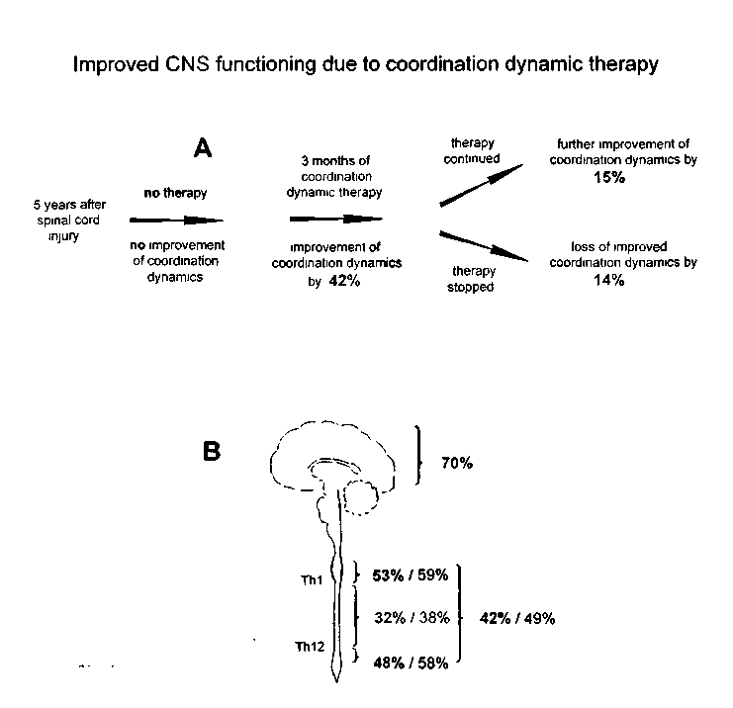
Fig. 4. - A. Schematic representation of improvements of CNS functioning in spinal cord lesion: with no therapy there is no improvement of the coordination dynamics, after 3 months of therapy there is a 42% improvement, followed by additional 15% (very approximately) further improvement later on, when the therapy was continued, and a 14% loss (very roughly), when the therapy was terminated. B. Improvement of coordination dynamics in CNS lesion due to coordination dynamic therapy for 3 months in dependence on the site of the lesion; first figure for forward and second figure for backward turning. Notice that the improvement is largest for cortex lesions (70%) followed by lesions of cervical (53%) and lumbosacral (48%) intumescence, and for lesions of the thoracic spinal cord (32%) for forward turning on the special coordination dynamic therapy device.

repair brain stem lesions. In one patient with a spinal cord and a brain lesion the coordination dynamics improved only by 16% during 6 months of coordi-nation dynamic therapy (25). If, for instance the reticular formation is not activating the brain it is not possible to functionally reorganize the cortex because it cannot be activated. May-be the reticular forma-tion has to be first to get repaired. Such situation may be present in patients being in the permanent coma following brain lesion and developed high brain pressure. The rate of CNS repair following a lesion seems to depend also on the functions of the lesioned neuronal network parts and their co-oper-ation and competition with other brain parts.
References
1. bobath. B.: Adult Hemiplegia: Evaluation and Treatment. William Heinemann Medical Books Ltd, London, 1978.
2. eriksson, P.S.. perhlieva, E., bjork-eriksson, T, alborn, A.M., nordborg, C, peterson D.A. and gage, F.H.: Neurogenesis in the adult human hippocampus. Nature Medicine 4: 1313-1317, 1998.
3. gould, E., beylin, A., tanapat, P., reeves, A., shors, T.J.: Learning enhances adult neurogenesis in the hippocampal formation. Nature Neurosci. 2(3): 260-265, 1999.
4. KELSO J.A.S.: dynamic patterns. The Self-Organization of Brain and Behavior. MIT Press, Cambridge, 1995.
5. kempermann, G., kuhn, H.G., gage, F.H.: More hippocampal neurons in adult mice living in an enriched environment. Nature 386: 493-495, 1997.

375

6. koepchen, H.P., lazar, H., klubendorf, D., huk.uhara, 17
T.: "Medullary apneusis" by lesions and cooling in the
ventrolateral solitary tract and genesis of respiratory rhythm.
J. Autonom. Nerv. Syst. Suppl.: 63-69, 1986.
7. praag, van H., kempermann, G., gage H.: Running increases cell proliferation and neurogenesis in the adult mouse dentate gyrus. Nature Neurosci. 2(3): 266-270, 1999.
8. schalow, G.: Conduction velocities and nerve fibre diame-
ters of touch, pain, urinary bladder and anal canal afferents
and a and y-motoneurons in human dorsal sacral nerve roots.
Electromyogr. din. Neurophysiol. 31: 265-296, 1991.
9. schalow, G.: Oscillatory firing of single human sphincteric
α₂ and α₃-motoneurons reflexly activated for the continence of
urinary bladder and rectum. Restoration of bladder function
in paraplegia. Electromyogr. din. Neurophysiol. 31: 323-355,
1991.
10. schalow, G: Recruitment within the groups of γ₁, α₂ and α₃-
motoneurons in dogs and humans following bladder and
anal catheter pulling. Gen. Physiol. Biophys. 11: 101-121, 1992.
11. schalow. G.: Recruitment of motoneurons in the occasional
firing mode in paraplegics. Electromyogr. Clin. Neurophysiol.
33: 401-408, 1993.
12. schalow, G.: Spinal oscillators in man under normal and
pathologic conditions. Electromyogr. Clin. Neurophysiol. 33:
409-426, 1993.
13. schalow, G.: Phase-correlated adequate afferent action
potentials as a drive of human spinal oscillators. Electromyogr.
din. Neurophysiol. 33: 465-476, 1993.
14. schalow, G.: Action potential patterns of intrafusal γ and
parasympathetic motoneurons, secondary muscle spindle
afferents and an oscillatory firing α₂-motoneuron, and the
phase relations among them in humans. Electromyogr. din.
Neurophysiol. 33: 477-503, 1993.
15. schalow, G., bersch, U., michel, D., koch, H.G.: Detrusor-sphincteric dyssynergia in humans with spinal cord lesions may be caused by a loss of stable phase relations between and within oscillatory firing neuronal networks. J Auton. Nerv. Syst. 52: 181-202, 1995.
16. schalow, G., zach, G.A.: Mono- and polysynaptic drive of oscillatory firing α₁ (FF) and α₂-motoneurons (FR) in a patient with spinal cord lesion. Gen. Physiol. Biophys. 15, Suppl. 1: 57-74, 1996.
schalow, G, zach, G.A.: Reflex stimulation of continuously oscillatory firing α and γ-motoneurons in patients with spinal cord lesion. Gen. Physiol. Biophys. 15, Suppl. 1: 75-93, 1996. 18. schalow, G, zach, G.A.: External loops of human premotor spinal oscillators identified by simultaneous measurements of interspike intervals and phase relations. Gen. Physiol. Biophys. 15, Suppl. 1: 95-119, 1996.
19. schalow. G., blanc, Y., jeltsch, W., zach, G.A.: Elec-tromyographic identification of spinal oscillator patterns and recouplings in a patient with incomplete spinal cord lesion: Oscillator formation training as a method to improve motor activities. Gen. Physiol Biophys. 15, Suppl. 1: 121-220, 1996. 20. schalow, G. and zach, G.A.: Reorganization of the Human CNS, Neurophysiologic measurements on the coor-dination dynamics of the lesioned human brain and spinal cord. Theory for modern neurorehabilitation (31 case reports). Gen. Physiol. Biophys 19 (Suppl. 1): 1-244. 2000.
21. schalow, G.: On-line measurement of human CNS organi-zation. Electromyogr. din. Neurophysiol. 41: 225-242, 2001. 22. schalow. G.: Time axis calibration in human CNS organi-zation for judging dysfunction. Electromyogr. din. Neuro-physiol. 41:485-505,2001.
23. schalow. G.: Stroke recovery induced by coordination dynamic therapy and quantified by the coordination dynamic recording method. Electromyogr. din. Neurophysiol, 42: 85-104, 2002.
24. schalow, G.: Improvement after traumatic brain injury achieved by coordination dynamic therapy. Electromyogr. din. Neurophysiol. 42: 195-203, 2002.
25. schalow, G.: Non-drug induced spasticity reduction achieved by coordination dynamic therapy. Electromyogr. din. Neurophysiol. 42: 281-293, 2002.
Address reprint requests to:
Giselher Schalow
Dr.med.habil., Dr.rer.nat, Dipl.Ing.
Untere Kirchmatte 6
CH-6207 Nottwil
Switzerland

376

