Stroke recovery induced by coordination dynamic therapy and quantified by the coordination dynamics recording method

Giselher Schalow¹

Abstract
Based on measurements of relative phase and frequency coordination of time-space distributed firing of single neurons and neuron assemblies in the human nervous system, the concept of coordination dynamics to describe the integrative functions of the human central nervous system (CNS) and the finding of neurogenesis in the human CNS, the coordination dynamic therapy has been developed with which it is possible to repair the lesioned or malfunctioning human CNS. With the developed coordination dynamic recording method the organization (the coordination dynamics) of the CNS can be measured on-line non-invasively. By measuring the present coordina-tion dynamics at different times with ongoing coordination dynamic therapy when exercising on a special coordi-nation dynamic therapy device, the progress in re-organization and repair of the lesioned CNS can be quantified.
In this paper it is reported that in 8 patients following stroke the lesioned CNS could partly be repaired by coordination dynamic therapy. The repair was quantified by the improvement of walking, hand function and the direct measurement of CNS organization (the coordination dynamics). In 4 patients the improvement of CNS organization (coordinations dynamics) was 70 ±14% within 3 months of therapy. In a patient where the inten-sive coordination dynamic therapy (at least 4 hours therapy with more than 15000 coordinated movements per day) lasted longer than one year, also the difficult repairable hand functions could substantially be improved. It is shown that in the healthy CNS of the author the coordination dynamics improved in the short-term memory by 20% within 10 min and in a stroke patient by 70% within 30 min, when exercising on the special coordination dynamic therapy device. As in other learning therapies (school) it is believed, that by repeated learning of move-ments, vegetative and higher mental junctions in the short-term memory, the learned CNS functions will also go into the long-term memory, which means the CNS has been reorganized. Improvements in the short-term memory are used to motivate the patient to perform a therapy.
Key-words: Coordination dynamics - Coordination dynamics therapy - Coordination dynamic recording method - Stroke repair quantijication - Spasticity - Short-term memory - Long-term memory - Neurotherapy.

Introduction
The concept of coordination dynamic therapy to reorganize the lesioned or malfunctioning human central nervous system (CNS) (21) builds upon the
Department of Neurology and Rehabilitation, University Hospital
Tampere, PB 2000, 33521 Tampere, Finland; Kaskein Kuntou-tubkebkub, PL 37, FIN-54801 Savitaipale, Finland. Coordination Dynamic Therapy Centre, Avemda del Parque Edif Benal Beach, Local 2, E-29630 Benalmadena-Costa (Malaga), Spain. Physiotherapy Nyffeler, Bahnhofs.tr. 1, CH-6312 Stemhausen, Switzerland.
theory of self-organization, pattern formation of neuronal networks and coordination dynamics (2-6, 22, 25, 26, 28-30). Pattern of coordination are gen-erated by the coordinated firing of single neurons and neuron assemblies and are characterized macro-scopically by low dimensional collective variables or order parameters whose dynamics are function-spe-cific. Loss of stability leads to switching of patterns. Fluctuation and differential stability govern the switching dynamics among multiple coordinative patterns. If a certain coordinative pattern has a very

Electromyogr. din. Neurophysiol., 2002, 42, 85-104.
85

high stability, it may seem as if this pattern is "hard wired" and is generated by a pattern generator. The patterns generated in the neuronal networks are a direct consequence of cooperative and competitive interactions between the intrinsic coordination dynamics of the neuronal networks, the intentional impulse patterns and the (movement induced) affer-ent input patterns.
The strategy to improve the functioning of the lesioned or malfunctioning CNS is based on mea-surements on phase and frequency coordination of firing of neurons and neuron assemblies. I have mea-sured in the physiologically functioning human CNS with the single-nerve fibre action potential recording method (12, 13) that neurons and neuron assemblies (spinal oscillators) fire with relative phase and fre-quency coordination (14, 17, 18) and with the coor-dination dynamic recording method (22, 30) that healthy persons can move arms and legs in coordi-nation with respect to phase and frequency. I have further measured that this phase and frequency coor-dination on the neural level, the neuron assembly level and macrsocopic level (movements) is partly lost following CNS lesion (15, 16, 19, 20, 22). The coordination dynamic therapy tries therefore to re-establish phase and frequency coordination between the firings of neurons of the neuronal networks by (re-)learning coordinated movements. The coordina-tion dynamic therapy is therefore a learning method, which is based on measurements in the human CNS and has a neurophysiologic theory.
An immanent part of a therapy is to have tools at hand to measure the improvement. The improve-ment of CNS functioning can indirectly be measured by the improvement of movement performances and can directly be measured by the newly developed coordination dynamic recording method (22, 30).
In this work the coordination dynamic therapy was used to improve the functioning of the CNS in stroke patients, and the coordination dynamic recording method was used to quantify the improve-ment of CNS functioning.
Method
The coordination dynamic therapy is based on 5 new developments/concepts in human neurophysi-ology: (I) Self-organization of neuronal networks.
The self-organization takes place by the relative coor-dinated firing of neurons with respect to time and space. The central nervous system (CNS) is viewed as a neuronal network which can be changed in its functioning by re-learning. (II) The organization takes place by a specifically changing relative phase and frequency coordination between the firings of neurons. (III) The building of new nerve cells in the adult human CNS and their proliferation with respect to functional aspects, which is led by learning processes including motor learning of coordinated rhythmic movements. (IV) The human CNS can also learn and store intergratively as a second mode of functioning (besides the localized one), which is used to reorganize the lesioned CNS as follows from the clinical work with the coordination dynamic therapy (21). (V) Each CNS can substantially be improved in its functioning as follows from the results when using the coordination dynamic therapy (21).
In severe CNS lesions restoring of physiologic functioning is only possible if the relearning is inte-grative, coordinated and efficient. The reorganization of the pathologically functioning CNS by relearn-ing can be achieved by: (I) The use of special instru-ments (like the special coordination dynamic therapy device (Figs.l, 6H, K, L)) for relearning of the lost phase and frequency coordination between the fir-ings of neurons and the lost coordination between the movements of arms, legs and trunk (may be more functional reorganization). (II) The exercise of automatisms, postures and old learned movements, which are only little changed by the lesion (may be more structural reorganization).
The efficiency of CNS reorganization by relearn-ing is determined by at least 4 factors: (I) The accu-racy of coordination of the exercised movements (approximately 5ms) to relearn or improve phase and frequency coordination of neuron firing and to reconnect network parts to recouple not moving arms or legs (for example a plegic arm) to a whole movement like walking. Co-movement (Fig. 1) is an example for a reconnection of subnetworks (II). The increase of the integrativity of coordinated CNS activation by exercising many phase and frequency coordinations as possible simultaneously to entrain more coordinations per time, to reorganize the CNS more globally and to activate and coordinate as many neurons and subnetworks simultaneously to improve also the very integrated functions of the

86

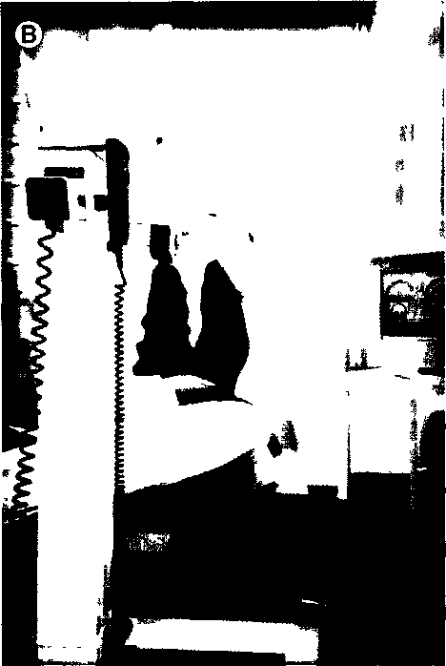
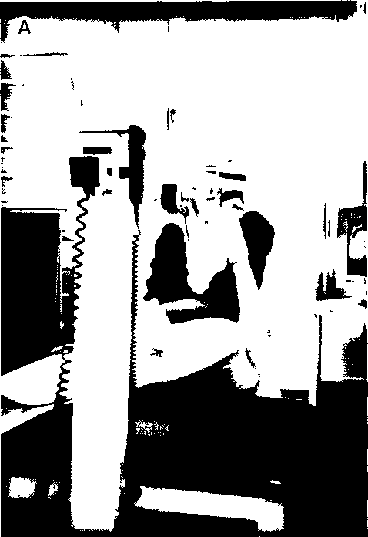

Fig 1 - Anti-phase co-movement induced in the right paretic leg during exercising on the special coordination dynamic therapy device, a 60-year-old stroke patient with an occlusion of the cerebri media on the left side. The paretic right hand is fixed with a bandage to the lever, so that the patient can exercise alone. When the right hand was supported by a therapist, also the right hand showed co-movements so that transiently the right hand could nearly hold the lever. A. Patient at the beginning of the exercises or after a break. The light knee is in the lateral position (no co-movements). B. When turning approximately 30 times the levers, the knee could be held by the patient in the middle position (co-movement in action) Interestingly, when the patient watched concentratedly at the right hand or leg, their functions further improved a bit, which means the right hand became a bit stronger in holding the lever and the right leg came faster into the middle (symmetrical) position. In the upper left of the computer display the momentary average coordination dynamics of the patient is shown when moving in coordination arms, legs and trunk.

CNS like the higher mental functions. (III) The increase of the physiologic movement induced re-afferent input and intential impulse patterns to enhance the physiologic self-organization of the lesioned networks and its communication with the outer world by regulatory processes. (IV) By the intensity of therapy. At least 4 hours therapy per day 5.5 times per week for 0.5 years (at least 15000 coordinated integrative movements per day). The "adaptive machine" CNS has to be forced to adapt.
Instructive training, interpersonal coordination and co-movements are used to enhance physiologic
movements in the patient. The movements which are often performed during coordination dynamic therapy are creeping, crawling, uprighting, jumping on springboard, walking, running and exercising on the special coordination dynamic therapy device in the lying, sitting and standing position.
The special coordination dynamic therapy device and the basic program to measure the coordination dynamics are a product by: Combo AG, Postfach 146, Tuggmerweg 3, CH-4503 Solothurn, Switzerland, Fax +41326219745.

87

Results
Improvement of CNS organization in the short-term memory
Reason to demonstrate improvement of CNS func-tioning in the short-term memory
Since under coordination dynamic therapy reor-ganization of the human CNS needs many months (see Discussion) it is of importance to have diagnos-tic means at hand to give the patients a prognosis concerning the time needed to reorganize their CNS. The coordination dynamic therapy is a learning method. Therefore, the thinking and the strategies of learning will hold. At school it is believed that if a pupil can retain something in the short-term mem-ory, then it will, with many repetitions at least partly also go into the long-term memory. The same think-ing holds here also for the motor learning. If a stroke patient can relearn in the short-term memory, then with many repetitions, the things learned are expected to also pass into the long-term memory. Therefore, when a patient asks whether it is senseful to undergo coordination dynamic therapy, the coordination dynamics are measured and it is tried to show him that the organization of his CNS can be improved in the short-term memory. Such demonstration of the improvement of CNS organization in the short-term memory will be shown herein.
Short-term memory in the physiologic case
The healthy CNS of the author is used here for comparison. Later on, this reference base has to be replaced by a healthy population. The author exer-cised for 0.5 hours on the special coordination dynamic therapy device (Fig. 6H, K, L) by turning forward and backwards to have a direct comparison for the diagnostic in a patient (see below). As can be seen from Fig. 2F (upper trace) the frequency of turning changed little around 1.1 Hz including for-ward and backward turning. At the beginning of turning, for approximately the first 15 seconds, the variation of frequency f (upper trace) and of df/dt (lower trace) was a bit larger, indicating that the CNS needed some time to fully regulate the exercised movements (Fig. 2A). The intermediate coordina-tions between pace (P) and trot gait (K) seemed a bit more difficult to achieve by the CNS of the author. After 5min of turning the variation of the time deriv-
ative of the frequency (Δdf/dt, lower trace) became smaller (Fig. 2B). The mean of Adf/dt for one minute became now 3.8. A bit of waxing and waning can be observed. After approx. 8 min of exercising, the coordination dynamics became best for forward turning (Fig. 2C). Adf/dt reached a value of 3.75 (Harmonic, lower trace of Fig. 2C). The variation of the rhythmicity (Δdf/dt) was now noise-like. For turning backwards on the special coordination dynamic therapy device (Fig. 2D), the mean rhyth-micity was even a bit better (Δdf/dt = 3.54). For most healthy persons backward turning is more difficult. At the end of exercising after approx. 33 min, the variation of the rhythmicity became a bit larger (Δdf/dt = 4.7, Fig. 2E). The author considered to stop turning. This thinking interfered with the coor-dination dynamics for turning and increased the arrhythmicity of turning. The two neuronal network functions, exercising on the device and thinking, were not completely independent of each other even for the not lesioned CNS.
To extract more knowledge from this experiment, the data were plotted graphically (Fig. 3). It can be seen from Fig. 3 that the rhythmicity of turning was best between 10 and 22 min of exercising. Backward turning had nearly no consequences for the improve-ment of CNS organization, quantified by Adf/dt and f for forward turning. In conclusion, the arrhyth-micity of turning (Δdf/dt) reduced first by approxi-mately 27% (motor learning) and subsequently increased again (maybe the CNS or the body may have got also a bit exhausted). The small changes in the frequency of turning may have different reasons as sedative and motor learning effects. Generally, not much information can be extracted from the graph to better understand CNS functioning.
Short-term memory in the stroke patient
Analysis of the coordination dynamics of the lesioned CNS provides more information. The sub-stantial improvement of the coordination dynamics of the CNS of a stroke patient is shown in Fig. 4. As can be seen from Fig. 4A, the frequency variation of turning (upper trace) is very large. It can be seen fur-ther that the stroke patient could perform trot gait coordination (K) better than pace gait coordination (P), since the frequency of turning (upper trace) for the trot gait coordination was higher and the fre-quency variation smaller (Fig. 4B to G). The varia-
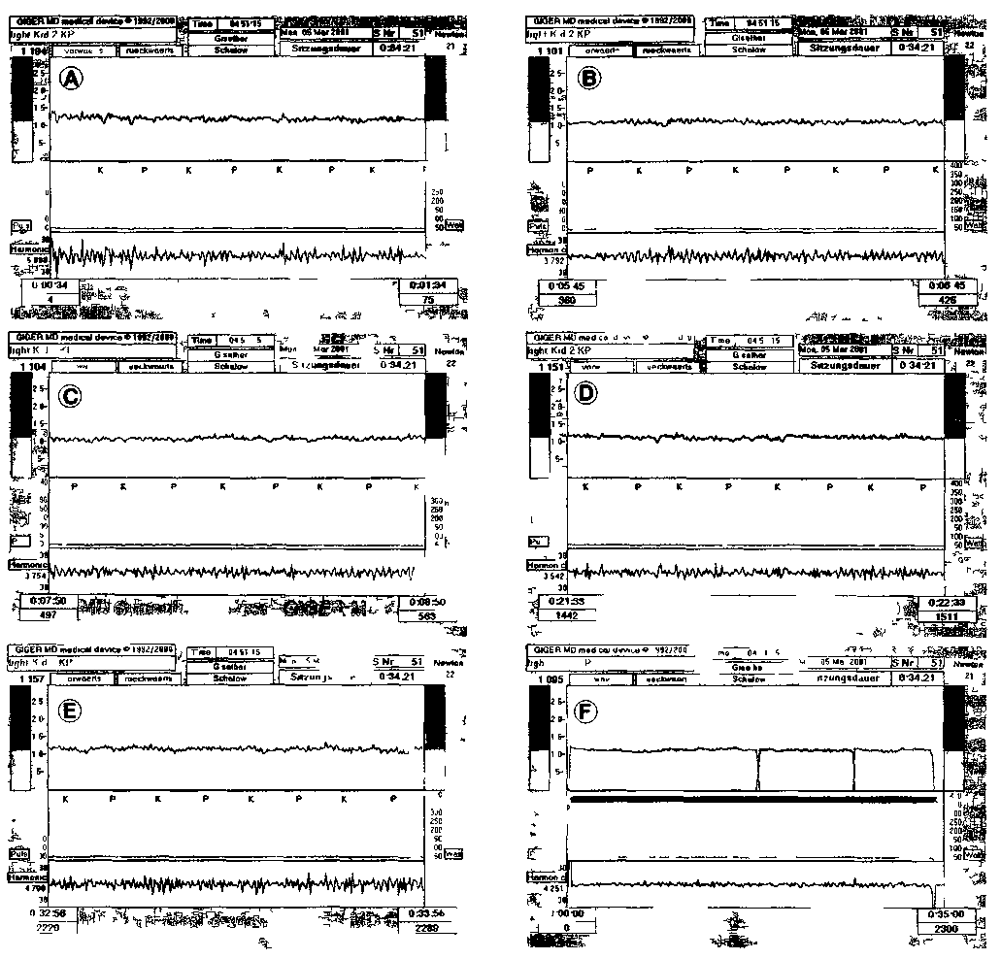

Fig 2 - Coordination dynamic recordings from a healthy CNS (author) showing improvement of the coordination dynamics in the short-term memory when exercising on the special coordination dynamic therapy device Upper trace = frequency f lower trace = df/dt The variation of df/dt = Δdf/dt is given below Harmonic The whole recording of exercising over 35 mm is shown in F Recording intervals ot 1 mm are shown in A-E A-C E = forward turning (vorwarts) D = b ickward turning (rückwärts)

tion of df/dt is so large, that this trace is not very much helpful for analyzing CNS organization at the beginning of exercising (Fig 4A to C, E, lower trace). With ongoing exercising the variation of the frequency reduced and the frequency of turning increased. After 30 mm of exercising, the coordina-
tion dynamics were much better (Fig 4G). The trot gait coordination (K) became better as did the pace gait coordination (P). The improvement of CNS organization due to exercising for 0.5 hours on the special coordination dynamic therapy device can be seen m Fig 4A through G. The frequency variation

89

Fig. 3. - Improvement of CNS organization in a healthy person (author) in the short-term memory. From the original record-ings the frequency f and the coordination dynamics (Δdf/dt) are plotted with ongoing time of exercising (mainly turning forward) on the special coordination dynamic therapy device as shown in Fig. 6H, K, L. Note that the frequency and Δdf/dt are changing less (Δdf/dt is reducing by approx. 27%) than in the case of after stroke (Fig. 5); Δdf/dt is best (= 3.75) after approximately 10 min of exercising; backward turning has only little effect on f and Δdf/dt. Load on the levers are 21 to 22 Newton; lever length = 8cm.
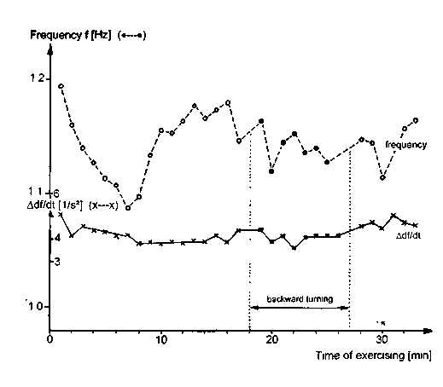
became smaller as did the variation of its time deriv-ative (lower trace). It can be seen from Adf/dt (lower trace, "Harmonic") that the coordinated movements of arms and legs became better because the arrhyth-micity of turning reduced. In Fig. 4F, G the char-acteristic structure of coordination becomes visible. The trot gait coordination (K) could be performed very well by the patient. The pace gait coordination (P) was not that good but still much better than at the beginning of the exercise. Rhythmic changes appear in the amplitude of Adf/dt indicating that the premotor spinal oscillators were not firing in optimal coordination as in Parkinson disease. Only a fre-quency analysis (Fourier analysis) will provide further information. The coordination of the motoneurons for backward turning in between the forward turning (Fig. 4E) was not as good. Larger variations can be seen in both traces.
The kinetic argument that the pace gait coordi-nation must be worse than the trot gait coordina-tion in a hemiparetic patient - because only one side is working and the other one not will have conse-quences on the pace gait coordination and not so much in the trot gait coordination, since in trot gait one paretic arm and one healthy leg and one healthy arm and one paretic leg are moving in coordination, whereas in pace gait the paretic side is moving against the healthy side - is not conclusive. Of course, kinetic arguments are coming in, but firstly different kinds of co-movement (21) from right to left are activated by the exactly coordinated afferent input from the moving arms and legs, and secondly the coordination of different stroke patients with a hemiparesis can be quite different, as can be seen below (Fig. 8).
The plotting of the coordination dynamics of relearning in the short-term memory in a graph (Fig. 5) will bring further information. It can be seen from Fig. 5 (and Fig. 4H) that the frequency of turn-ing increased from 1.0 to over 1.3 Hz, which makes an improvement of CNS organization likely. At the same time, during this 30 min of exercising the arrhythmicity of turning decreased very much, namely from 33 to 15. The arrhythmicity of coordi-nated movements in the healthy CNS was around 4 (Fig. 4). Therefore, even though the arrhythmicity of the coordinated movements of the stroke patients reduced very much, it was still far from normal. Anyhow, the coordinated movements became more physiologic.
Since, according to the theory of coordination dynamics, with the increasing stability of the attrac-tor "physiologic movement" the stability of the attractors "pathophysiologic movements" decreased (because of non-use), as certain kinds of spasticity, it was of interest to see what will happen with spas-ticity of the left paretic hand if the organization of the CNS improves in the short-term memory due to exercising a very coordinated movement. The author expected a reduction of spasticity in the short-term memory, as it has always been the case till now. Since the hand grip spasticity was that strong that when giving the hand it was nearly impossible to get free from the paretic spastic hand, the patient could turn with the spastic hand, because the patient could hold the lever because of spasticity. The interesting ques-tion was, how long will the spastic hand hold the

90

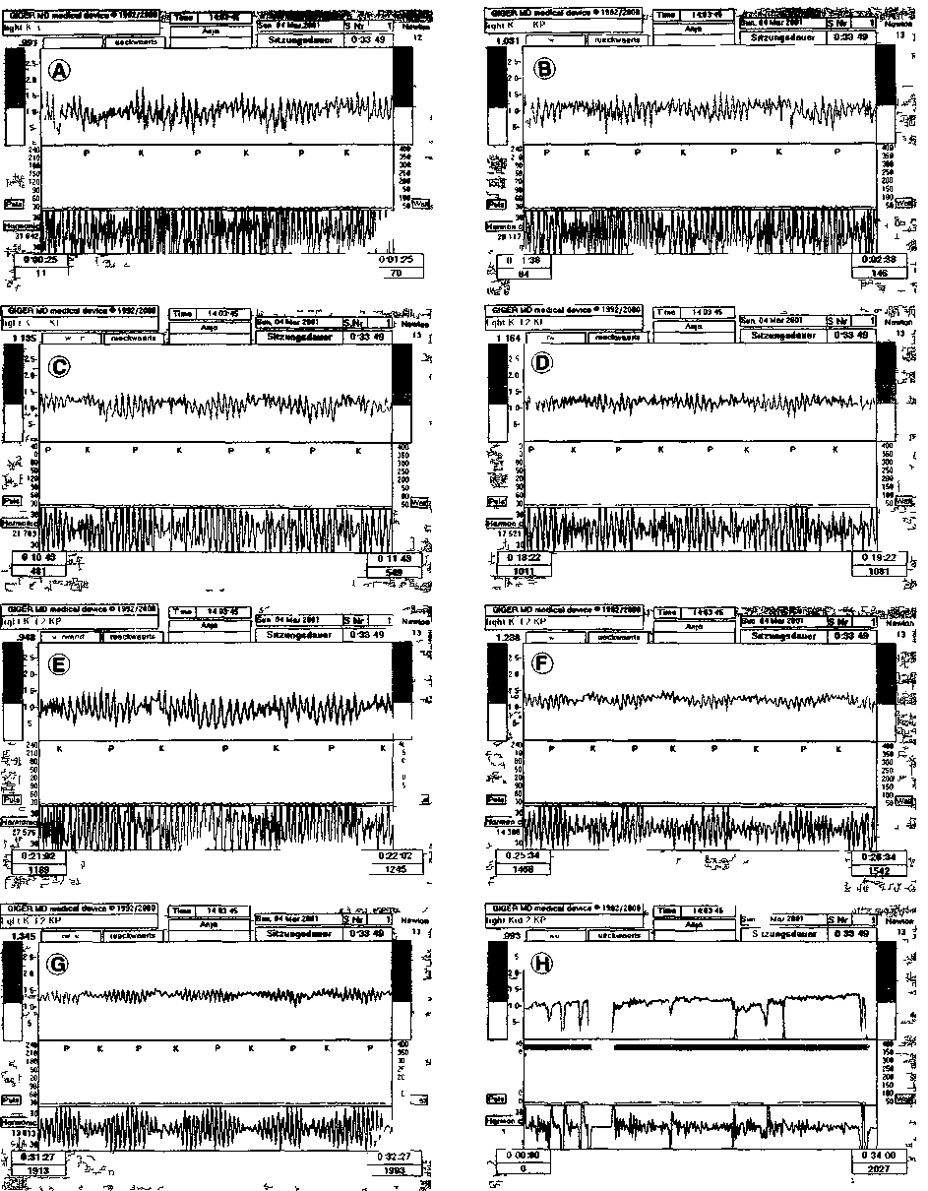
Fig 4 Coordination dynamic recordings from a stroke patient showing CNS organization improvement in the short-term memory when exercising on the special coordination dynamic therapy device. The whole recording of exercising over 34 min is shown in H. Forward (vorwarts) and backward (rückwarts) turning for 1 min interval is shown in A to G. Note the substantial improvement in the short-term memoiy of frequency f (upper trace) and df/dt (lower trace) between A and G.
91
lever until the spasticity reduces so much that the hand will slip from the lever. After 360 turns on the device in 6.5 minutes the left spastic hand slipped from the handle and was then fixed with a bandage. The power to turn the handle was approx. 13 New-ton. Thus, the spasticity became smaller than 13 New-ton. The next interesting question was, what effect will have backward turning on forward turning. The experience so far in patients is that backward turn-ing enhances the coordination dynamics for forward turning. For the physiologic case, no significant change could be observed (Fig. 3). Even though backward turning was much worse (Fig. 4E) than forward turning (Fig. 4D) in the stroke patient, the frequency increased strongly for forward turning (Fig. 5) in contrast to the physiologic case (Fig. 3). Also, arrhythmicity decreased further.
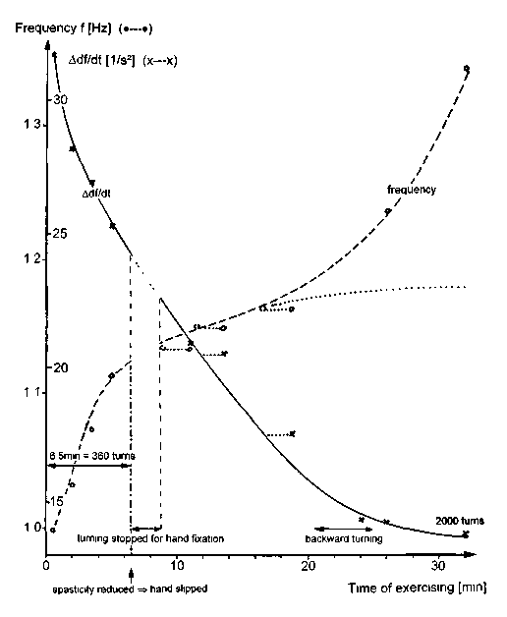
In conclusion, the improvement of the coordina-tion dynamics (reduction of Δdf/dt) in the short-term memory was with 59% (33 to 15) larger than in the physiologic case (27%, 5.09 to 3.75). Related to a fre-quency of 1Hz, the improvement was in the stroke patient even 70% and in the healthy person only 20%.

Overlap between coordinated activation
of CNS neuronal networks for movements and
higher mental functions observed in stroke patients
Eight stroke patients underwent coordination dynamic therapy. The functions on the paretic side improved in the short- and long-term memory and also the speech improved, if impaired. One patient with impaired speech centre, who could speak 4 lan-guages, spoke the first words after stroke in English, which was not his native language, in accordance with reports that later learned languages are stored differently in the cortex than the native language (7). When this patient exercised on the special coordi-nation dynamic therapy device, his leg functions improved in the short-term memory (higher-order co-movement (21)) after approximately 30 turns (Fig. 1), but his speach improved substantially only after 4000 turns. At the beginning of exercising, the patient was mixing up all 4 languages so that he got angry because he could not say what he wanted and nearly nobody could understand him. But after 4000 turns he could mainly speak one language. When he got exhausted after 6000 turns he was mixing up
Fig. 5. - Improvement of CNS organization in a stroke patient (who has never exercised on the special coordination dynamic therapy device before) with orgoing time of exercising. The paretic left hand is first not fixed to the handle till it slips from it after 6.5 min. After fixating the hand, the exercising is con-tinued. The curves for the frequency and Δdf/dt are partly cor-rected for the time needed for hand fixation. Note that Δdf/dt is reducing stronly (by more than 50%), indicating that the CNS organization of that stroke patient is strongly improving in the short-term memory; the frequency of turning is increasing strongly, which is mostly a good sign for improvements of the functioning of the lesioned CNS. It seems as if the backward turning is enhancing the frequency strongly. Without backward turning the frequency may have increased less as indicated by the dotted line.
languages again. Therefore, at the beginning of the coordination dynamic therapy an improved commu-nication with this patient was mainly only possible if he had turned a few thousand times on the special coordination dynamic therapy device. This clearly indicates that in this patient there was a relationship between the improvement of the coordination dynamics for movements and higher mental func-tions, indicating that there was interlacing between

92

the neuronal networks generating movement and those generating higher mental functions. In other stroke patients the speech improved when the patient had to speak numbers or letters in coordination with the coordinated arm and leg movements. The num-bers or letters appeared on a screen changing in coordination with the movement (Fig. 5D of (22)).
Substantial improvement of hand function
in a stroke patient following 1 year of coordination
dynamic therapy
A now 62-year-old well known violinist (Fig. 6A) suffered a stroke 5 years ago so that his right arm was hanging down, his hand was spastic (Fig. 6B) and he could not hold the bow any more to play vio-lin. The patient himself exercised walking and arm movements a few hours per day to recover from stroke. Due to his own efforts, his arm came a bit upwards from the hanging position when he was playing violin together with his son in the way that the musician held the violin and his son was moving the bow in coordination (Fig. 6C). Activating the old learned attractor “performing violin music” activated a bit the right arm (Fig. 6C). When the patient started coordination dynamic therapy 3.5 years after the stroke, including 1500 turns on the special coor-dination dynamic therapy device (Fig. 6K), he could just hold the bow in the right hand (Fig. 6D). The music he played was at the beginning poor, since firstly he could hardly hold the bow in the hand and also not in the right way and secondly the movements of the right arm and hand worked poorly in coordi-nation with the left one. With ongoing coordination dynamic therapy, including exercising of the finger positioning on the special coordination dynamic ther-apy device to hold the bow (Fig. 6L), the patient could hold the bow better and the amplitude of arm movements increased (Fig. 6D, E, F) and the music (Stille Nacht, heilige Nacht...) he played to show the progress sounded better and better.
After 1.5 years of coordination dynamic therapy, including now 10000 turnings on the special device, he could fully lift up the arm and move the fingers separately (Fig. 6G) and could hold a cup for drink-ing rather normally again (Fig. 6I). His hand and arm power increased that much that he could turn the device only with the formally right plegic hand
(Fig. 6H). When playing violin the positioning of the fingers of the right hand were quite normal again and he was not lifting the right side any more (Fig. 6E, F) in comparison to the beginning of play-ing (Fig. 6D). His grand doughter was now proud of his grand dad (Fig. 6F, H, K) and was telling him that he has to turn more rythmically, when she was looking at the computer display and saw larger fre-quency variation in his exercise (Fig. 6K).
When giving his first concert again after the stroke (Fig. 6M, playing by himself), his performance was quite good again, even though the stress before and during the concert was that strong that the posi-tioning of the hand when holding the bow was ruined. The bow holding was nearly as bad as at the beginning of intensive therapy (Fig. 6D) and far from normal in comparison with that of her daugh-ter playing the second violin beside her farther (Fig. 6M). Interesting is that the stress ruined tran-siently the hand and finger movements, but not the music he played. When the stress was over two days later, he could hold the bow properly again (Fig. 6F). The stress was therefore able to partly distroy the relearned hand movements, but not the playing of music, indicating that in this case the hand movement and the playing violin was stored differently in the CNS.
The coordination dynamics, quantifying the progress in CNS organization directly, are shown in Fig. 7. For forward turning, the coordination dynam-ics improved in 9 months by 50% (Δdf/dt reduced from 16.8 to 8.3). After additional 3 months of ther-apy the coordination dynamics improved further from 8.3 to 7.2. A normal value for the coordination dynamics (Δdf/dt) is approximately 4 (for a turning frequency of 1 Hz). The author had a coordination dynamic value of 3.7 (Fig. 2C). For backward turning the coordination dynamics improved during 3 months from 14.6 to 10.6; no earlier values are available. The author had for backward turning a coordination dynamic value of Δdf/dt = 3.5 (Fig. 2D). When standardizing the coordination dynamics to the frequency of turning, the coordination dynamics of the patient improved for forward turning in 1 year by 60% (Δdf/dt / f = 18 →7; = 60%) and for back-ward turning in 3 months by 16 %. Such frequency normalization is useful because normally the fre-quency of turning increases with stroke recovery (and patients turn with different frequencies). With

93

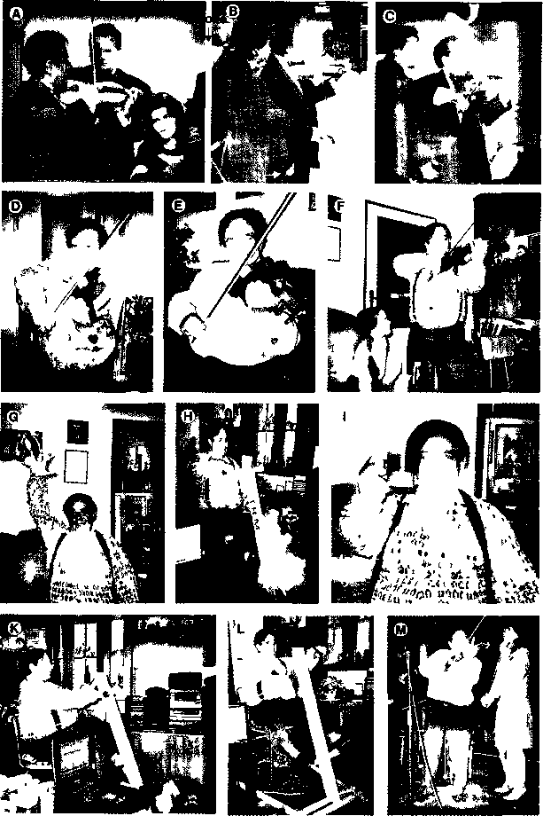
Fig 6 - Coordination dynamic therapy-induced stroke recovery of a now 62-year-old musician made visible by the improvements of the movements. A. Before stroke, the musician is performing with his orchestra. B, C. After the stroke the patient is performing in concerts with his son, he is holding the violin with the left hand and his son is moving in coordination the bow. In B the plegic arm is hanging down and the hand is spastic, in C (later) the now paretic arm is coming a bit upwards (is already a bit flexed), as if the paretic side wants to contribute to the coordinated movements of the old-learned CNS activation “performing violin music”. D. The patient can just hold the bow by himself 3.5 years after the stroke the positioning of the fingers is very poor. At this stage coordination dynamic therapy was started supervised by the author. E. With the ongoing therapy the finger positioning is already better for holding the bow the shoulder is more downwards because the patient has already a bigger amplitude for arm movement when moving the bow. F. Five years after the stroke the movements of the left arm, hand and fingers are not far from normal. G, H, I. The patient can fully lift the formally plegic arm and can move the fingers (G), can turn the device (hand and arm power came back) (H) and can hold a cup for drinking (I), note in I the picture of toimei violin playing. K, L. Patient exercising on the special coordination dynamic therapy device, in L he is training the finger positioning for holding the bow when playing violin (in the integrative activation ot neuronal net-works for relearmng also those network parts have to be essentially activated which generate the functions which have to be relearned). M. Patient playing violin again in a concert with his daughter. He is playing the first, she the second violin. The son is on the other side in the background. Note that the positioning of the right hand and fingers is poor because of the stress to organize the concert and performing for the first time again What cannot be seen in the picture is that the music he played was not ruined by the stress. Two days later, when the stress was over, the positioning of hand and fingers was physiologic again (F).
94
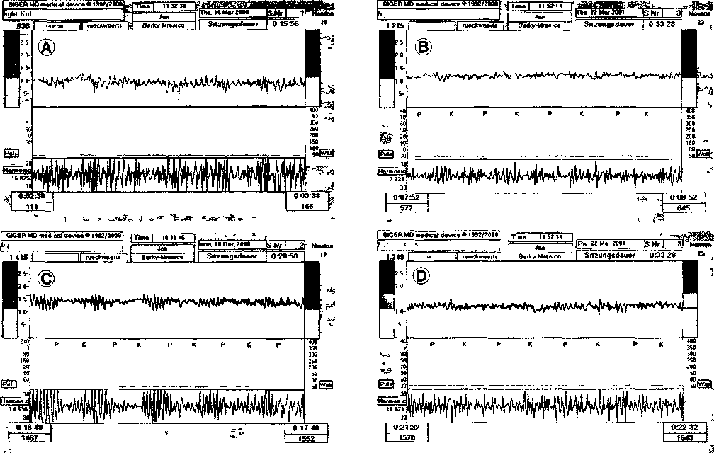

Fig 7 - Improvement of coordination dynamics in a musician who suffered a stroke. A, B. Forward turning. D, E. Backward turning.

increasing recovery from stroke the patients can per-form movements faster, due to the more precise phase and frequency coordination of CNS neurons, neuron assemblies and moving arms and legs.
This patient may not be able to relearn the for-mer dynamicity of playing the instrument, but he may become able again to play music for children, where not so much dynamicity is needed in the hand movement, and may compose music for children. This would give the patient a new perspective for his future life. This case report indicates that stroke patients can relearn hand and finger functions.
Stroke recovery quantified by the coordination
dynamisc recording method in 4 patients
Four of the 8 patients suffered stroke at the age between 36 to 57 years and underwent coordination dynamic therapy for 3 months 1 5 to 11 5 years after the stroke with at least 4 hours therapy per day
5 5 times per week. The relearning in physiologic CNS functioning was quantified by the improvement of movements like walking, jumping and hand grip power (Fig. 9) and by measuring the coordination dynamics at the beginning and at the end of the ther-apy (Fig 8). It can be seen from Fig. 8 that in all 4 cases the frequency of turning increased and the variation of the frequency reduced which means that the patients relearned to turn more rhythmically at a low dynamic level. But also the variation of the time derivative of frequency (Δdf/dt) reduced strongly (lower traces), indicating that also at a higher dynamic level the rhvthmicity improved. The inciease of turning frequency and the reduction of Adf/dt indicate that the lesioned CNS could generate bet-ter coordinated movements at a higher speed.
In the first patient, the variation of df/dt reduced more in general (Fig 8B), Δdf/dt had a more noise-like structure. In the other 3 patients more specific properties of the coordination dynamics became visible The second patient could perform after the

95

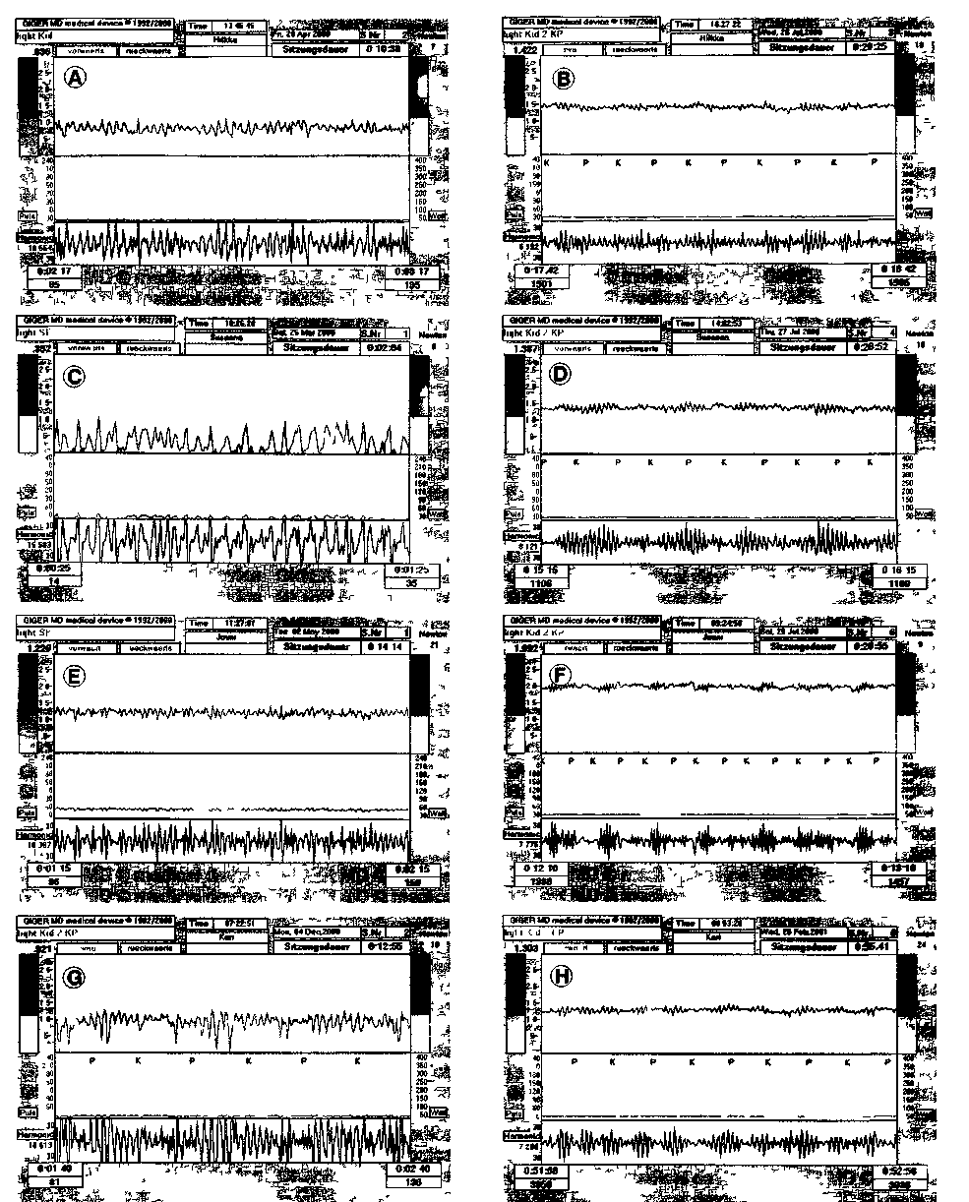
Fig 8 - Coordination dynamics recordings of 4 stroke patient at the beginning of therapy (A, C, E, G) and after 3 months of therapy (B, D, F, H). Note that the amplitude of variation of frequency (Af) and its time derivative (Adf/dt) reduced in all 4 patients. Ordmate, f (upper trace) and df/dt (lower trace). Abcissa, time coordinate (1min from left to right) calibrated by the pace (P) and trot gait (K) coordinations.
96

therapy quite well the trot gait coordination between arms and legs (K) but less well the pace gait coor-dination (P) (Fig. 8D). In the third patient the CNS could generate after therapy all coordinations between arms and legs quite well apart from the changing coordinations between trot and pace gait (K→P) (Fig. 8F). In the fourth patient easy (Δdf/dt small) and difficult coordinations (Δdf/dt large) can be seen (Fig. 8H). But the easy and difficult coordi-nations were also changing with time with respect to the pace and trot gait CNS organization calibration (with respect to P and K). Therefore, even though the coordinations dynamics improved very much in all 4 patients after 3 months of therapy, the deficits in the coordination dynamics were quite different before and after the treatment.
From the direct measurements of CNS organi-zation (Fig. 8) follows that the normalized arrhyth-micity (Δ(df/dt)/f) reduced by 70 ± 14 % (s.d.; range 54-87%). The CNS organization with respect to the coordination dynamics improved therefore by 70%. But the indirect measurements of CNS organization by the relearned movements also showed substantial progress in all 4 patient. In Fig. 9 the improvements of walking and hand grip power of the 4th patient (Fig. 8G, H) are shown. The stroke patient relearned faster free walking (Fig. 9A) with a better perfor-mance and longer walking on the treadmill (Fig. 9C). His hand grip power of the paretic hand became stronger because he could turn longer on the special coordination dynamic therapy device without hand fixation of the paretic hand (Fig. 9B). A bad flu (marked by flu in Fig. 9) after 60 days of therapy reduced the progress in all relearned movements for a longer time than the flue was lasting. The hand grip power was transiently completely lost.
Comparison between longer and shorter therapy times. Even though the motor functions improved con-siderably during the 3 months of coordination dynamic therapy in all four patients, there was only little progress in the hand and finger functions on the paretic side. In the musician the arm, hand and fin-ger functions improved very much. What is then the reason that the hand functions improved only little for the 4 patients after 3 months of therapy and very much in the musician performing more than one year intensive therapy? Every lesion is different and what the upper coordination dynamics show (Fig. 8) is
that the repair adapts to these differences between the lesions. Maybe, the musician also had a less severe brain lesion due to stroke. But the main rea-son for the only little recovery of the hand function is probably the much shorter therapy time. The importance of longer therapy times will be discussed below with respect to the induction of neurogenesis in the adult CNS.
Exhaustion of the body during the week when per-forming intensive coordination dynamics therapy
One criterion for the efficiency of the coordina-tion dynamic therapy is to push the patient to his limit every weekday (4 to 5 hours therapy per day, 5 to 5.5 days per week), to force the 'adaptive machine' CNS to adapt to fully recruite all possible repair mechanisms including neurogenesis. On the other hand the body, including CNS, needs also time to recover.
It is the general experience of the therapy that the patients get exhausted towards the weekend and are most fit at the beginning towards the middle of the next week. In the 4th stroke patient (Fig. 8G, H) the becoming exhausted has been quantified by the walking times for 600m (Fig. 10). The patient per-formed coordination dynamic therapy for 4 to 5 hours per day from Monday to Friday. But all 7 weekdays he walked the 600m and the walking times (speed) were measured. It can be seen from Fig. 10 that the patient could walk fastest on Tuesday and Wednes-day and got exhausted toward the weekend and recovered during the weekend to get better again from Monday to Wednesday.
Some scatter of the data in Fig. 9 will be due to the different stage of exhaustion during the week. Best movements should be obtained in this patient on Tuesday and Wednesday.
Discussion
Importance of measuring improvement of CNS organization in the short-term memory
It has been shown in this paper that coordination dynamic therapy can partly repair the physiologic functioning of the by the stroke lesioned CNS. The improvement of CNS functioning can be quantified directly by measuring CNS organization with the

97

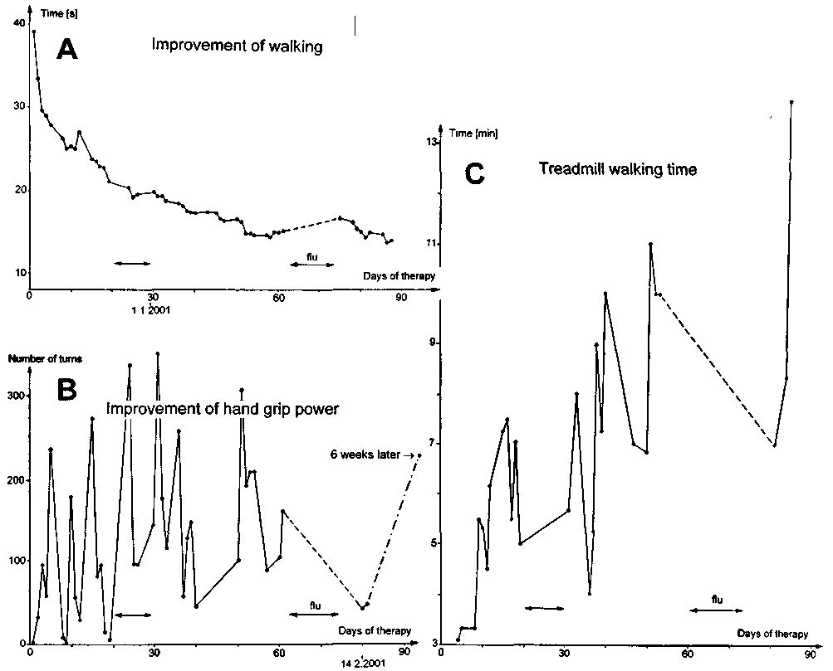

Fig. 9. — Improvement of CNS organization due to coordination dynamics therapy quantified by the improvement of walking and hand grip power. The coordination dynamics of that patient at the beginning and at the end of therapy are shown in Figure 8G and 8H respectively. A. Walking times for 19.2 m with ongoing days of therapy. Note that a bad flu increased the walking times, whereas a small flu (←→) had no or only little effect. B. Number of turns until the paretic hand slipped from the handle in dependence on the days of therapy. The dashed line indicates that turning without fixation of the paretic hand was not possible due to the bad flu. After the flu, the hand grip power was reduced. Six weeks later (with ongoing therapy) the volitional hand grip power increased again with 218 turnings before slipping from the handle. C. Duration of treadmill walking time (speed = 3 km/h) in dependence on the days of therapy. The dashed line indicates that treadmill walking was not possible during and some time after the flu due to the weakness of the patient.

coordination dynamic recording method (Fig. 7, 8) and can be quantified indirectly by the improvement of movements like walking and hand grip power (Fig. 9). Improvement of CNS organization in the short-term memory (Fig. 4) in a stroke patient informs the therapeut and the patient that the lesioned CNS of the patient can be improved in its functioning if a long intensive coordination dynamic
therapy is performed. The quantification of improve-ment in the short-term memory is therefore of prog-nostic value. Mostly the patients can also feel the improvement of CNS organization in the short-term memory. They seem to feel better in their CNS. The spasticity reduces, walking and hand functions get better and blood circulation, speech and vision become better.

98

Fig. 10. - Walking times over 600m from Monday to Sunday (average of 4weeks) of a 49-year-old stroke patient 4 years after the stroke. Walking was performed all 7 days per week, all other exercises only from Monday to Friday. Lower trace (B), when the biggest value is omitted. The best times were achieved on Wednes-days with little more than 16 minutes. Note that the patient is getting exhausted towards the weekend and recovers during the weekend
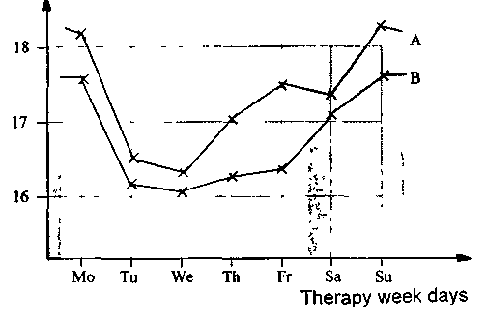
Time [min.s]
for walking 600m
Comparison of the improvement of CNS organisation between a healthy person and a stroke patient
a. Arrhythmicity (Δdfldt). In a healthy person the arrhythmicity Adf/dt reduced by 27% in the short-term memory (Figs. 2, 3) and in a stroke patient by 59% (Figs. 4, 5). Arrhythmicity standardized to 1Hz (Δdf/dt /f) reduced in the healthy person by 20% and in the stroke patient by 70%. The coordination dynamics improved therefore in the stroke patient, more than 3 times as much as in the healthy person, when turning on the special coordination dynamic therapy device (Fig. 1).
b. Frequency. The behavior of the frequency f of turning was different in the stroke patient than in the healthy person (Figs. 3, 5). In the stroke patient the frequency increased with ongoing time of turn-
ing and in the healthy person it did not. But there are major differences in the dependences of the fre-quency of turning between the lesioned CNS and the healthy CNS. The lesioned CNS is often not able any more to generate coordinated arm and leg move-ments quickly, because of the loss of relative phase and frequency coordination among neuron firings. When the timed firing of CNS neurons is less coor-dinated with respect to time and space (less exact), then for example much less crossing of activated synfire chains (1) (crossing of excitation in neuronal network connections) is possible. In tennis those players win (among other reasons), who can react and place exactly the ball most quickly. Their coor-dination dynamics will really be better than those of the others, because the timed firing of the neurons in their CNS is dynamically better (more precisely) organized.
With the improvement of CNS organization in the short-term memory in stroke patients, their CNS becomes able to faster generate complicated coordi-nations between arms and legs. The increase of the frequency of automatic turning in the short-term memory (Fig. 5) and in the long-term memory (Fig. 8) is an indicator for better CNS organization in the short-term and long-term memory.
In a healthy person the coordination dynamics are anyway good, so that small frequency changes are covered by other influences like thinkings and sedative behavior.
Healthy persons can mostly turn automatically at two frequencies, namely at 1 Hz and nearly 2Hz. The turning frequency around 1 Hz corresponds to a walk-ing speed of approx. 4km/h and the 2Hz frequency corresponds to a running speed of approx. 7km/h.
In conclusion, the patients with a severe CNS lesion cannot turn fast automatically and the fre-quency of turning is a measure for improvement in CNS organization. The healthy person can turn at many frequencies. Automatically they turn at approx. 1 Hz or 2Hz which corresponds to the leg alternation frequency of walking and running (jogging).
c. Integrativity of coordinated CNS organization. It can be seen from Fig. 5 that the frequency of for-ward turning increased strongly again after backward turning in the stroke patient. The dotted line in Fig. 5 indicates how the forward turning frequency may have increased without backward turning It seems therefore as if the backward turning had substantial

99

beneficial effect on the forward turning. Patients say also that they can turn better forward if they have turned backwards in between. A possible explana-tion is that the backward turning activated slightly different CNS subnetworks than the forward turn-ing. Including the effects of short-term memory, the integrativity of coordinated CNS activation is larger if forward and backward turning are performed in alternation. The integrativity of coordinated CNS activation is one criterion of increasing the efficiency of improvement of CNS organization (see Method) in the short-term and long-term memory.
Necessity for longer therapy times to improve the functioning of the lesioned CNS
It has been shown in this work that a world-wide known violinist recovered from stroke by the coor-dination dynamic therapy (Figs. 6, 7). Also the crit-ical arm, hand and finger functions recovered sub-stantially. The improvements of CNS organization were such that the goal "Cure rather than care" has been achieved.
Mostly arm and hand functions recover less well than leg and feet functions. There are two possible reasons. (I) The patient is forced to use the paretic leg, because otherwise he cannot walk; but the patient must not use the paretic arm and hand, because he can do nearly everything with the other arm and leg. But improvements of arm and hand functions are only achieved by using them. (II) The leg is included more in the walking automatism (stepping automa-tism), mainly located in the spinal cord, than the arm. Therefore co-movement (21) from the healthy to the paretic side (to improve the paretic side) will be stronger for the leg than for the arm movement. In other words, the cortex is more involved in arm and hand than in leg and feet movements. A lesion of the cortex on one side will therefore affect more arm and hand functions than leg and feet move-ments.
But why did arm and hand functions improved substantially in the musician (Fig. 6) and much less in the other stroke patients? From the recovery of 5 patients suffering stroke, spinal cord lesion or brain lesion from birth (cerebral palsy), it seems that sub-stantial recovery is occurring additionally after very approximately 5 months of continuous intensive
coordination dynamic therapy. As if something is growing in the lesioned CNS which needs a lot of time. From lesions of the nervus ischiadicus (periph-eral nervous system) we know that it takes more than a year that distal muscles start to function again, because the motoneuron axons have to grow a long distance down the Biigners bands to the distal mus-cles, and the growing time lies in the range of 1 to 2 years (growing velocity = 1 to 2 mm/day; growing distance ≈ 1m = 1000mm; => v = s/t; t = s/v = grow-ing time = 1000mm / 2mm/day = 500days = 1 to 2 years). Further, thick axons regenerate (grow) faster than thin ones (9-11, 24).
Therefore a possible explanation that the patient has to perform an intensive continuous coordination dynamic therapy for at least half a year is that new nerve cells have to proliferate from stem cells and have to be built into the neuronal networks accord-ing to functional aspects, which means additionally to neurogenesis axons and dendrites have to grow and form functioning synapses. Following CNS lesion many neurons of the neuronal networks will be partially denervated. Partial reinnervation of other old neurons and (by neurogenesis) newly built neurons will take place. Membrane property changes of synapses and dendrites may take place controlled by the innervating neuron kind. In a frog model it has been shown that in the not excitable membrane of slow muscle fibres Ca-channels were incorporated (or unblocked) for excitation in the whole membrane or in inlocalized parts which were controlled by the innervating neuron. A functioning synapse was not necessary for that trophic control (9-11, 24). There-fore many intricate repair mechanisms (including structural and functional ones) at different levels will take place, when the "adaptive machine" CNS is forced to adapt by pushing the patient to his limits to restorate the coordinated firing of CNS neurons with respect to time and space. If membranes of dendrites and cell somas of neurons could partially made excitable in similarity to the slow fibre mem-brane this would substantially change the timed coordinated firing of CNS neurons.
The most plausible explanation of bigger recov-ery of CNS functioning in the case of the musician is that the therapy time was much longer (more than 1 year instead of 3 months), so that more adaptive growth of nerve cells and neuronal networks and learning was possible.

100

Spasticity, grip automatism and hand grip power
It has been shown in Fig.5 that hand grip spas-ticity can be used for holding the handle when turn-ing on the special coordination dynamic therapy device. Such spasticity should not be mixed up with the grip automatisms and volitional hand grip power. The volitional hand grip is fully controlled by the patient. The grip automatism can be activated by the patient, but is otherwise automatic. The grip spasticity is an uncontrolled activation of the hand and is a fully pathologic organization of the human CNS. In principle it is possible to have a mixture of spasticity, grip automatism and volitional hand grip power depending on the lesion.
When turning on the special coordination dynamic therapy device, spasticity reduced because the organization of the lesioned CNS became better in the short-term memory. Therefore the hand slipped from the handle in Fig. 5 after 6.5min of turning because of the reduction of spasticity. If the patient could have activated the grip automatism, then the hand would have not slipped from the handle, because the grip automatism is no spasticity. If a patient has only little volitional hand grip power and no grip spasticity and cannot activate the grip automatism, then after some time of turning his hand will slip from the lever because of exhaustion.
Therefore in this case of hand grip spasticity and lit-tle volitional hand grip power the hand slipped from the handle after some time of turning. The difference between spasticity and hand grip power is that spas-ticity cannot be controlled by the patient and volitional power can. Another difference is that with coordination dynamic therapy induced stroke recovery the voltional hand grip power increases (the patient can turn longer on the device (Fig. 9B)) and the grip spasticity reduces. Therefore theoretical and practical knowledge is nec-essary to judge upon hand function in patients.
Spasticity, stepping automatism and walking
When a patient is walking on a treadmill, differ-ent kinds of pathologic and physiologic CNS orga-nizations can take place (in some similarity to hand function) like extensor spasticity, flexor spasticity or rigidity besides the stepping automatism and voli-tional walking. In stroke patients mostly one leg has
to be supported by the therapist to enable the patient to walk to improve CNS organization to make the patient walking again. Often the stepping automa-tism can be used to improve supported walking. The stepping automatism can often be activated by bumping with the hand on the forefoot just before the lift-off phase. The overstretching of the knee to use the leg as a crutch has to be avoided, because it hinders the re-learning of physiologic walking.
In some brain lesions the extensor spasticity can be that strong that spasmolytic drugs cannot help and it is also impossible to flex the leg by the ther-apist even if one is trying to induce the flexor reflex. Then only emotional treatment (Zuwendung) may help or the use of the special coordination dynamic therapy device (by not using the extremely spastic leg) to reduce spasticity in the short-term memory. When turning a few thousand times on the device the extensor spasticity will reduce. Such extreme exten-sor spasticity has been observed by the author till now only in hypoxic brain lesion but not in stroke.
Spasticity can efficiently be reduced in the short-term and long-term memory when exercising on the special coordination dynamic therapy device and the volitional power will mostly increase simultaneously. Spasmolytic drugs on the other hand reduce spas-ticity and volitional power simultaneously (mostly by blocking the input to the motoneurons). In most cases there is therefore no indication for using spas-molytic drugs. If spasmolytic drugs are administered to patients performing coordination dynamic ther-apy, then the drug concentration can be reduced (21).
Necessity of avoiding infections
It has been shown (Fig. 9) that a flu hindered reorganization of the CNS. Generally, infections (for example lung or bladder infections) hinder the improvement of CNS organization and for a longer time than the infection is lasting. Infections therefore have to be avoided as much as possible.
Quantification of coordination dynamic therapy induced CNS recovery
The improvement of the organization of the lesioned CNS in the stroke patients was measured

101

indirectly by the improvement of movements like the increase of walking speed (Fig. 9A) or hand grip power (Fig. 9B, (23)) and directly by the coordina-tion dynamics (reduction of arrhythmicity, Figs. 7, 8; (21, 22)). The coordination dynamic therapy induced CNS recovery can therefore be quantified, which is important for the patient to motivate him for further intensive therapy. The therapist can use the data for adapting the therapy to the progress in CNS recovery and the research worker gets hard data for understanding better the functioning of the human CNS and can in this way enhance the effi-ciency of CNS re-organization.
Stress
It has been observed earlier and quantified by the coordination dynamic recording method that stress can in the short-term memory reduce or destroy relearned movements (30). This stress-induced dete-rioration of relearned movements was also observed in the musician. When the patient played first time again in a concert after stroke, he had problems to hold the bow (Fig. 6M). Two days later, when the stress was over, the positioning of the fingers was much better again (Fig. 6F).
Interesting is that the stress partly ruined the bow hand movement, but did not ruin the music he was playing. The playing of music was therefore more resistant against stress, which may indicate that the sense for music is stored in a different way in the brain (probably more integrative) than the hand movement. It is known that a patient with a brain lesion, who cannot speak any more, may be able to sing.
Why are some neuronal network organizations more resistant against stress than others? In the con-cept of coordination dynamics all network states are generated by self-organization. Only some attractors are that deep that it seems as if they are hard-wired. If stress worked with noise-like fluctuations on the attractors, then the deeper attractors would be more resistant against stress. A more convential concept is that some network states are generated more by a functional organization of the neuronal networks (like learning data at school) whereas others are pri-mary more structural ones (like the escape automa-tism running). Against the argument that at least some automatisms are generated by a hard-wired
structure is the finding that in spinal cord lesion, when the intumescenta lumbosacralis is lesioned (net-works which are mainly generating the stereotyped walking and running), the patient can still relearn walking. Against this argument stays the possibility of structural repair including neurogenesis.
The importance of these discussions comes from the clinical consequences. It seems so far that the relearning of phase and frequency coordination is achieved more by a functional reorganization whereas the exercising of automatisms is primarily work on the structural repair. Sensitivity to stress may help to distinguish between principally different network organizations. Further research has to shed more light into the complexity of CNS repair.
General consideration in human CNS research
It has been demonstrated here in stroke patients in comparison to a healthy person that the coordi-nation dynamics give much more information con-cerning the organization of the human CNS, when the CNS is lesioned. It was therefore argued earlier (21) that lesion studies in man will bring substantial further insight concerning the understanding of the functioning of the human CNS. Comparably little understanding will come from animal experimenta-tion and the analysis of data of the healthy human CNS. The problem is not what neuronal network can produce what function (as in artificial neuronal network studies) but how the neuronal networks of the human CNS are generating certain functions. When the tremendously good regulations of the human CNS are disturbed then CNS functions become exposed.
In a recent review article phase synchronization and large-scale integration has been proposed for the functional organization of the brain (27). I measured relative phase and frequency coordination between single neurons and neuron asemblies 8 to 10 years ago with the single nerve fibre action potential recording method (12-18). Varela et al. argue (27) that there is no direct proof that synchrony leads to changes in behaviour when it is selectively altered. I have measured in the premotor network of the spinal cord that there are selective changes of phase and frequency coordination in the firings of α and γ-motoneurons, secondary muscle spindle afferents

102

and oscillatory firing motoneurons (neuron assem-blies) when the continence functions of the urinary bladder and the rectum are altered (12-20). Syn-chronization occurred only transiently. It seems there-fore that relative coordination rather than synchro-nization is the basic mode of organization. Relative coordination allows also a much higher complexity of CNS organization than only synchronization. When the motoneurons in the CNS fired oscillatory in synchrony, then the whole body would shake. Already when the coordination among the motoneu-ron firings is disturbed, then the tremor enhances strongly as we can observe in Parkinson patients. Besides the use of more clinical methods like positron-emission tomography (PET), functional magnetic resonance imaging (fMRI), transcranial magnetic stimulation (TMS) and measurements of the coordination dynamics between arm and leg movements (21), basic methods in human neuro-physiology (like the single-nerve fibre action poten-tial recording method (12, 13)) have also to be used to get basic data concerning the organization of the human CNS. We have to understand the organiza-tion of the human CNS on the single neuron level, the neuron assembly level and the macroscopic level to understand how the CNS is generating certain functions and behaviors. Parallel experiments have to be performed in humans and animals, to get also those data which are extremely difficult to get hold of in man.
References
1. abeles, M.: Local Cortical Circuits. An Electrophysiological Study. Springer, Berlin, 1982.
2. haken, H.: Synergetics, an Introduction: Non-equilibrium Phase Transitions and Self-organization in Physics, Chemistry and Biology. Springer, Berlin, 1983.
3. haken, H., kelso, J.A.S. and bunz, H.: A theoretical model of phase transitions in human hand movements. Biol. Cyber. 51: 347-356, 1985.
4. holst. E.v.: Die relative Koordination als Phänomen und als Methode zentralnervoser Funktionsanalyse. Erg Physiol. 42: 228-306, 1939.
5. jung, R.: Physiologische Untersuchungen üiber den Parkin-sontremor und andere Zitterformen beim Menschen. Z. ges. Neural. Psychiat. 173: 263-332, 1941.
6. kelso, J.A.S.: Dynamic Patterns. The Self-Organization of Brain and Behavior. MIT Press, Cambridge. 1995.
7. kim, K.H.S., relkin, N.R., lee, K.-M. and hirsch, J.: Distinct cortical areas associated with native and second languages. Nature 388: 171-174. 1997.
8. langhorst P., schulz B. and lambertz M.: Reticular formation of the lower brainstem. A common system for cardio-respiratory and somatomotor functions: discharge patterns of neighboring neurons influenced by cardiovascular and respiratory afferents. J. Auton. Nerv. Syst. 411-432, 1983.
9. miledi. R.. parker, I. and schalow, G.: Calcium transients in normal and denervated slow muscle fibres of the frog. J. Physiol. 318: 191-206, 1981.
10. schalow. G. and schmidt. H.: Action potentials induced in slow muscle fibres by partial denervation. Nature (London) 253: 122-123. 1975.
11. schalow, G.: Elektrophysiologische und morphologische Untersuchungen zur Differenzierung der Tonusfasern des Frosches. Inauguraldissertation. Universitat des Saarlandes, 1983.
12. schalow. G.: Conduction velocities and nerve fibre diame-ters of touch, pain, unnary bladder and anal canal afferents and α and γ-motoneurons in human dorsal sacral nerve roots. Electromyogr. Clin. Neurophysiol. 31: 265-296, 1991.
13. schalow. G.: Oscillatory firing of single human sphincteric α₂ and α₃ motoneurons reflexly activated for the continence of urinary bladder and rectum. Restoration of bladder function in paraplegia. Electromyogr. Clin. Neurophysiol. 31: 323-355, 1991.
14. schalow, G.: Impulse patterns of single encoding sites of human secondary muscle spindle afferents. Electromyogr. Clin Neurophysiol. 33:451-464. 1993.
15. schalow. G.: Recruitment of motoneurons in the occasional firing mode in paraplegics. Electromyogr. Clin. Neurophysiol. 33: 401-408. 1993.
16. schalow G.: Spinal oscillators in man under normal and pathologic conditions. Electromyogr. Clin. Neurophysiol. 33: 409-426. 1993.
17. schalow, G.: Phase-correlated adequate afferent action potentials as a drive of human spinal oscillators. Elec-tromyogr. Clin. Neurophysiol 33: 465-476, 1993.
18. schalow. G.: Action potential patterns of intrafusal γ and parasympathetic motoneurons. secondary muscle spindle afferents and an oscillatory firing α_{r}motoneuron, and the phase relations among them in humans. Electromyogr. Clin. Neurophysiol. 33: 477-503, 1993.
19. schalow. G., bersch. U.. michel, D. and koch, H.G.: Detrusor-sphincteric dyssynergia in humans with spinal cord lesions may be caused by a loss of stable phase relations between and within oscillatory firing neuronal networks. J. Auton. Nerv. Syst. 52: 181-202. 1995.
20. schalow, G., blanc, Y, jeltsch, W. and zach, G.A.: Elec-tromyographic identification of spinal oscillator patterns and recouplings in a patient with incomplete spinal cord lesion: Oscillator formation training as a method to improve motor activities. Gen. Physiol. Bwphys. 15, Suppl. 1: 121-220, 1996.
21. schalow, G. and zach, G.A.: Reorganization of the Human CNS. Neurophysiologic measurements on the coordination dynamics of the lesioned human brain and spinal cord. Theory for modern neurorehabilitation (31 case reports). Gen. Physiol. Biophys. 19 (Suppl. 1): 1-244, 2000.
22. schalow, G.: On-line measurement of human CNS organization. Electromyogr. Clin. Neurophysiol. 41: 225-242, 2001.

103

23. schalow, G. and molnar, M.: Koordnationsdynamik-Therapie: Rückenmarkverletzung. Physiotherapie 2: 16-26, 2001.
24. schmidt, H.. and schalow, G.: In-vitro and In-vivo Exper-iments on the Incorporation of Na-Channels into the Membrane of Frog Slow Muscle Fibres. In: Membrane Permeability: Experiments and Models (AH Bretaa ed.) Techsearch Adelaide, 1983.
25. schoner, G., jiang, W.Y. and kelso, J.A.S.: A synergetic theory of quadrupedal gaits and gait transitions. J. Theor. Biol. 142: 359-391, 1990.
26. schoner, G., zanone, P.G. and kelso, J.A.S.: Learning as change of coordination dynamics: theory and experiment. J. Motor Behav. 24: 29-48, 1992.
27. varela, E, lachaux, J.-P., rodriguez, E. and martinerie, J.: The brainweb: Phase synchronization and large-scale integration. Nature Reviews/Neuroscience 2: 229-239, 2001.
28. zanone, P.G. and kelso, J.A.S.: Evolution of behavioral attractors with learning: Nonequilibrium phase transitions. J. Exp. Psychol.: Human Perception and Performance 18: 403-421, 1992.
29. zanone, P.G. and kelso, J.A.S.: Coordination dynamics of learning and transfer: collective and component levels. J.Exper. Psychol.: Human Perception and Performance 23: 1454-1480, 1997.
30. schalow, G.: Time axis calibration in human CNS organization for judging dysfunction. Electromyogr. Clin. Neurophysiol, 41:485-505, 2001.
Address reprint requests to:
Giselher Schalow
Dr. med. habil., Dr. rer. nat., Dipl. Ing.
Untere Kirchmatte 6
CH-6207 Nottwil
Switzerland

104

