Low-load coordination dynamics in athletes, physiotherapists, gymnasts, musicians and patients with spinal cord injury, after stroke, traumatic brain lesion and with cerebral palsy
G. Schalow¹, M. Pääsuke²
Summary
Low-load coordination dynamics were measured in athletes, physiotherapists, gymnasts, musicians and patients after stroke, traumatic brain injury and spinal cord lesion during exercise on a special coordination dynamic therapy device to quantify differences in central nervous system (CNS) organization between healthy subjects and patients with CNS injury.
In healthy humans coordination dynamics (arrhythmicity of turning) varied between 5.2 and 6.0 for forward and between 6.9 and 10.7 s⁻² for backward turning. The frequency of turning varied between 1.24 (athletes) and 1.49Hz (musicians) for forward and between 1.11 and 1.25Hz for backward turning. Apart from the poor rhythmicity of backward turning among physiotherapists, gymnasts and musicians, inter-group differences were small in com-parison to intra-group variation. In patients with spinal cord lesion the coordination dynamics value was 8.3 for forward and 11.0 for backward turning. The frequencies for forward and backward turning were 1.20 and 1.20Hz respectively. The values for coordination dynamics and frequency of turning thus did only slightly differ from those measured for healthy subjects. The patients after stroke, traumatic brain injury and cerebral palsy had much higher coordination dynamic values (20.4, 22.9 and 30 Us respectively) and lower forward (0.85, 0.93, and 0.52Hz) and backward turning frequencies (0.98, 1.06, 0.42Hz), suggesting strongly pathologic CNS organization. Low-load coordination dynamics (20N) are thus useful to measure progress in CNS organization due to therapy in patients with CNS injury.
Key-words: Neurotherapy - Coordination dynamic values - Healthy humans - CNS injury.

Introduction
I previous reports, it was shown that after stroke (4), traumatic brain injury (5) and spinal cord lesion (6) the lesioned central nervous system (CNS) could partly be repaired by administering coordination dynamic therapy for 3 months. Further therapy
¹ Coordination Dynamic Therapy Centre, Avenida del Parque, Edif. Benal Beach, Local 2, E-29630 Benalmadena-Costa (Malaga), Spain.
² Institute of Exercise Biology, University of Tartu, 5 Jakobi Street, Tartu 51014, Estonia.
resulted in further repair. Improvements of CNS functioning could be quantified by improvements of movements and by measuring the improvement of the coordination dynamics between arm and leg movements (1-6).
Since the coordination dynamics of arm and leg movements, quantified by the arrhythmicity of turn-ing when exercising on a special device, reflect cer-tain aspects of human CNS organization, values of coordination dynamics measured in healthy indi-viduals are needed to allow comparison and to iden-tify differences in neuronal network organization between normal and injured CNS.

Electromyogr. din. Neurophysiol., 2003, 43, 195-201.
195

Method
The macroscopic self-organization of the neu-ronal networks of the human CNS generated by the relatively coordinated firings with respect to time and space of single neurons and neuron assemblies (for example premotor spinal oscillators) can partly be quantified by the coordination between arm and leg movements (1-3). The coordinated firing with respect to phase and frequency (and space) of single neurons and neuron assemblies gives rise to coordi-nated movements between arms and legs with respect to phase and frequency. When turning on a special device (leaver length = 8cm) where the coordination between arms and legs is given by the instrument, the quality of macroscopic CNS organization is mea-sured by the arrhythmicity of moving (Δ(df/dt)/f)), that means by the motor control the CNS is able to generate. When the ryhmmicity of turning is good the coordination dynamic value is small whereas if the rhythmicity of turning is poor (the arrhythmic-ity is large), a high value of coordination dynamic is obtained. For further details see (1, 2).
Results
Low load coordination dynamics were measured in 7 athletes, 17 physiotherapists, 7 gymnasts and 10 musicians for forward and backward turning when exercising on the special coordination dynamic ther-apy device. All subjects were female apart from the athletes. Typical recordings are shown in Fig. 1. The measuring mode can be seen in Fig. 1A. The subject turned first l0min forward, then 5min backwards and then 5 min forward again. The load was 20N and the lever length 8cm. A time window of 1min duration was scrolled through the 20min of record-ing to look for the best part of the coordination
dynamics for forward and backward turning. The frequencies of turning were taken from parts with the best coordination dynamics.
Low-load coordination dynamics in athletes,
physiotherapists, gymnasts and musicians
In Fig. 1A good coordination dynamics are shown obtained for a female athlete (track and field run-ning). The frequency of turning (upper trace) was very stable and very similar for forward and back-ward turning. The coordination dynamics were good, i.e. rhythmicity of turning showed small variations. Also for backward turning the coordination dynam-ics were good and did not change for the different coordinations between arms and legs (pace gait, trot gait and intermediate coordinations). The author (G.S.) has very similar coordination dynamics (used in a previous publication as control data) as those in Fig. 1A, B.
A typical coordination dynamics recording obtained for a decathlon athlete is shown in Fig. 1C, D. The frequency of turning is increasing with ongoing exercise time, otherwise the coordination dynamics are similar to those in Fig. 1A, B. Typical coordination dynamics recordings obtained for a physiotherapist, a gymnast and a musician are shown in Fig. 1E-K. All of them had more or less problems to turn backwards rhythmically. The frequency of backward turning was lower than for forward turning (Fig. IE, G, I). Especially for the intermediate coordinations between pace and trot gait for backward turning the subjects had big problems; often they got stuck (Fig. IF, K, the frequency of turning went transiently to zero). Coordination dynamics and frequency values for forward and backward turning of the different groups are summarized in Table 1. The main difference between athletes on

Fig. 1. - Original recordings of coordination dynamics of a good balanced CNS (A, B), an athlete (C, D), a physiotherapist (E, F), a gymnast (G, H) and a musician (I, K) (all female). Left, overall traces of 20min (A, C, E, G, I): 10min forward turning, followed by 5min backward turning (blue) and 5min forward turning again. Right (B, D, F, H, K), 1 min window of backward turning. Upper trace = frequency of turning in Hz (mostly between 1 and l.5Hz); lower trace = coordination dynamics [1/s²] = arrhythmicity of turning; P = pace gait coordination; K = trot gait coordination. Middle trace or line = output in Watt, not changing very much. Note that physiotherapists, gymnasts and musicians had problems with turning backwards on the special coordination dynamic therapy device. Coordination dynamics values (mean Δ/min), mean force (mean Newton/min) and mean frequency (mean frequency/min) per minute are indicated. Time and turn windows of the overall exercise are also indicated.
196

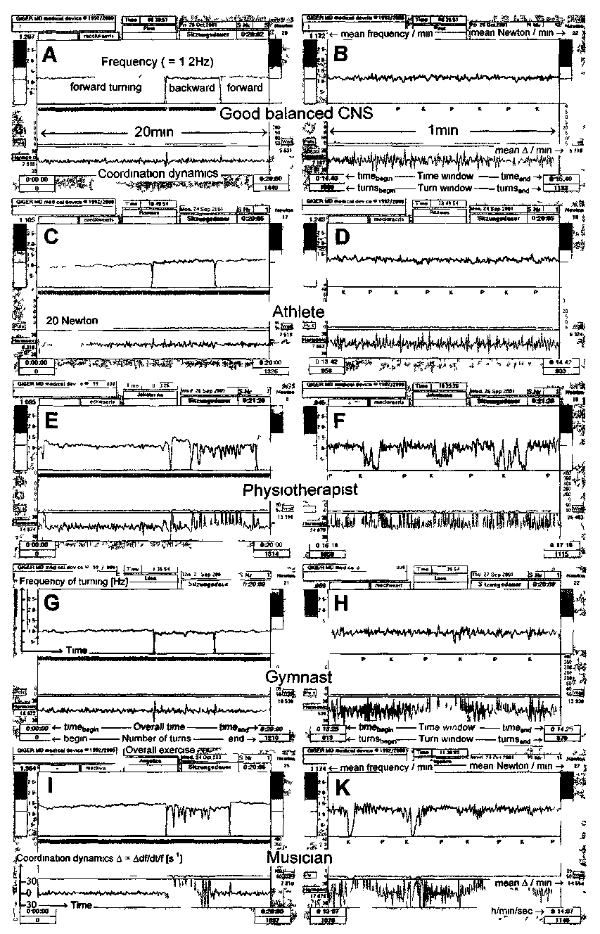
197

one hand and physiotherapists, gymnasts and musi-cians on the other hand was, that the athletes could turn better backwards for a load of 20 Newtons.
Low-load coordination dynamics in patients with CNS lesion
Low-load coordination dynamics of a patient with a traumatic brain injury and a patient with cere-bral palsy are shown in Fig. 2. The patient with the traumatic brain injury was not able to turn at a con-stant frequency and the arrhythmicity of turning was large (Fig. 2A). The frequency of turning even seemed to jump. It is evident from a time-stretched part for forward turning (Fig. 2B) that the patient could turn reasonably well for the easy coordina-tions pace (P) and trot gait (K), but for the difficult intermediate coordinations, the turning nearly stopped. For backward turning the frequency and coordination dynamic changes were similar. For the easy coordinations pace and trot gait (mainly gen-erated in the spinal cord), the turning was good (high frequency and low coordination dynamics), but for the difficult intermediate coordinations (when the brain had to vary spinal cord movement pattern) the turning stopped or nearly stopped (low frequency and high variation of rhythmicity, Fig. 2C).
In a 28-year-old patient with cerebral palsy the CNS organization was even worse (Fig. 2D-I). Before coordination dynamic therapy (Fig. 2D, E, F), she could not turn steadily at all (Fig. 2D). The forward turning was sometimes as good as in the other patient (Fig. 2B), but the backward turning was very arrhythmic (Fig. 2F). After 2 months of coordina-tion dynamic therapy, her coordination dynamics got better (Fig. 2G, H, I), especially she could some-how maintain a steady frequency during turning (Fig. 2G). Coordination dynamics and frequency values for the different groups of patients are sum-marized in Table 1.
Comparison of low-load (20N) coordination dynamics between normal subjects and patients with CNS lesion
All athletes, physiotherapists, gymnasts and musi-cians could turn forward quite rhythmically; the
patients could not. Even though some physiothera-pists, gymnasts and musicians had some problems in backward turning (they sometimes got stuck) the rhythmicity for backward turning was generally still better than in the patients with CNS injury. The patients had problems with all coordinations and especially with the intermediate coordinations. For further original recordings see (1-6). The normal subjects had only sometimes problems with the dif-ficult intermediate coordinations.
Numerical values for low-load coordination dynamics of normal subjects and patients with CNS lesion
In Table 1 mean coordination dynamics (Δ(df/dt)/f = A) and mean frequencies of turning (f) are shown for athletes, physiotherapists, gymnasts, musicians and patients with spinal cord lesion, after stroke, traumatic brain lesion and with cerebral palsy. The difference between the mean frequencies of forward and backward turning (Δf) are also shown.
Athletes: The athletes had a mean values of coor-dination dynamics (Δ(df/dt)/f = Δ) of 6.0 for forward and 6.9 1/s² for backward turning. The frequency of forward turning was 1.24 Hz and for backward turning 1.19Hz; the frequency difference was Δf = 0.05Hz. Even though the organization of the CNS of athletes was not specially good, the CNS functioning was balanced with respect to forward and backward turning. Also the athletes could turn backwards rhythmically for the intermediate coordinations.
Physiotherapists: The physiotherapists had a coordination dynamics value of 5.9 for forward and 9.4 1/s² for backward turning. The frequency of for-ward turning was 1.28Hz and 1.15Hz for backward turning; the frequency difference amounted to Δf = 0.13Hz. The CNS organization of the physiothera-pists was not as balanced as in athletes, because the coordination dynamics (arrhythmicity of turning) value for backward turning was much higher (worse) and the frequency difference between forward and backward turning was larger (0.13Hz).
Gymnasts: The gymnasts could turn forward a bit better (A = 5.6), but the backward turning (Δ = 10.7) was even worse than in the athletes. The frequency difference between forward (f = 1.28) and backward turning (f = 1.11) was even larger (Δf = 0.17).

198

Musicians: The musicians (piano, violin and cello player) had the best low-load coordination dynamics values for forward turning (5.2), but the backward turning was quite uncoordinated (Δ = 10.7). The fre-quency of forward turning was quite high (1.49Hz) and the frequency difference between forward and backward turning (f = 1.25 Hz) was large (Δf = 0.24Hz).
Patients with spinal cord lesion: The patients with a spinal cord lesion (including cervical, thoracic and lumbar injuries) had a coordination dynamics value of 8.3 ± 3.0 for forward turning and 11.0 ± 5.7 for backward turning. The intra-group variation of coordination dynamics (standard deviation) for for-ward and backward turning was larger than in the physiologic cases (athletes, gymnasts, physiotherapists, musicians). This means that some paraplegics could
turn more rhythmically than the healthy subjects. The frequency of backward turning was slightly higher (1.21 Hz) than the frequency of forward turning (1.20Hz), giving a negative frequency difference (Δf = -0.01). In 33% of the cases the frequency for forward turning was higher than that for backward turning. The negative frequency difference between forward and backward turning is pathologic, since in all athletes, physiotherapists, gymnasts and musicians the frequencies for forward turning were larger than those for backward turning under this turning regime. Stroke patients: The mean coordination dynamics value was 20.4 ± 15.5 for forward turning, hence much higher than in the physiologic cases. The value for backward turning was not so high (11.3 ± 5.7). The frequency for forward turning was smaller (0.85Hz) than that for backward turning (1.21)

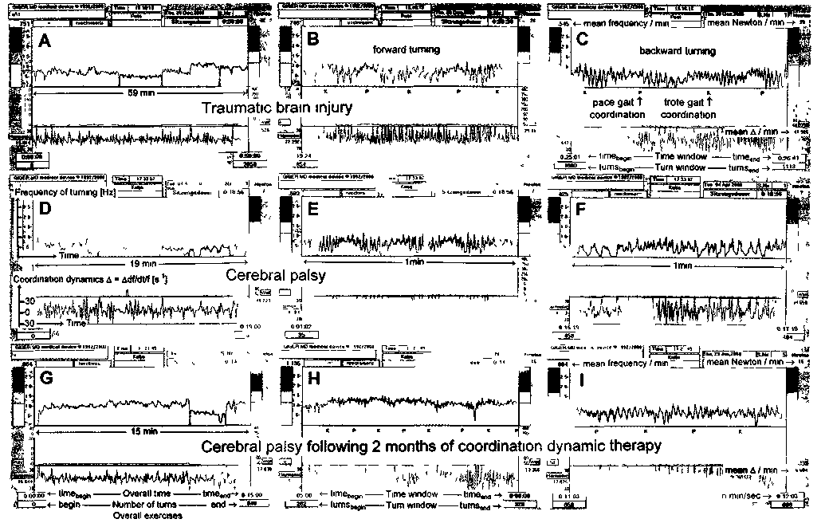
Fig. 2. - Original recordings of coordination dynamics of a patient with traumatic brain lesion (A, B, C) and a patient with cerebral palsy (D through I). Left panel = overall traces of 59min (A), 19min (B) and 15min (C), middle panel (B, E, H) = 1min window of forward turning, right panel (C, F, I) = 1min window of backward turning. Other symbols, see Figure 1. Note that the frequency variations (upper trace) for forward and backward turning are much larger than in the physiologic case (Figure 1)
199

Table 1 a. — Low-load coordination dynamics in healthy humans (mean ± SD)
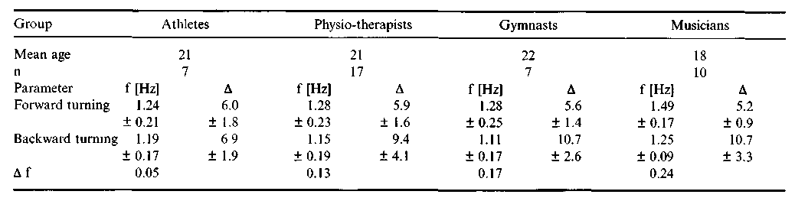

resulting in a frequency difference of Δf = -0.05 which is more pathologic than in the cases of spinal cord lesion.
Traumatic brain injury: Patients with traumatic brain lesions had much higher coordination dynamic values for forward (22.9) and backward turning (23.0). The frequency of forward turning (f = 0.93Hz) was much smaller than that for backward turning (f = 1.06) resulting in a large negative frequency difference (Δf = -0.13Hz).
Cerebral palsy: In Table 1 the coordination dynamics of one patient was over 30 for forward and backward turning and the frequency of turning was very low for forward and backward turning (0.52Hz and 0.42Hz, respectively). In 5 children, 4 to 8 years of age, the coordination between arms and legs was that bad, that they were not able to turn on such a device by themselves. After 3 months of coor-dination dynamic therapy, they were still not able to turn by themselves, even though a therapist assisted them to make at least 10000 turns per day 5 times a week. After 5 months of therapy they became able to turn by themselves. This emphasizes that the coor-dination dynamics can be that poor in cerebral palsy that it may not even be possible to measure it with the device. In lighter forms of cerebral palsy the coordination dynamics can be measured. This emphasizes the necessity to quantify the improve-ments of CNS organization due to therapy, by the progress in single cases, as has been done so far in this research and therapy project.
Discussion
Low load (force = 20N) coordination dynamics have been measured in normal humans and in
patients with CNS lesion, who have never exercised on the device before.
Coordination dynamics in athletes, physiotherapists, gymnasts and musicians
In normal individuals the value of coordination dynamics varied between 5.2 and 6.0 for forward turning and between 6.9 and 10.7 1/s for backward turning. The frequency of forward turning varied between 1.24 (athletes) and 1.49 Hz (musicians) and the frequency for backward turning varied between 1.11 and 1.25Hz. The frequencies for forward turning were always larger than those for backward turning. The frequency difference varied between Δf = 0.05Hz (athletes) and Δf = 0.24Hz (musicians). Apart from the poor backward turning among physiotherapists, gymnasts and musicians, inter-group differences were small in comparison to intra-group variation (see the large values of standard deviations for each group, Table 1).
It is single cases that have to be followed up
The motor control of coordinated arm and leg movements is generated by the volitional impulse patterns and the movement induced re-afferent input in subneuronal networks of the CNS with their coor-dination dynamic tendencies. These coordination dynamic tendencies, that means in the concept of coordination dynamics the landscape of attraktors (1), depend on the inherited initial networks and on the history of learning of the CNS. Since the varia-tions of the turning frequency and the coordination dynamics were large within each group of normal

200

Table Ib. - Low-load coordination dynamics in patients with CNS injuries (mean ± SD)
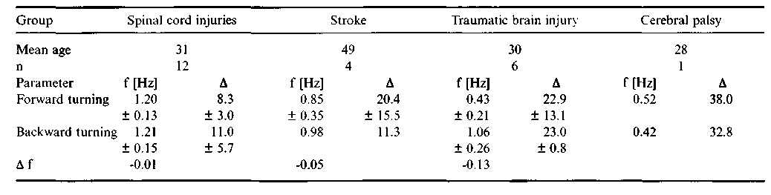
Low load coordination dynamics (Δ(df/dt)/f = A) of athletes, physiotherapists, gymnasts and musicians (Table la) and patients with CNS lesion (Table1b), who had not before exercised on the special coordination dynamic therapy device (all females, only athletes male). Frequency (f) and coordination dynamics (Δ [1/s²], mean ± standard deviation) for forward turning and backward turning on the special coordination dynamic therapy device. Mean age and number of subjects are given for each group. Third row (Δf), frequency difference between forward and backward turning (intra-group difference). Note that the standard deviation of the coordination dynamics is large even for normal subjects, suggesting big differences in CNS organization between different subjects.

subjects, the coordination dynamic tendencies of the substantially activated neuronal networks were quite different between the normal subjects, indicating inter-subject differences in genetics and learning his-tories. In patients with CNS lesions the variation of the frequency and the coordination dynamics were even larger, suggesting a further enhancement of variation between the CNS organizations. Thus fol-lowing up of single subjects will most likely provide for a better understanding of CNS organization and re-organization following injury than the following up of groups of patients or subjects.
Information value of low-load coordination dynamics
Since the coordination between arm and leg movements is very poor in patients with CNS lesion and the values of coordination dynamics are very large, measurement of low-load coordination dynam-ics seems suitable to quantify CNS organization in patients.
For normal subjects the low load coordination dynamics were quite similar and thus provided only little information on the differences in CNS organi-zation between different subjects.
In a following paper it will be shown that the measurements of high-load coordination dynamics will give further insight into differences between CNS organization of healthy subjects and those with CNS lesions.
References
1. schalow. G. and zach, G.A.: Reorganization of the Human
CNS, Neurophysiologic measurements on the coordination dynamics of the lesioned human brain and spinal cord. The-ory for modern neurorehabilitation (31 case reports). Gen. Physiol. Biophys., 19 (Suppl. 1): 1-244,2000.
2. schalow, G.: On-line measurement of human CNS organi-zation. Electromyogr. Clin. Neurophysiol., 41: 225-242, 2001.
3. schalow, G.: Time axis calibration in human CNS organization for judging dysfunction. Electromyogr. Clin. Neuro-physiol., 41: 485-505, 2001.
4. schalow, G.: Stroke recovery induced by coordination dynamic therapy and quantified by the coordination dynamics recording method. Electromyogr. Clin. Neurophysiol., 42: 85-104, 2002.
5. schalow. G.: Improvement after traumatic brain injury achieved by coordination dynamic therapy. Electromyogr. Clin. Neurophysiol., 42: 195-203, 2002.
6. schalow, G: Recovery from spinal cord injury achieved by 3 months of coordination dynamic therapy. Electromyogr. Clin. Neurophysiol., in press.
Address reprint requests to:
Giselher Schalow
Dr.med.habil, Dr.rer.nat., Dipl.Ing.
Untere Kirchmatte 6
CH-6207 Nottwil
Switzerland www.cdt.host.sk

201

