High-load coordination dynamics in athletes, physiotherapists, gymnasts, musicians and patients with CNS injury
G. Schalow, M. Pääsuke¹,I. Kolts²
Abstract
High-load coordination dynamics were measured in athletes, physiotherapists, gymnasts, musicians, patients with spinal cord injury and a patient with multiple sclerosis during exercise on a special coordination dynamic therapy device to quantify improvement in the central nervous system (CNS) organization due to therapy in patients and to quantify differences in the CNS organization between healthy subjects and patients with CNS injury.
The values of high-load coordination dynamics for the group of athletes were two times better than those of physiotherapists, gymnasts and musicians, but still two times poorer than the best value achieved so far in a patient with a spinal cord injury after 10 months of continuous intensive coordination dynamics therapy. Especially the physiotherapists, gymnasts and musicians had poor coordination between arms and legs for the difficult intermediate coordinations between pace and trot gait for high load. Exhaustion of the CNS and improve-ment of CNS functioning in the short-term memory could be made visible using hysteresis-like curves for load increase and decrease. When not receiving therapy, patients with CNS injury could not turn at high loads, and showed poor coordination at lower loads only. After exercising 7,000 coordinated arm and leg movements per month, the CNS organization for high load improved in 3 healthy subjects by 36%. In patients with CNS injury, such improvements of high-load coordination dynamics took several months of intensive coordination dynamics therapy including 350,000 coordinated movements per months. The rate of learning may differ in healthy subjects and patients very approximately by a factor of 50 depending on the severity of the injury. On the other hand how-ever, the high-load coordination between arms and legs, necessary for walking could be improved during therapy even in patients with multiple sclerosis, with the consequence that they could manage better in every day life.
Key-words: Neurotherapy - Coordination dynamics therapy - Coordination dynamic recording method - High-load coordination dynamics - Rate of motor learning - Spinal cord injury - Multiple sclerosis.

Introduction
In previous reports it was shown that in stroke
(13), traumatic brain injury (14) and spinal cord injury (15) the lesioned central nervous system (CNS) could partly be repaired when administering coordi-
¹ Institute of Exercise Biology, University of Tartu, 5 Jakobi Street, Tartu 51014, Estonia
² Institute of Anatomy.
Coordination Dynamic Therapy Centre, Avenida del Parque, Edif. Benal
Beach, Local 2, E-29630 Benalmadena-Costa (Malaga), Spain.
nation dynamics therapy for 3 months. Further ther-apy resulted in additional repair (15). Improvements of CNS functioning could be quantified by improve-ments of movements and by measuring the improve-ment of the low-load coordination dynamics between arm and leg movements (10-16).
Coordination dynamics therapy (13-15) is a method to (1) induce functional repair by re-learn-ing the impaired coordinated firing of neurons (due to CNS injury) with respect to time and space (4-9), and (2) to induce structural repair by relearning automatisms like creeping, crawling, walking and

Electromyogr. din. Neurophysiol, 2003, 43, 353-365.
353

running and by pushing the patients to their limits of exercising to force the "adaptive machine" CNS to adapt for repair (10). Coordination dynamics values (11, 12) of "healthy" humans are needed, to have comparative values for the learning progress in patients to obtain further information on learning and memory in patients and in healthy subjects.
In a recent report differences in low-load coordi-nation dynamics were shown between normal sub-jects and patients with CNS injury (16). It could be shown that the low-load coordination dynamics (Δ(df/dt)/f = A) between arm and leg movements during exercise on a special coordination dynamics therapy device (force = 20Newton) nicely described differences between patients with spinal cord injury (Δ = 8.3 s⁻²), stroke (20.4), traumatic brain injury (22.9) and cerebral palsy (in the range of 30 to 40 1/s²). However, values of low-load coordination dynamics were very similar for athletes, physiother-apists, gymnasts and musicians. They varied only between 5.2 and 6.0 1/s². It seems therefore that low-load coordination dynamics values are not sufficient to elucidate basic differences in the self-organization of the neuronal networks of the human CNS, at least under physiologic conditions. It will be shown in this paper that high-load coordination dynamics values will give further substantial insight into the human CNS concerning organization, exhaustion, learning and re-learning.
The idea to measure high-load coordination dynamics came from coordination dynamics mea-surements in patients with CNS injuries and multi-ple sclerosis (MS). In Fig. 1 a coordination dynamics recording is shown from a 20-year-old patient with a cervical spinal cord lesion sub C4/5, which was complete according to school medicine diagnosis. When the patient exercised on the special coordination dynamic therapy device in the sitting position with no hand fixation, he managed to turn 101 times before his right hand (poorer side) slipped from the handle. For the first 50 turns, there were no or only little coordination dynamics changes with the changes of the coordination between arms and legs, dictated by the device. The patient was only turning with the muscles activated in arms and hands. The legs were only moving passively in accordance with the assumption that the patients' spinal cord injury was complete. But when, after approximately 50 turns, the patients muscle power disappeared and
the frequency of turning decreased (Fig. 1, upper trace), the patient tried as hard as possible to con-tinue to exercise: he activated all available volitional power (all available volitional descending impulse patterns) and the coordination dynamics started to change rhythmically with the coordination changes between arm and leg movements till the patients right hand slipped from the handle. The rhythmic changes of coordination dynamics indicates that some muscles or muscle parts in the legs were acti-vated so that the legs were moving a bit on volition giving rise to coordination dynamics changes between arms and legs. Consequently, during very high voli-tional activation, the patients' CNS (1) could acti-vate more muscles (in this case even muscles below the lesion level), (2) the activation of the CNS was more integrative (also networks for leg muscles were activated), and (3) the coordination dynamics of the highly activated CNS for high volitional activation may differ substantially from that for low activation (compare Fig. 41 with Fig. 4K) because more muscles are activated and "upstream" more neural networks.
The lesioned CNS of a female patient with mul-tiple sclerosis, who could not leave her wheelchair, was found to be able to activate muscles for medium or high power only for a few seconds, when turning on the special coordination dynamic therapy device. These measurements were in accordance with the everyday life experience that she could use her hands only for a few seconds during eating and other nec-essary everyday tasks before hand and arm muscles got exhausted. Physicians applying school medicine told her that her hand and arm power were quite normal, because she could shortly generate quite high force, when measuring the force with a dynamome-ter. Her endurance was not measured.
It will be shown in this paper that the measuring of high-load coordination dynamics is of importance to quantify CNS dysfunction in patients and to quan-tify differences in CNS organization between healthy subjects and between healthy subjects and patients.
Method
The integrative self-organization of the neuronal networks of the human CNS (2, 17-19) generated by the relatively coordinated firings with respect to time and space of single neurons and neuron assem-

354

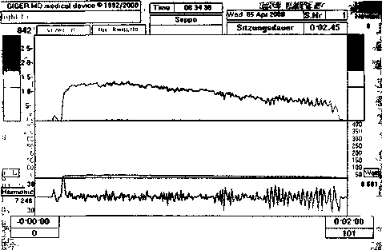
Fig. 1. - Coordination dynamics recording from a patient with a spinal cord lesion sub C4/5 during exercise on a special coor-dination dynamic therapy device at 8 Newton, lever length 8 cm. Upper trace: frequency (f), lower trace: coordination dynamics ((Δ(df/dt)/f). Note the rhythmic changes of the coordination dynamics towards the end of the 2 mm recording. At the end of the recording the patient's right hand slipped from the lever and the turning stopped.
blies (for example, premotor spinal oscillators) can macroscopically partly be quantified by the accuracy of coordination between arm and leg movements (11-13). The coordinated firing with respect to phase and frequency (4-9) (and space) of single neurons and neuron assemblies gives rise to coordinated movements between arms and legs with respect to phase and frequency. When turning on a special device (leaver length = 8cm) where the coordination between arms and legs is determined by the instru-ment, the quality of macroscopic CNS organization is measured by the arrhythmicity of turning (Δ(df/dt)/f)), i.e. by the motor control the CNS is able to generate. When the rhythmicity of turning is good the coordination dynamics value is small whereas if the rhythmicity of turning is poor (the arrhythmicity is large), a high value of coordination dynamic is obtained. With increasing load, quanti-fied by the force (up to 200Newton) which is needed to turn the levers, the coordination dynamics increase both in healthy subjects and in patients.
The coordination dynamics therapy rests on the measurements that following CNS injury the phase and frequency coordination (5, 7, 8) of neuron firing is impaired (6, 9). With the re-learning (or improve-ment) of phase and frequency coordination of neu-ron firings in the CNS, induced by the arm and leg
movement stimulated coordinated re-afferent nat-ural input patterns, many CNS organizational states reappear. A structural repair, including neurogenesis (1, 3), is believed to be induced by pushing the patient to his/her limits (high numbers of coordinated move-ments performed every day) and by exercising automatisms like creeping, crawling, walking and running, which are believed to get genetic support for repair.
Results
Values of high-load coordinaton dynamics were measured in 7 athletes, 17 physiotherapists, 7 gym-nasts and 10 musicians for forward turning, during exercise on a special coordination dynamics therapy and recording device. With the exception of the groups of athletes all the subjects were female. The subjects were the same as those subjected to earlier measurements of low-load coordination dynamics (16). Typical recordings are shown in Fig. 2. The layout of the measurements is shown in Fig. 2A, C. The subjects were turning continuously in the for-ward direction, and the load was increased every 2min from 20 to 200N and then decreased to 20N again. A time window of 1 min was scrolled through the 18min stored record to look for the best part of the coordination dynamics (smallest arrhythmicity of turning) for each increasing and decreasing load step. When plotting the coordination dynamics val-ues against the load of exercising hysteresis-like curves were obtained (Figs. 3, 5, 6).
High-load coordination dynamics in healthy subjects
In Fig. 2A, B good high-load coordination dynamics for forward turning are shown for a female track and field athlete. The frequency of turning slightly increased with the increasing load. The value of the coordination dynamics at 200N (Fig. 2B) was higher (12.5) than that at 20N (6.1). Rhythmicity of turning showed noise-like variations and no system-atic differences between pace (P) and trot gait coor-dinations (K) on the one hand and intermediate coor-dinations on the other one can be seen. The CNS functioning of this female athlete was well balanced, because the CNS was able to generate coordinated

355

arm and leg movements also for the difficult inter-mediate coordinations for high load. The author G.S. (male) has values of high-load coordination dynamics similar to those shown in Fig. 2A, B; his low-load coordination dynamics values were used earlier as reference values.
In Fig. 2C, D the high-load coordination dynamics are shown for a male decathlon athlete. The athlete was responding to load increase with increased turning frequency (Fig. 3C), which seems to be typ-ical of athletes. As the frequency trace in Fig. 2D suggests, the athlete had some coordination prob-lems for the intermediate coordinations (between P and K) at 200N.
Physiotherapists, gymnasts and musicians responded typically to load increases with a transient decrease of the frequency of turning (load-escape, Fig. 2E, G, I). For the high load of 200N not only the numerical coordination dynamics values were higher (approximately 40, Fig. 2F, H, K) instead of 12.5 (B) or 7.7 (D), but typically all the subjects encountered significant problems at intermediate coordinations. The value of coordination dynamics increased and the frequency of turning decreased for the difficult intermediate coordinations, giving rise to rhythmic changes in the frequency and the coordination dynamics (Fig. 2F, H, K). At relatively low loads (20 to 100N), most physiotherapists, gym-nasts and musicians could turn well in forward direc-tion for all coordinations. But at high loads (150 and 200N) they had big problems to move arms and legs in coordination for the difficult intermediate coor-dinations. Since the activated muscles are approxi-mately the same for all coordinations, the coordina-tion dynamics increase in the healthy subjects mainly originated in the poor CNS organization for high load (for further reasoning see discussion).
Coordination dynamics for load increase and decrease - exhaustion and improvement in the short-term memory in healthy subjects
When plotting the coordination dynamics values in dependence on load increase / decrease, hystere-sis-like curves were obtained for single subjects (Fig. 3A-M) and groups of athletes, physiotherapists, gymnasts and musicians (Fig. 3N-Q).
If the curve for decreasing load (dashed line) was above the curve for increasing load (solid line) (Fig. 31), the CNS of the subject was exhausted after exercising at high load. If the curve was below, then the CNS of the subject (or group of subjects) improved in its functioning in the short-term mem-ory (Fig. 3B, G, M). If the curve for decreasing load was first above and then below the curve for increas-ing load (Fig. 3E, N), then the CNS changed from exhausted to a better functioning status in the short-term memory.
As Figure 3 shows, the coordination dynamics for increasing and decreasing load showed more intra-group (Fig. 3A-M) than inter-group variations (Fig. 3O-Q). The group hysteresis-like curve for the athletes had a smaller slope than those for physio-therapists, gymnasts and musicians, which means that the athletes were able to coordinate their arm and leg movements much better for high loads. An athlete (rower, Fig. 31) had a well functioning CNS as suggested by the small coordination dynamics increase with the load increase, but after exercising at high loads his CNS became exhausted as suggested by the worse values of coordination dynamics mea-sured at the subsequent load decrease. The CNS of a gymnast (Fig. 3G) and a musician (Fig. 3M) was not functioning well for high loads, since the coor-dination dynamics values increased quite a lot upon

Fig. 2. - High-load coordination dynamics recordings for a well and balanced functioning CNS of a female athlete (A, B), a male athlete (C, D), a physiotherapist (E, F), a gymnast (G, H) and a musician (I,K). In the recordings A through K, the upper traces represent frequency of turning, the middle traces show load changes in Watt, and the lower traces show the coordination dynamics. In A, C, E, G, I, the whole record of 18min duration is shown during force changes in steps from 20 to 200N and backwards, and in B, D, F, H, K, a time window of 1min is shown when the load was approximately 200N (P and K are the pace and trot gait coordination positions). Note that for force changes between 20 and 200N the power in Watt changed stepwise in athletes and persons with a well functioning CNS (A, C), but not in physiotherapists, gymnasts and musicians who showed a transient frequency reduction. Note further that for the load of 200N physiotherapists, gymnasts and musicians could exercise quite well on the special coordination dynamics therapy device for the easy coordinations pace and trot gait but not for the difficult intermediate coordinations; the frequency of turning decreased strongly and the coordination dynamics increased strongly (worsened) for the intermediate coordinations, which means that the proband's CNS had serious problems to organize the motor control for the difficult intermediate coordinations between arms and legs for high load.
356

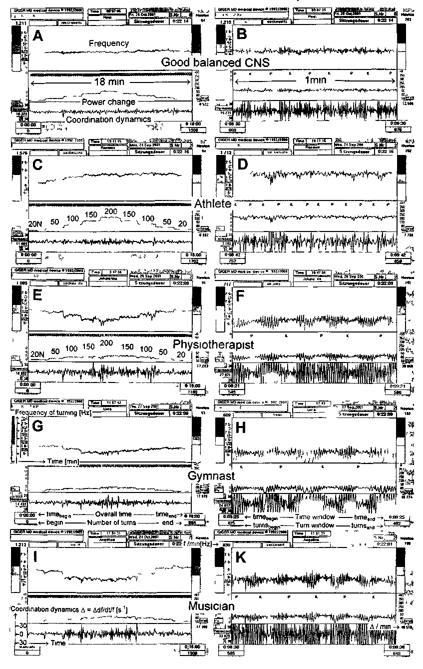
357

load increases. Physiotherapists, gymnasts and musi-cians had mostly better (smaller) values of coordi-nation dynamics for decreasing load than for increas-ing load (Fig. 3B, D, G, M), which means that their CNS was functioning better after having exercised at high loads.
The mean coordination dynamics of all groups showed similar behaviour for increasing and decreas-ing load. For the group of athletes (Fig. 3N), the mean values of coordination dynamics were in gen-eral better for high loads than they were for the other groups (Fig. 3O, P, Q); their coordination dynamics did not increase so much upon increasing load. The mean numerical high-load coordination dynamic val-ues for load increase and decrease (∑Δ = 1/9 (Δ (20N) +...+ Δ(200N) +...+ Δ(20N)) also showed that the athletes could turn more coordinatedly (∑Δ = 8.1) than physiotherapists (13.7), gymnasts (15.8) and musicians (15.4).
High-load coordination dynamics in patients with CNS injury
High-load coordination dynamics recordings for two patients with a spinal cord injury and one with multiple sclerosis are shown in Fig. 4. In Fig. 4C the overall high-load coordination dynamics are shown of a male 29-year-old patient with a complete spinal cord injury sub L3 after 7 months of coordination dynamic therapy. The frequency of turning did not decrease for increasing load and there was no load escape (frequency reduction at increasing load). The coordination dynamics for increasing and decreasing load were as good as those of the female track and field athlete in Fig. 2A, who showed nearly ideal val-ues. The coordination dynamics value for 143N was 4.76 (Fig. 4D). At that time however, he could only manage approximately 150N as the highest load. Three weeks earlier the patient could not manage well 150N (Fig. 4A): the frequency decreased for the high load which means that the load curve in Watt (middle trace in Fig. 4A) became deformed and did
not show the nicely stepwise shape as in Fig. 4C. Also the coordination dynamics values for the high-est load (145N) were much higher (A = 8.06) than 3 weeks later (Δ = 4.76). With further coordination dynamics therapy, i.e. with further CNS improve-ment, the patient could finally also manage the 200N load step, first with poor (after 8 and 9 months of therapy, Fig. 6A, a, b) and then with good coordi-nation (after 10 months) (Fig. 6A, c).
In Fig. 4E, F high-load coordination dynamics are shown of a 28-year-old patient with a spinal cord injury sub C5. This patient could just manage 150N but could perform for less than 2min. The patient turned in backward direction because it was easier for him. The frequency for backward turning decreased for the high loads (load escape and exhaustion). For the load change from 50 to 100N the frequency of turning decreased, the frequency variation increased and the coordination dynamics value strongly increased (Fig. 4F). In the 1min time window of load change the coordination dynamics value was 24.4 1/s.
The high-load coordination dynamics of a 47-year-old patient with severe multiple sclerosis (MS) are shown in Fig. 4G-K. The highest load this MS patient could manage after 2 months of coor-dination dynamics therapy was 50N (Fig. 4G, I). At the beginning of therapy the patient could only man-age approximately 20N. At low load (8N) the coor-dination dynamics value was 6.8 (Fig. 4H), at 51N it was 26.0 (Fig. 41), and after force reduction to 7N it reached 5.9 (Fig. 4K). Of importance with respect to this high-load coordination dynamics recording is that at the beginning and at the end of the mea-surements (Figs. 4H and 4K) the patient could turn well for the trot gait coordination (K, arrhythmicity small) but not for the pace gait coordination (P, arrhythmicity large). But when exercising at 51N (Fig. 41), the best rhythmicity of turning was between pace and trot gait coordination. This means for this MS patient that the more integratively activated CNS (when turning at high load) showed a different CNS organization than the less integratively activated

Fig. 3. - Coordination dynamics in dependence on load increase (solid line) and decrease (dashed line) in athletes, physiotherapists, gymnasts, musicians (A-Q) and patients with spinal cord injury and multiple sclerosis (R, S, T). In A through M and R through T, hysteresis-like curves for single subjects, and in N through Q curves of the mean values of coordination dynamics are shown. Note the bigger intra-group (A-M) than inter-group (N-Q) variations of the hysteresis like curves.
358

Coordination dynamics between arms and legs in dependence on load increase and decrease
359
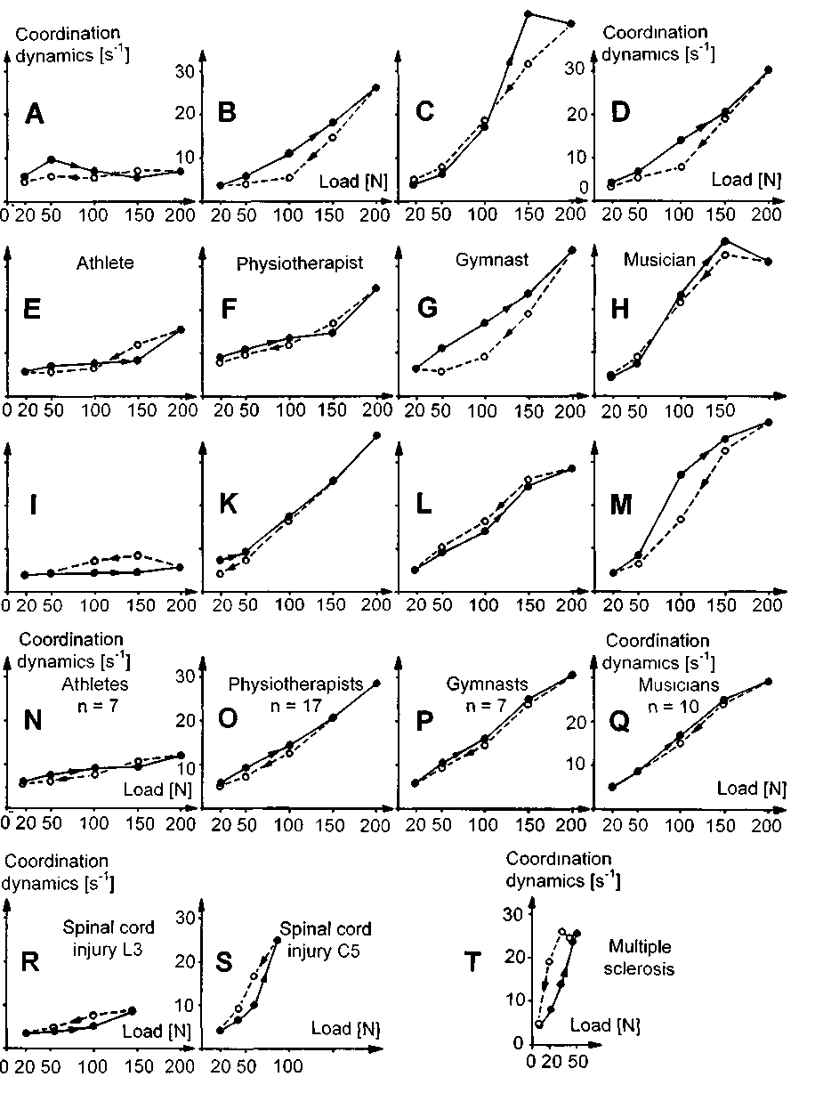

CNS (when turning at low load). Further, it seems to be typical of MS patients that they have problems to turn at higher loads (see discussion).
In conclusion, the high-load coordination dynam-ics can measure the CNS organization quality level (coordination dynamics value) in the load level the patient can reach.
Coordination dynamics for load increase
and decrease - exhaustion and improvement
in the short-term memory in patients with CNS injury
Fig. 3R-T shows hysteresis-like plottings of the coordination dynamics for patients for load increase and decrease. The high-load coordination dynamics of the patient with the spinal cord injury sub L3 (Fig. 3R) was similar to that of the athlete (rower) (Fig. 31). But the former could only manage 150N instead of 200N at that time. After high-load turning he was exhausted similarly as the athlete (Fig. 31), because his coordination dynamics were worse (higher) for decreasing load. This patient used to be an athlete before the spinal cord injury. The high-load coordination dynamics in the patient with the spinal cord injury sub C5 showed a strong increase with load increase and was worse upon load reducion (Fig. 3S). This means that the patient's CNS showed very poor organization for higher loads (see also Fig. 4F) and his CNS and body were exhausted after high-load turning, as there were no rhythmic changes in the high-load coordination dynamics.
The coordination dynamics hysteresis curve for the patient with MS showed a very strong increase with load increase (Fig. 3T), and the highest load the patient could manage was SON. The load decrease
revealed strong exhaustion (load decrease curve above the load increase curve) mainly of the CNS, since for some coordinations between pace (P) and trot gait (K) the arrhythmicity of turning was small (Fig. 41).
Low intensity motor learning in healthy subjects
Coordination dynamics therapy is a learning method to re-learn or improve the impaired relative phase and frequency coordination between the fir-ings of CNS neurons and to re-learn or improve coordinated movements. It is therefore of importance to know whether the improved coordination dynamics after exercising were only a result of learning in the short-term memory, lasting for a few minutes up to a few hours, or whether the motor performance improvements were kept for longer.
In an athlete, a physiotherapist and a musician (piano player), the high-load coordination dynamics measurements (and training at the time, approxi-mately 3,500 times turnings per session) were repeated approximately every 16 days (Fig. 5). The coordination dynamics improved quickly by very approximately 36% after two sessions. But after 2 to 3 repeated measurements and exercises the coordi-nation dynamics changed only little further (Fig. 5) as if with this intensity of exercising the maximum improvement of CNS organization was achieved.
Low-intensity motor learning in patients with CNS injury
In patients with severe CNS injury there was no substantial longer lasting CNS improvement observed so far with low intensity motor learning.

Fig. 4. - High-load coordination dynamics recordings for a patient with a spinal cord injury sub L3 (A-D), a patient with a spinal cord injury sub C5 (E,F), and a patient with multiple sclerosis (G-K). A-D and G-K, forward turning and E, F backward turning. A, C, E, G, I - overall recording traces; B, D, F, H, K - time window traces of 1min. Upper traces - frequency, middle traces - power in watt (stepwise increasing and decreasing in A, C, E, G) and lower traces - coordination dynamics (Δ(df/dt)/f = A). A. Stepwise load increases and decreases from 20N to 150N and backwards. For high loads, the frequency of turning decreases transiently; the patient with the spinal cord injury cannot manage the high load (load escape). B. For the high load (145N) the coordination dynamics slightly increase for the intermediate coordinations. C. After 3 weeks of further coordination dynamics therapy, the frequency of turning does not decrease for the high load any more (no load escape). D. The frequency and the coordinaton dynamics do not vary very much for the different coordinations between arms and legs including the difficult intermediate coordinations. E. Load increases and decreases between 20 and 150 Newton for backward turning with load escape. F. Decrease of the frequency and increase of the coordination dynamics upon load-increasing from 50 to 100N. G. The patient with multiple sclerosis can only manage a maximum load of SON. H, I, K. Coordination dynamics and frequency of turning at the start of the high-load test (H), for the highest load of 51N (I) and at the end (K).
360

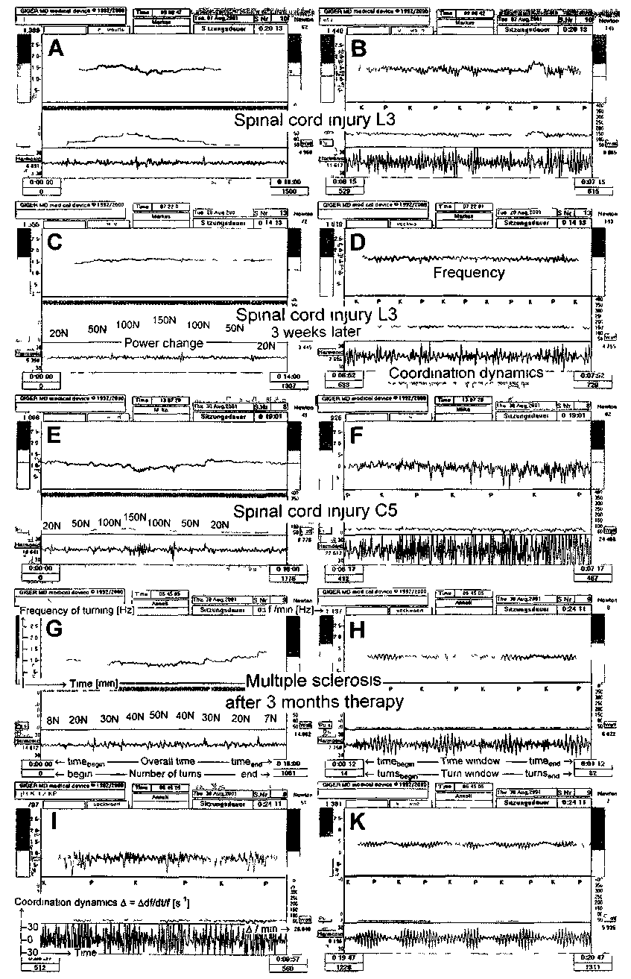
361

High-intensity motor learning in patients
with CNS injury
High-load coordination dynamics were measured in a patient with a spinal cord injury sub L3 with ongoing intensive coordination dynamics therapy. After 7 months of therapy the high-load coordina-tion dynamics were good for the maximum force of 150N (Fig. 4C, D). The patient was not able to turn at 200N. After 8 months of therapy, the patient was able to turn on the special coordination dynamic therapy and recording device also at 200N, but the coordination dynamics were poor and he was strongly exhausted after the high-load test (Fig. 6Aa, coordination dynamics values for load decrease were strongly above those for load increase). After 9 months the coordination dynamics were still poor but the patient was not as much exhausted any more (Fig. 6Ab, ∑Δ = 11% better). After 10 months of continuous coordination dynamic therapy his high-load (and low-load) coordination dynamics were very good and he was not exhausted any more (Fig. 6Ac). The motor performance improved dra-matically between months 9 and 10 of therapy, by ∑Δ = 71%.
In the patient with multiple sclerosis the high-load coordination dynamics improved between month 2 and 3 of therapy by ∑Δ = 10%, shown in the patient being no more exhausted (Fig. 6B). The improvements were much smaller with respect to the coordination dynamics values and the maximum load managed compared to the patient with the spinal cord injury (Fig. 6A). But the quality of the patient's life substantially improved by the increase of the coordinated volitional power up to SON and less exhaustion after 3 months of coordination dynamics therapy. She became able to walk with the rolator instead of being always in the wheelchair and she became able to prepare her meals by herself and eat them without assistance.
Discussion
Exhaustion and improvement of the CNS in the short-term memory.
By measuring the coordination dynamics for load increases and decreases it became possible to mea-
sure physical performance and fitness. If in hysteresis-like curves (Figs. 3, 5, 6) the numerical coordination dynamics were worse (bigger) for load decrease than for load increase then the body (CNS, circulation, muscles, ...) became exhausted with the high-load exercising, and if the coordination dynamics became better (smaller) then after exercising the body worked better in the short-term memory.
If in addition to the increase of the numerical coordination dynamics the high-load coordination dynamics were small for certain coordinations and large for other ones (rhythmic changes in the coor-dination dynamics like in Fig. 2F, H, K; Fig. 4H, I, K) then the exhaustion mainly originated in the CNS. Because the activated muscles were mainly the same for all different coordinations between arms and legs and since for some certain coordinations
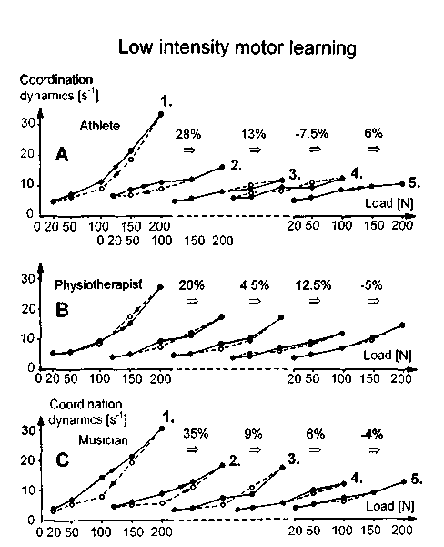
Fig. 5. - Improvement of high-load coordination dynamics due to 5 times (1 to 5) repeated (low- and) high-load coordination dynamics testing and exercising (low-intensity motor learning) in an athlete, a physiotherapist and a musician (all female). The mean time interval between 2 sessions was 16 days and the number of turns per session was approximately 3,500. The solid line represents load increases and the dashed line load decreases at the hysteresis-like curves. The percentage values indicate improvement in the high-load coordination dynamics (sum of all load steps = ∑Δ).

362

the coordination dynamics had small values the mus-cles were not exhausted. The hysteresis-like curves in combination with the recordings for high loads provide us therefore with the information whether the whole body or mainly the CNS became exhausted. The CNS of the patient with the spinal cord injury sub C5 showed exhaustion upon high-load testing (Fig. 3S), but the high-load coordination dynamics did not show much change of the coordi-nation dynamics with the changing coordinations (Fig. 4F, no or only little rhythmic changes). This patient was thus more exhausted in general after the
High-intensity motor learning
Fig. 6. - A. High-load coordination dynamics in a 27-year-old patient with a complete spinal cord injury sub L3 after 8 (a), 9 (b) and 10 months (c) of high-intensity coordination dynamics therapy (the solid line represents force increases up to 200N and the dashed line represents load decreases). The percentages indicate improvement in high-load coordination dynamics (sum of all load steps). No load scale shown in Ab. Note that after 8 months of therapy the coordination dymamics hysteresis curve suggests a very exhausted CNS (a, dashed line markedly above the solid line), after 9 months a reduced exhaustion (b) and after 10 months nearly no exhaustion. Between months 9 and 10 of therapy the high-load coordination dynamics improved dramat-ically (by 71%). B. High-load coordination dynamics in a 48-year-old patient with multiple sclerosis after 2 (a) and 3 (b) months of high-intensity coordination dynamics therapy. Even though the high-load coordination dynamics at 50N are approximately the same, the summed high-load coordination dynamics (∑Δ) improved by 10%, since there was no exhaustion after high-load turning (b).
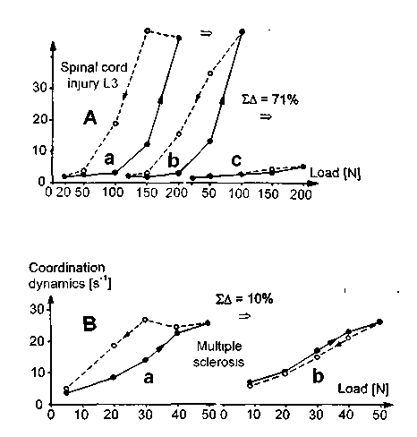
exercise. The patient with multiple sclerosis showed strong exhaustion in the hysteresis-like curve (Fig. 3T). But in the recordings for high and low load (Fig. 4H, I, K) strong rhythmic changes of the amplitude of arrhythmicity of turning (coordination dynamics) can be seen. This means that the patient was able to turn well for certain coordinations and less well for other coordinations. The muscles were thus not exhausted. The problems of coordinated arm and leg movements were thus mainly coming from the CNS. It is known that multiple sclerosis is a CNS disease rather than muscle disease. During the second (Fig. 6Ba) to the third months of coor-dination dynamics therapy (Fig. 6Bb) the exhaus-tion disappeared in the MS patient indicating an improvement in the CNS functioning.
Hysteresis-like plots of the coordination dynam-ics for load increases and decreases in combination with the recordings for high loads provide informa-tion whether it is mainly the CNS or the whole body that becomes exhausted upon high-load exercise.
Good coordination between arm and leg movements for high load is necessary for walking
In Fig. 3N-Q it can be seen that the coordina-tion between arm and leg movements for high load was better in athletes than in physiotherpists, gym-nasts and musicians. It was shown earlier that the low-load coordination dynamics were best in the musicians (16). These results are likely, because the athletes exercise mainly under high load (running, jumping) whereas the musicians exercise more under low load (playing violin or piano). It follows there-fore, that we have to exercise the coordination between trunk, legs, feet, arms, hand and fingers also for the load we need for every day life. Since the body weight has to be carried during walking, the patients have to exercise the coordination between arms, legs and trunk also for high load to re-learn walking.
Different CNS organizations for low-load and high-load exercise
It can be seen from Fig. 4H that the patient with multiple sclerosis could turn most rhythmically for low load (8N) at the trot gait (K) coordination. The

363

amplitude of arrhythmicity was smallest at the trot gait (K) coordination. For the high load of 51N the best coordination (smallest amplitude of arrhyth-micity) was between pace (P) and trot gait (K). This means that the CNS organization in this patient was different for high and low loads. Since for high-load exercising more muscle parts and more muscle fibres are activated and upstream more motoneurons and their subneural networks, the high-load exercising is a more integrative activation of the CNS.
During coordination dynamics therapy the neural networks of the CNS have to re-learn the impaired phase and frequency coordination (6, 9) more in gen-eral and especially in the injured neural networks. But the neural networks can only learn if they are substantially activated. The same argument follows also from neurogenesis; neurogenesis took place only in substantially activated parts of the CNS (1, 3, 10). A more integrative neural network activation is asso-ciated with a greater probability that also the sub-stantially injured subneural networks get activated. Best for the therapy is to activate many not injured networks simultaneously with a few injured ones, so that during integrative CNS organization the injured networks learn from the healthy ones and not vice versa. In a stroke patient the impaired side has to be activated in addition to the healthy side. In a patient with a spinal cord injury in the thoracic spinal cord, the legs have to be made move in coordination with the arms. Repeated separate activation of an arm, a leg or a finger is (1) too little an integrative activa-tion of the CNS, (2) such therapy will not repair the CNS in general, (3) and such therapy will have a low efficiency of repair because subnetworks of the CNS are less often activated.
Need for long-lasting, intensive coordination dynamic therapy
The so far best low-load and high-load coordina-tion dynamics were achieved in a 29-year-old patient with a spinal cord injury sub L3. After 10 months of intensive coordination dynamics therapy his high-load coordination dynamics (∑Δ = 2.8, Fig. 6Ac) were better than those of the group of athletes (∑Δ = 8.1, Fig. 3N). On the other hand, in patients with spinal cord injuries no improvement could be observed when they exercised again after a period of 3 months
(healthy subjects would most likely improve, see below), and they got worse by 14% if they stopped after an intensive therapy (15). For a repair of the spinal cord and other CNS injuries an intensive, long lasting and efficient therapy seems to be necessary.
An athlete, a physiotherapist and a musician exer-cised on the special coordination dynamics therapy device at a low intensity (7,000 coordinated arm and leg movements per month). In the first month they improved strongly (by 36%), while only little progress was achieved with further exercising subsequently. Patients with CNS injury would improve only very little or not at all (depending on the severity of their injury) with low intensity motor learning (see above). Patients with stroke or traumatic brain injury improved by 70% during 3 months of coordination dynamics therapy (13, 14) including 350,000 coor-dinated arm and leg movements per month. Patients with spinal cord injury improved by 42% (15). The rate of learning in patients with CNS injury is therefore very approximately lower by a factor of 50 (7,000 • 50 = 350,000).
The patient with the complete spinal cord injury sub L3 (Figs. 4A-D. 6A) started to improve strongly with respect to the high-load coordination dynamics after 6 months of intensive therapy, and after 10 months he had better high-load (and low-load (16)) coordination dynamics (Fig. 6A) than the athletes (see above). This indicates that long-lasting therapies are needed.
Simple gymnastics and stretching are helpful to prevent tendons from shortening, joints from stiff-ening, and to make the body mobilized; they how-ever are only of little help with respect to the repair of the severely injured CNS.
The physiotherapists and the gymnasts had poor high-load coordination dynamics in comparison to those of the athletes (Fig. 3N,O,P). For an improve-ment of the coordination dynamics, i.e. an improve-ment of CNS organization, the type of movements and their performance precision are of importance.
Improvements also in patients with multiple sclerosis
(MS)
It could be shown in the 47-year-old patient with advanced multiple sclerosis that the high-load coor-dination dynamics could be slightly improved, with

364

the consequence that her everyday life improved sub-stantially. Because of becoming exhausted after high-load exercise, she usually exercised in the evening.
The argument that MS patients should not exer-cise under high loads, because they are getting too much exhausted is not in accordance with the progress in this patient achieved by coordination dynamics therapy including higher-load exercise. Another patient with advanced MS also improved with coordinaton dynamics therapy including the continence: she developed the feeling of the urge to void earlier and became thus able to be continent and to empty the bladder on volition.
References
1. eriksson, P.S., perfilieva, E., bjork-eriksson, T., alborn, A.M., nordborg, C., peterson D.A. and gage, F.H.: Neurogenesis in the adult human hippocampus. Nature Medicine. 4: 1313-1317, 1998.
2. kelso, J.A.S.: Dynamic Patterns. The Self-Organization of Brain and Behavior. MIT Press, Cambridge, 1995.
3. praag, van H., kempermann, G., gage H.: Running increases cell proliferation and neurogenesis in the adult mouse dentate gyrus. Nature Neurosci., 2(3): 266-270, 1999.
4. SCHAlow, G: Conduction velocities and nerve fibre diameters of touch, pain, urinary bladder and anal canal afferents and α and γ-motoneurons in human dorsal sacral nerve roots. Electromyogr. din. Neurophysiol., 31: 265-296, 1991.
5. schalow, G.: Oscillatory firing of single human sphincteric α₂ and α₃-motoneurons reflexly activated for the continence of urinary bladder and rectum. Restoration of bladder function in paraplegia. Electromyogr din. Neurophysiol., 31: 323-355, 1991.
6. schalow, G.: Spinal oscillators in man under normal and pathologic conditions. Electromyogr. din. Neurophysiol.. 33: 409-426, 1993.
7. schalow, G.: Phase-correlated adequate afferent action potentials as a drive of human spinal oscillators. Electro-myogr. din. Neurophysiol., 33: 465-476, 1993.
8. schalow, G: Action potential patterns of intrafusal γ and parasympathetic motoneurons, secondary muscle spindle afferents and an oscillatory firing α₂-motoneuron, and the phase relations among them in humans. Electromyogr. clin. Neurophysiol., 33: 477-503, 1993.
9. schalow, G. and zach, G.A.: External loops of human premotor spinal oscillators identified by simultaneous measurements of interspike intervals and phase relations. Gen. Physiol Biophys., 15 (Suppl. 1): 95-119, 1996.
10. schalow, G. and zach, G.A.: Reorganization of the Human CNS, Neurophysiologic measurements on the coordination dynamics of the lesioned human brain and spinal cord. Theory for modern neurorehabihtation (31 case reports). Gen. Physiol. Biophys., 19 (Suppl. 1): 1-244. 2000.
11. schalow. G.: On-line measurement of human CNS organi-zation. Electromyogr. dm. Neurophysiol., 41: 225-242, 2001.
12. schalow, G.: Time axis calibration in human CNS organization for judging dysfunction. Electromyogr. din. Neurophysiol, 41:485-505.2001.
13. schalow. G.: Stroke recovery induced by coordination dynamic therapy and quantified by the coordination dynamics recording method. Electromyogr. Clin. Neurophysiol., 42: 85-104. 2002
14. schalow. G.: Improvement after traumatic brain injury achieved by coordination dynamic therapy. Electromyogr. din. Neurophysiol., 42: 195-203, 2002.
15. schalow, G.: Recovery from spinal cord injury achieved by 3 months of coordination dynamic therapy, Electromyogr. din. Neurophysiol, 42: 367-376, 2002.
16. schalow, G and pääsuke, M.: Low-load coordination dynamics in athletes, physiotherapists, gymnasts, musicians and patients with spinal cord injury, after stroke, traumatic brain lesion and with cerebral palsy. Electromyogr. din. Neu-rophysiol, 43:195-201, 2003.
17. swinnen, S.P.: Intermanual coordination: From behavioural principles to neural-network interactions. Nature Reviews / Neuroscience 3: 350-361, 2002.
18. varela, F., lachaux, J.-P, rodriguez, E. and martinerie, J.: The brainweb: Phase synchronization and large-scale integration. Nature Reviews/Neuroscience, 2: 229-239, 2001.
19. zanone, P.O. and kelso, J.A.S.: Coordination dynamics of learning and transfer: collective and component levels. J.Exper. Psychol.: Human Perception and Performance, 23: 1454-1480. 1997.
Address reprint requests to:
Giselher Schalow
Dr. med. habil. Dr. rer. nat., Dipl. Ing.
Untere Kirchmatte 6
CH-6207 Nottwil
Switzerland
www.cdt.host.sk

365

