Coordination dynamics in Parkinson's disease patients
and healthy subjects quantified by the coordination dynamics
recording method and sEMG
G. Schalow, M. Pääsuke, J. Ereline, H. Gapeyeva
Abstract
Coordination dynamics were measured in Parkinson's disease patients to quantify central nervous system (CNS) dysfunction. The low-load coordination dynamics in the patients were impaired by 56% for forward and 44% for backward moving in comparison to a control group of similar age. Exercising at higher load was only partly possible. When the disease preferentially affected one side of the body, the coordination dynamics were worse for the affected side. A dexterity test showed that coordination of hand and arm movements could be improved in the short-term memory when exercising on the special coordination dynamics recording and therapy device. Simultaneously taken surface EMG (sEMG) showed that the motor pattern was impaired in the Parkinson's disease patients. sEMG recordings showed further that the fast fatigable muscle fibre activation was impaired. FF-type muscle fibres were already activated for low load in one and not at all in another muscle. In conclusion, coordination between motoneuron firings and between arm and leg movements were found to be impaired in Parkinson's disease patients.
Key-words: Parkinson's disease - Coordination dynamic - s EMG - Motor program - Muscle fibre tvpes

Introduction
Coordination dynamics therapy has been shown to be able to improve the functioning of the human central nervous system (CNS) after traumatic brain injury (15), stroke (14) and spinal cord injury (16). The improvement of the CNS functioning was partly that substantial that one can speak of a partial cure of the injured CNS (17).
Coordination dynamics therapy is a learning method in which the CNS re-learns the impaired rel-ative phase and frequency coordination for the self-organization of its neuronal networks and re-learns lost or impaired movements. Even though the learn-
Institute of Exercise Biology and Physiotherapy, University of Tartu, 5 Jakobi Street, Tartu 51014, Estonia.
ing of the severely injured CNS is approximately 50 times slowlier than that of a healthy CNS (19), it seems that every CNS, including the malfunctioning one, can learn and re-learn. It should therefore be possible to improve the functioning of the CNS also in neurodegenerative diseases by learning, that means by coordination dynamics therapy.
In two papers it will be shown that in Parkinson's disease the CNS functioning can be measured and improved. This first paper reports on the measure-ment of the CNS functioning using the coordination dynamics recording method and surface electromyo-graphy (sEMG) to quantify CNS malfunctioning. In the second paper it will be shown that a 35% improvement of CNS functioning can be achieved in Parkinson's disease patients by a low intensity coor-dination dynamics therapy for 2.5 months (20).
Parkinson's disease is a complex disorganisation of the human CNS reflecting malfunctioning of the

Electromyogr. din. Neurophysiol, 2003, 43, 473-485.
473

basal ganglia There is a degeneration of neurons in the substantia nigra and a decrease in the dopamine content of the striatum and putamen due to a degen-eration of the nigrostriatal connections (6). This view is supported by the effectiveness of dopamine (L-dopa) therapy (6) The characterising symptoms are tremor, rigidity and cogwheel phenomenon. Akinesia and postural reflex disorders are also present (4, 5) Since rigidity, cogwheel phenomenon, akinesia and postural automatism disorders can often be found in different kinds of brain injuries, the extensive resting tremor seems to be typical for the Parkinson disease. It has been reported earlier (11) that
the tremor frequencies in Parkinson's disease (6-8Hz, 8-12Hz) are in the range of the eigenfrequencies of premotor spinal oscillators (1, 10) Besides muscle-limb mechanical aspects uncontrolled premotor spinal oscillators are likely to substantially con-tributing to the Parkinsomc tremor even though the cause is assumed to be mainly the malfunctioning of the basal ganglia.
Since Parkinson's disease patients have substan-tial coordination problems, as can be observed for example when they change clothes or eat, an analy-ses of CNS dysfunction in the concept of coordi-nation dynamics may be expected to provide further

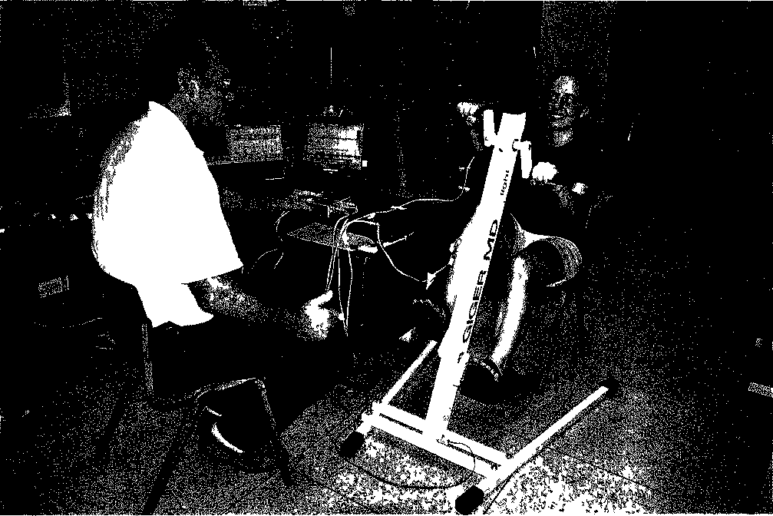
Fig 1 Measuring layout for recording the coordination dynamics by the coordination dynamics recording method and by elec-tromyography. An 18-year-old woman is exercising on the special coordination dynamics therapy device and mechanical coordination dynamics are recorded and displayed on a laptop (the display is showing the frequency and the changing coordination dynamics). Elec-tromyographic activity is recorded from the Mm. tibialis anterior and biceps brachii. Two differential surface electrodes (4cm apart) and one earth electrode (in between) are used for recording from each muscle (they can be seen on the M. tibialis anterior). The electric activity is preamplified (l000x the author GS is touching one preamplifier with the left hand) and displayed on an oscilloscope (Gould 1504). Printer and plotter cannot be seen. Load changes (increase and decrease) are achieved by the author (G.S.) turning a small breaks knob situated close to the 1 of “light” on the device to increase the force from 20 to 200Newton and backwards. The volunteer is only smiling when exercising at lower loads not at 150 and 200N.
474

insight into the Parkinson's disorganisation. It will be shown in this paper that with the recording of the coordination dynamics between arms and leg movements with the coordination dynamics record-ing method and sEMG, especially for low loads, more neurophysiologic knowledge can be obtained on the malfunctioning of the CNS in Parkinson's disease. The understanding of the Parkinson's dis-ease (for references, see 7) within the concept of coordination dynamics will lead to treatment that can result in a substantial improvement of the CNS functioning in Parkinson's disease patients (20).
Method
The organization of the human central nervous system (CNS) can be measured in terms of coordi-nation dynamics (13), i.e. by the arrhythmicity of turning, when a patient or a volunteer exercises on a special coordination dynamics recording and ther-apy device (Fig. 1). The device dictates the patient the exact coordinations pace and trot gait between arms and legs and the difficult intermediate coordi-nations between pace and trot gait. The quality of CNS organisation is quantified by the ability of the CNS to adapt to the changing coordinations between arms and leg movements. If the patient's CNS can adapt its organisation very well, then the patient can turn rhythmically at a steady frequency for all coor-dinations. If the CNS organization is very poor, then the arrhythmicity of turning is large for all coordi-nations, which means that the CNS cannot or can hardly generate complicated movements via the motor program. Patients with brain injury can often turn reasonably rhythmically for the easy coordina-tions pace and trot gait but have problems for the difficult intermediate coordinations, when physio-logic functioning of brain neuronal networks is nec-essary to vary physiologically the neuronal network organisations of the spinal cord. The ability to gen-erate easy and complicated coordinated movements is measured integratively (mechanically) by the arrhythmicity of turning (coordination dynamics A(df/dt)/f [s⁻¹], A/min [s⁻²]) and is measured between different muscles (electrically, not integrative) by surface electromyography (sEMG). Since during the measurement, the patient or volunteer is exercising mostly in the sitting position, muscle activation for
carrying body weight is of only little importance. An increase of the load during exercising therefore (by increasing the brake force from 20 to 200Newton and backwards), in combination with the changing coordinations, provides detailed information about the motor program of healthy subjects and patients with pathologic CNS organisation. The advantage of the mechanical coordination dynamics is that the CNS organisation of these movement states can be easily measured by a single parameter (order para-meter = arrhythmicity of turning) and quantifies the integrative action of all activated muscles. With sEMG information is obtained via the motor unit action potentials on the motor program and on the coordinated firing of neurons in the CNS.
The special coordination dynamics system therapy and recording device© GIGER MD® is a product by: Combo AG, Postfach 146, Tugginerweg 3, CH-4503 Solothurn, Switzerland, Fax +41326219745.
Results
Coordination dynamics were measured in 8 patients in whom Parkinson's disease had set on 5 to 10 years ago, and were compared with the coor-dination dynamics of a control group of similar age to obtain information about the pathologic central nervous system (CNS) organization to develop treat-ment. In a following paper it will be shown that the functioning of the CNS in Parkinson's disease patients can substantially be improved by coordina-tion dynamics therapy. The average age of the patients was 69 years (range 63 to 75 years).
Low-load and high-load coordination dynamics in Parkinson patients and normal subjects
Original recordings of low-load and high-load coordination dynamics of a healthy 72-year-old woman are shown in Fig. 2A-D. The coordination dynamics look similar to those of a subjects in the age range between 18 and 25 years (18, 19). From Fig. 2A it can be directly seen that the CNS of the elderly woman learned quickly the coordinations for the difficult backward turning for low load. Within 5min the variation of the frequency (upper trace) reduced strongly, indicating motor learning, namely

475

the ability to turn at a constant frequency. The coor-dination dynamics in the 1 min time window (Fig. 2B) shows good coordination for the pace gait coordination (P) and poor coordination (big varia-tion) for the trot gait (K). For higher loads up to 150N (Fig. 2C) the frequency reduced. The volun-teer tried to cope with the higher loads by frequency reduction; the load in Watt (middle trace of Fig. 2C) does not show a nice stepwise shape. In the time win-dow for 100N (Fig. 2D) the frequency for forward turning increased for the easy coordinations pace and trot gait and decreased for the difficult intermediate coordinations.
Original recordings of low-load and high-load coordination dynamics of a 73-year-old Parkinson's disease patient are shown in Fig. 2E-H. No princi-pal differences to the healthy subject can be seen. For low load the backward turning also improved (Fig. 2E, upper trace) but may be not as much. The coordination dynamics in the time window for back-ward turning do not show any dependence on pace and trot gait (Fig. 2F, lower trace). In the overall high load recording (Fig. 2G), load escape (decrease of turning frequency with increasing load) can be seen as in most so far measured cases. For forward turning at 100N (Fig. 2H) the frequency increased for the easy pace and trot gait coordination and decreased for the intermediate coordinations between pace and trot gait. Since every CNS is different, the differences in the coordination dynamics between the patient's CNS and those of the control group woman do not allow any conclusions as to the dif-ferences between Parkinson's disease patients and healthy persons.
The numerical values of the coordination dynamics however should reflect differences in CNS orga-nization between physiologic and pathophysiologic cases at least because of the resting tremor in Parkin-son.
The values of low-load coordination dynamics of the Parkinson patients (5 females, 3 males) for low-load forward and backward turning were: Δ_{forward} = Δ(df/dt)/f = 8.4 ± 4.2 s⁻² (mean ± standard deviation) and Δ_{backward} = 16.9 ± 13.2 s⁻². The numer-
ical values of low-load coordination dynamics of the normal subjects of the control group of similar age (4 females, 2 males, mean age = 73) for forward and backward turning were 5.4 ± 2.2 s⁻² and 11.8 ± 8.1 s⁻², respectively. As expected with respect to the degen-eration of substantia nigra, the Parkinson's disease patients had therefore, poorer (higher) low-load coordination dynamics values. But the intra-group differences were larger than the inter-group differ-ences, making improvement measurements (see the following paper) of the coordination dynamics of single cases with ongoing therapy necessary.
Differences occurred for the high-load exercise on the special coordination dynamics therapy device (Fig. 1). The volunteers of the control group were all able to turn up to a load of 150N. Even though 3 subjects had moderate heart problems, no heart problems occurred during 150N high-load exercising! The numerical values of high-load coordination dynamics for increasing loads up to 150N were ∑Δ = Δ(20N) +...+ Δ(150N) +...+ Δ(20N) = 114.1. The Parkinson's disease patients were not able to exercise at loads up to 150 N. Only one of them could reach the load of 150 and another one a load of 100N. In general, the Parkinson's disease patients could develop less power. This result is reasonable: the accuracy of coordination of motor unit firing was more impaired in Parkinson's disease patients, which results via an inefficient CNS organization in reduced power development (see below).
One-sidedness of Parkinson's disease
The possibility that the coordination dynamics are not substantially associated with Parkinson's disease could be ruled out by letting the patients exercise on the special coordination dynamics ther-apy and recording device with both legs but only with one hand. When one side of the body was pref-erentially affected by the disease, also the coordina-tion dynamics were more impaired on that side. In 7 out of the 8 patients the one-sidedness was mea-sured by simply turning with both legs but only with

Fig. 2. - Low-load (A, B. E, F) and high-load mechanical coordination dynamics (C. D, G, H) for a 73-year-old Parkinson's disease patient (E, F, G, H) and a healthy 72-year-old woman (A, B. C, D). The overall recordings are shown on the left panel (A, C, E, G) and time windows of one minute are shown on the right panel (B, D, F, H).
476

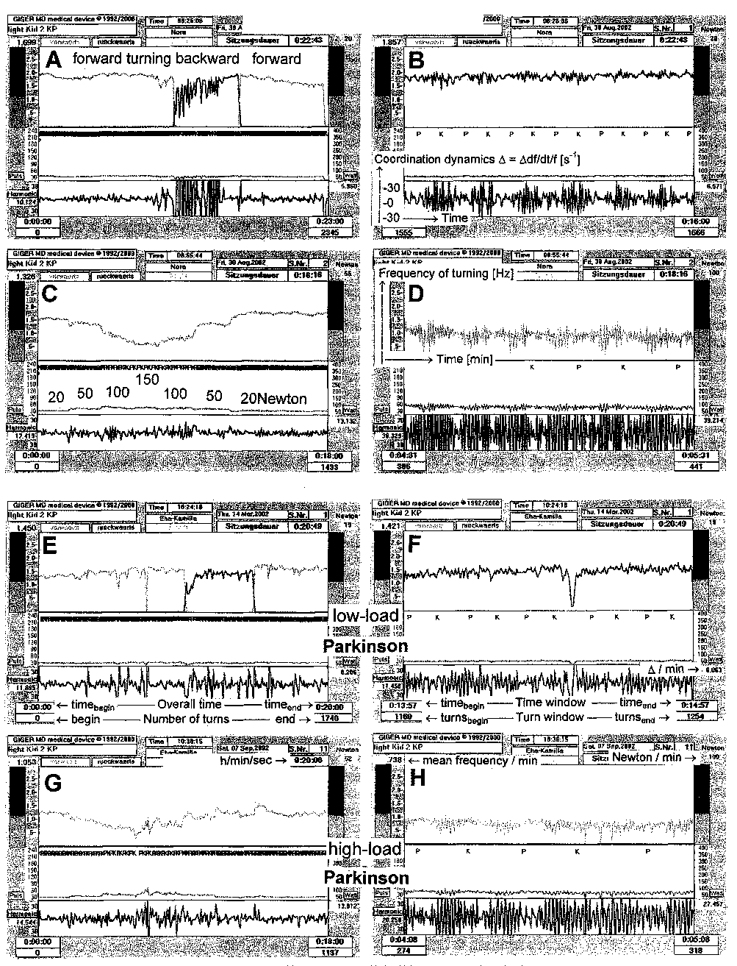
477

the right or left hand. Since Parkinson's disease patients got easily exhausted, the turning with right and left hand was alternated 6 times to take care of the reduction or change in the power of turning; mean values of the coordination dynamics calcu-lated from the 3 times values obtained from turning with the right and the left hand respectively were used for comparison.
Original recordings of the one-sidedness of a Parkinson's disease patient is shown in Fig. 3. In Fig. 3C the coordination dynamics for the hand changing is shown. The patient turned first with the "good" hand, and the frequency of turning was steady and the arrhythmicity of turning was small (the coordination dynamics value was good). After changing to the "bad" hand, the frequency (upper

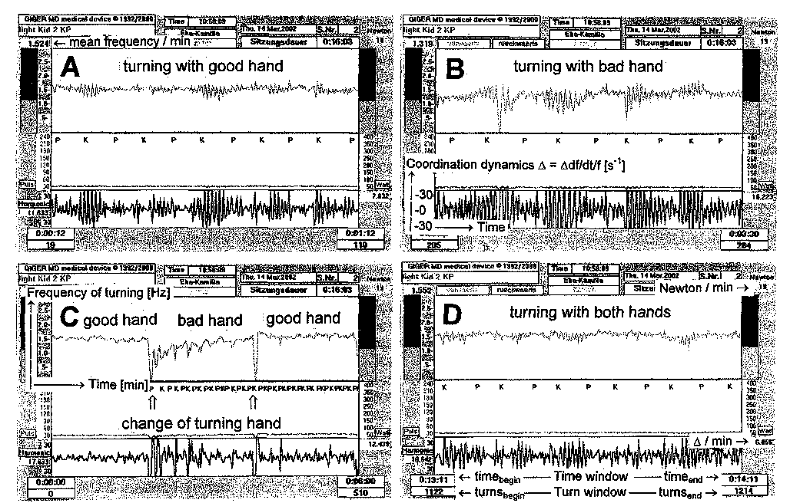
Fig. 3. - One-sidedness of mechanical coordination dynamics in a 73-year-old Parkinson's disease patient exercising on the special coordination dynamic therapy device with both legs but only one hand (alternated). A. Turning with the good hand (less affected side). B. Turning with the bad hand with more resting tremor (worse affected side). C. Part of the overall recording; two hand changes are indicated. D. Coordination dynamics upon exercising with both arms and both legs.
Fig. 4. - Surface electromyographic recordings from M. tibialis anterior and M. biceps brachii of a healthy 18-year-old woman (Fig. 1) for loads increasing from 20 to 200N (A-E) and for high speed turning at 20N (F, recording layout as in Fig. 1). Corresponding mechanical coordination dynamics are given in "G" and "H". Note that the phase "φ" between the muscle activation of the tibialis anterior and the biceps brachii muscles (marked in "B") is changing continuously according to the coordination changes between arms and legs. The calibration 200µV is the voltage at the muscle (at the screen = 1000 x 200µV = 200mV). For the description of "G" and "H", see legend to Fig. 2.
478

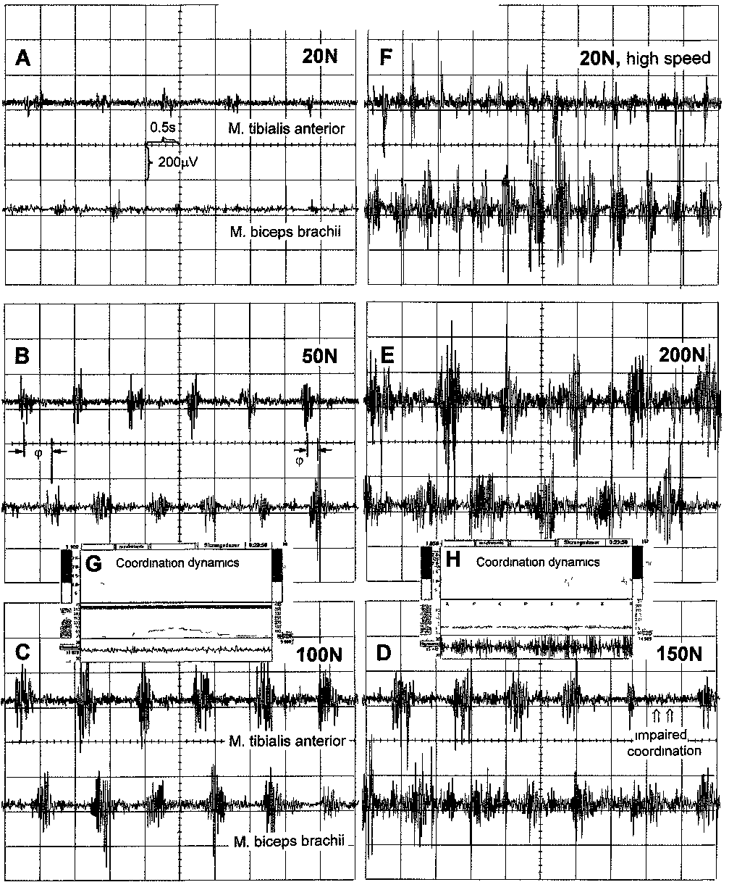
479

trace) got reduced and was changing more, and the arrhythmicity of turning (lower trace) became larger (Fig. 3C). After changing back to the "good" hand again, the frequency stability was becoming better again and the arrhythmicity of turning got smaller. Interestingly, even though the patient was becoming slightly tired (the coordination dynamics got slowly worse with ongoing turning) the turning only with the "bad" hand was still more rhythmical in the short-term memory as can be seen from the increase of the frequency and the reduction of the frequency variation in the upper trace of Fig. 3C. As can be seen from Fig. 3, the turning with the good hand showed better coordination dynamics (Δ = 8.6 s⁻²; Fig. 3A) than with the bad hand (Δ = 16.2 s⁻²; Fig. 3B). After turning with the good and the bad hand 3 times each, the patient turned with both hands (and both legs; Fig. 3D) and the coordination dyna-mics were of course better than when turning only with one hand and both legs (Δ = 6.9 s⁻² in this case). The numerical difference between right and left was 27% ±18% (range 7% to 50%). In two of the 7 measured patients the difference was 7% which means that the Parkinson's disease affected both sides similarly, and in 5 cases the right or the left side was stronger affected by the disease (difference 19% to 50%). The higher (worse) values of coordination dynamics coincided with a larger resting tremor in the patients.
Improvement of hand coordination in the short-term memory quantified by a dexterity test
The resting tremor is impairing the patients' everyday life, e.g. during putting on clothes or dur-ing eating. A dexterity test showed that the hand coordination could be improved during 1 hour coor-dination dynamics therapy. Seven patients under-went dexterity tests (Minnesota Manual Dexterity Tests). The patient had to pick round wooden pieces
from one hole and put them to another one. After warming up for 10 min on the special coordination dynamics therapy device the first tests were per-formed. Then the patients were let to exercise for 1 hour on the special coordination dynamics therapy device again and the tests were repeated. If the CNS would function better after 1 hour of coordination exercises then the patients should be able to change the pieces faster afterwards. It was indeed so. There was an improvement of the dexterity by 4% ±2%. A coordination dynamics therapy might thus be an adequate method to improve the coordination in Parkinson's disease patients.
Electromyography during exercising
on the special coordination dynamics therapy device
To obtain more information on the coordination dynamics in the CNS and its impairment in Parkin-son's disease surface electromyography (sEMG) was performed.
Physiologic sEMG coordination dynamics. Fig. 4 shows the EMG coordination dynamics of a healthy volunteer during exercising on the special coordina-tion dynamics therapy device (Fig. 1). From A through E, the load increases from 20 to 200N. For 20N (A) only little electrical activity of low amplitude could be recorded. With 50 N more activity with higher amplitude occurred (B). The turning frequency was around 1 Hz (Fig. 4G, H). According to the coordination changes between arms and legs the muscle activation of the M. biceps brachii was changing against the activation of the M. tibialis anterior. The phase of coordination change is marked by φ (Fig. 4B). With further load increase the muscle activation got stronger and higher sEMG activity was recorded (C, D, E). Some large single motor unit potentials appeared (Figs. 4E, 5F). For 150 and 200N there was also activity between the single muscle activations appearing, which may have

Fig. 5. - Surface electromyography from arm and leg muscles of a Parkinson's disease patient in comparison to that obtained for the healthy young woman (Figs. 1, 4). In addition to the recordings shown in Fig. 4, also M. quadriceps femoris is measured. A. C. E. Turning at the own speed automatically. B, D. Forced high speed turning at 20N (note the different calibrations in "B"). F,G. Recordings on a faster time scale (10ms/cm) to show triphasic single motor unit potentials. The main amplitude of the triphasic motor unit potentials have opposite direction because of the different direction of transmission or different polarization of the recording electrodes.
480

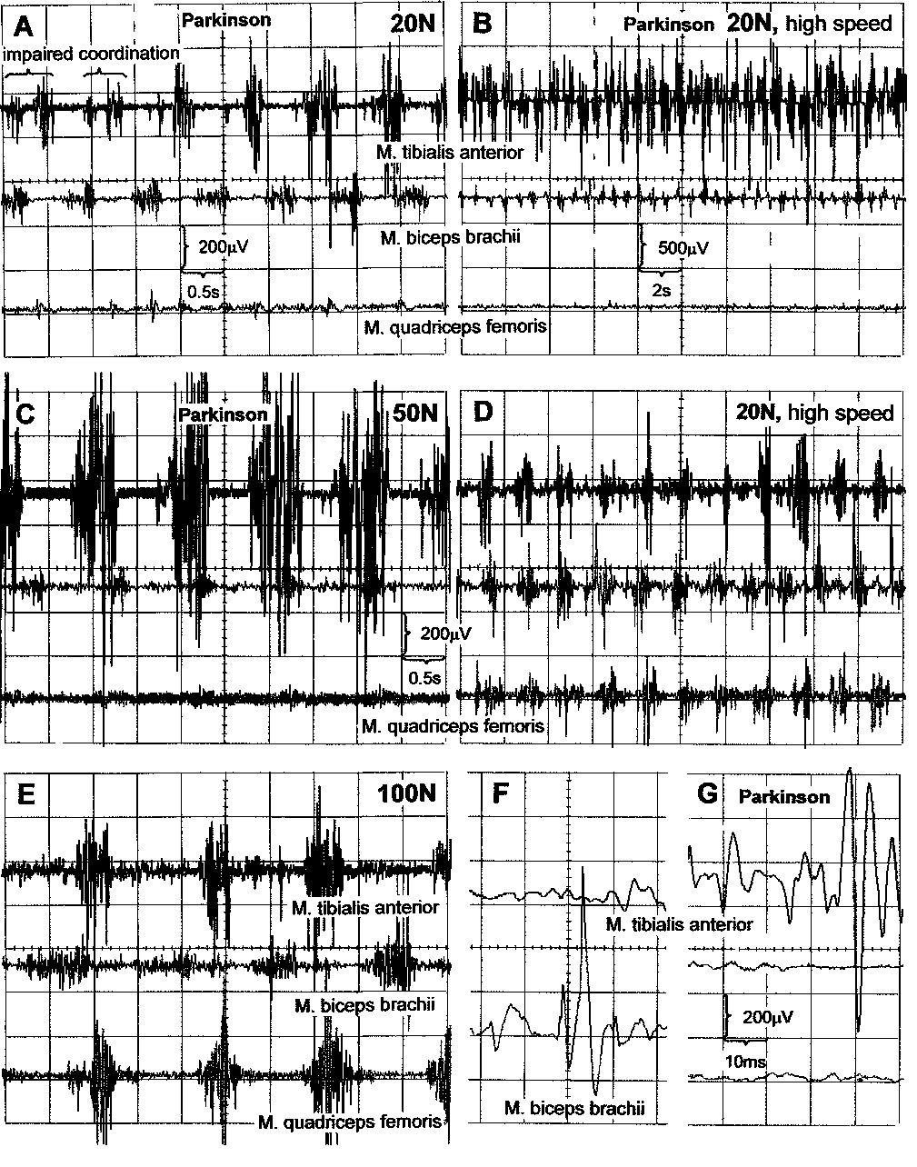
481

been partly physiologic and partly due to a subopti-mal coordination between the motoneurons activat-ing the muscles for high loads (Fig. 4H). An increased cross-talk between the muscles (recorded activity from adjacent muscles because of large electrode dis-tance) probably occurred. But also impaired coor-dination of the whole muscle activation could be observed in this healthy volunteer (Fig. 4D, tibialis anterior trace). The time period between the marked two muscle activations in Fig. 4D was too long. Thus, suboptimal coordination, which was observed in the mechanical coordination dynamics of healthy young (Fig. 4H) and elderly volunteers (Fig. 2A-D) can also be observed in sEMG coordination dynamics.
Activation of large motor unit action potentials by high speed turning. For the low load of 20N, only little activity of low amplitude was recorded (Fig. 4A). For low-load 20N high-speed turning (approx. 2Hz) much higher activity was registered including large motor unit potentials (Fig. 4F). Thus also the fast motor unit potentials are activated for fast turning. By turning at different loads (measured in Newton) and different speeds (frequency) different muscle fibres (slow, fast fatigue-resistant, fast fatigable) can be activated as can be upstream the motoneurons (α₃, α₂, and α₁-motoneurons; see Fig. 4 of Ref. 13) activating these different muscle fibres, and further upstream the premotor neuronal networks activating these different motoneurons (as, e.g. the different frequencies of oscillatory firing networks). Still fur-ther upstream supraspinal centres (including the sub-stantia nigra, subject to degeneration in Parkinson's disease) are activated, varying premotor neuronal networks.
sEMG coordination dynamics in Parkinson's disease. In Fig. 5 the electromyographic recordings of a Parkinson patient is shown in comparison to that of a healthy subject (Fig. 1) taken during the exercise on the special coordination dynamics ther-apy and recording device. In addition to Fig. 4 it was also recorded from the M. quadriceps femoris.
Discoordination between muscle fibre types. For the low load of 20N (Fig. 5A; .turning frequency » 1.2Hz) the M. tibialis anterior and the M. biceps brachii are strongly activated in the Parkinson patient in comparison to the physiologic case (Fig. 4A). For 50N (Fig. 5C) a tremendous activation occurs in the M. tibialis anterior in comparison to the physiologic
case (Fig. 4B). Large and very large motor unit potentials are activated probably originating from fast fatigable muscle fibres activated by α₁-motoneu-rons. For the load of 100N (double load) only few fast fatigable muscle fibres are activated in the phys-iologic case (Figs. 4C, 5E). The sEMG amplitudes only reach a half or a third of the value in the patho-physiologic case. For 20N high-speed turning also too many fast fatigable muscle fibres are activated (note the different voltage calibration) in the Parkin-son's disease patient (Fig. 5B) in comparison to the physiologic case (Figs. 5D, 4F). On a faster time scale it can be seen that the recorded large single motor unit potentials have a physiologic shape (Fig. 5G) in comparison with the physiologic case (Fig. 5F). The motor unit action potentials have a nice triphasic shape. The duration of the action potential is in the range of 8 to 10ms in both the physiologic and pathophysiologic case (Fig. 5F,G). The activity of the M. biceps brachii seems not to be as much dif-ferent from the physiologic case (Fig. 5A-D). But the activity of the quadriceps femoris is very pathologic in the opposite direction. No motor unit potentials of large size were activated for 20 and SON or for 20N high-speed (f ≈ l.55Hz) turning (Fig. 5A, B, C) in comparison to the physiologic case (Fig. 5E, D). Probably only the slow muscle fibres and the fast fatigue-resistant muscle fibres were activated, which generate only small motor unit action potentials (Fig. 5A). To be sure that the electrodes were not positioned on a tendon due to an anatomical varia-tion, we shifted the electrodes of the M. quadriceps femoris, but the recorded activity remained similarly small.
Impairment of motor program. As can be seen from the M. tibialis anterior trace in Fig. 5A, the motor program is impaired already for 20N load more than in the physiologic case for 150N (Fig. 4D). The muscle activation is even split, as is marked in Fig. 5A. Also more motor units fire in between the main muscle activations in comparison to the phys-iologic case (Fig. 4A). This was to be expected since the mechanical coordination dynamics of Parkinson's disease patients were worse than in the physiologic case (see above).
Conclusion. The electromyographic activity recorded during the exercise on the special coordi-nation dynamics recording and therapy device sug-gests impaired coordination between the motoneu-

482

rons in the CNS, not only between the motoneurons of the same kind but also between different kinds of motoneurons. In this demonstrated case there were too many fast fatigable muscle fibres activated in the tibialis anterior and none in the quadriceps femoris muscle. Since fast fatigable muscle fibres are activated by α₁-motoneurons, which fire oscillatory between 8 and 12Hz for high activation, this over-activation of the fast muscle fibres (and α₁-motoneu-rons) could contribute to tremor of 8 to 12Hz (or to the half or the double of this frequency range), depending on the dysfunction of the other arm and leg muscles and the muscle-limb mechanics.
Discussion
Impairment of coordination dynamics in Parkinson's disease patients
The values of coordination dynamics at low loads in Parkinson's disease patients (mean age = 69) for Δ_{forward} = Δ(df/dt)/f = 8.4±4.2 s⁻² and Δ_{backward} = 16.9 ±13.2 s⁻² were larger by 56% and 44% respectively than for the control group of similar age (5.4 ±2.2 s⁻² and 11.8 ± 8.1 s⁻² respectively; mean age = 73). Earlier mea-surements of coordination dynamics at low loads for young athletes, physiotherapists, gymnasts and musicians were between 5.2 and 6.0 s⁻² for forward turning and between 6.9 and 10.7 s⁻² for backward turning (18). The control group of similar age (mean age = 73) had thus similar values of coordination dynamics at low loads as young healthy subjects (mean age = 21 years). The impaired coordination dynamics for low loads (higher values) are thus a typical neurophysiologic measure for patients with Parkinson's disease.
The patients were expected to show higher values of low-load coordination dynamics since with neurone cell death due to trauma or degeneration the timed firing of neurones gets impaired and in consequence also the coordination dynamics between motoneuron firing, between muscles and between arm and leg movements get impaired (12). This rea-soning is in accordance with the finding that Parkin-son's disease patients are more deficient in the reg-ulation of force-time parameters rather than simply in force production of knee extensor muscles (8). Some identified single motor unit action potentials
in the Parkinson patient were of a similar shape than those of a healthy subject suggesting that most likely the cause of the disease does not originate in the
muscles.
Discoordinated activation of the different muscle fibre groups and the cause of tremor
It was shown in Fig. 5 that there were too many fast fatigable muscle fibres (FF type) activated in the tibialis anterior muscle and too few in the quadriceps femoris muscle, suggesting a disproportionate acti-vation of fast fatigable muscle fibres. In combination with a reduced inhibition between the motoneurons, so that motoneuron firing partly synchronises, the tremor with a frequency of 8 to 12Hz (eigenfrequency of oscillatory firing α₁-motoneurons = 8-12Hz (12)) can be explained in this patient. If in another patient the same holds for fast fatigue resistant (FR) muscle fibres innervated by α₂-motoneurons, a tremor with a frequency of 6 to 8Hz (eigenfrequency of oscillatory firing of a₂-motoneurons = 6-8Hz) could be expected. Nevertheless it remains to be measured whether falsely activated premotor spinal oscillators are the main cause for tremor since there are many other rhythms and rhythm couplings in the CNS. E.g., it has been measured in the human CNS that during low force isometric contraction there was repeated recruitment according to the size principle in each motoneuron group with a frequency of 0.3 to 0.4 Hz (12).
Coordination dynamics and L-dopa treatment
If in Parkinson's disease there would be an insta-bility of dopamine release or if in the treatment of Parkinson's disease is associated with an increased risk of dopamine-receptor over-stimulation (2), then coordination dynamics therapy could help to sta-bilise dopamine release, and measuring of the coor-dination dynamics during L-dopa treatment and dosage could reduce the risk of dopamine-receptor over-stimulation. But it is difficult to understand how a systemic L-dopa treatment can help to avoid the disproportional activation of certain muscle fibre groups in different muscles and right-left differences (one-sidedness).

483

Integrativity of neuronal network activation
It was shown in a healthy young woman (Fig. 4) that the amount of muscle fibre activation changed for increasing load when exercising on the special coordination dynamics recording and therapy device. For 20N there was little muscle fibre activation. Sub-stantial activation of muscle fibres was only achieved between 50 and 100N. For a re-learning of physio-logic movements a substantial activation is neces-sary, because only those networks can learn or re-learn which are substantially activated in similarity to neurogenesis. Neurogenesis takes place only in those network parts which are substantially activated (3, 9, 12).
In the Parkinson's disease patient it was found by sEMG that an over-activation of the tibialis anterior muscle was taking place for low load. For higher loads or higher speeds (»2Hz) no activation of the quadriceps femons muscle occurred (Figs. 4, 5). Thus different loads and speeds have to be applied to analyze different neuronal network properties of the CNS. Tremor frequency measurements on fin-gers alone will provide only little information about the integrative properties of CNS organisation. How much coordinated power can be generated by a patient can only be found out by letting the patient exercising with high power and measuring the coordination and the motor program of arm and leg movements.
If, on the other hand, one wants to train fine con-trol (such as coordinated hand and finger move-ments during eating) and high load movement con-trol (such as during walking) in Parkinson patients then coordination for low and high loads has to be exercised. Also in sports, like modern pentathlon (shooting, fencing, running, riding, swimming), coor-dination has to be trained for low and high loads. High load coordination is needed for running and low load coordination for shooting.
The impaired coordination dynamics found in Parkinson's disease patients, measured with the coor-dination dynamics recording method, were in accor-dance with the impaired motor program measured by sEMG. The coordination dynamics (the arrhyth-micity of turning) value was the integrative or order parameter for characterising the neuronal network state "exercising co-ordinatedly with arms and legs". The EMG gave detailed information concerning a
small part of the motor program and partly upon single motoneuron firing in the human CNS. The sEMG did not provide information on the integra-tive motor program generating the movement; this was given by the coordination dynamics during the exercising on the special coordination dynamics therapy device.
Acknowledgement
This study was partly supported by the Estonian Science Foundation, grant no 5278
References
1 agarwal, G.C. and gottlieb, G.L.: Oscillation of human ankle joint in response to applied sinusoidal torque on the foot. J. Physiol. (London) 268: 151-176, 1977.
2 carlson, A.: Treatment of Parkinson's with L-DOPA. The early discovery phase, and a comment on current problems. J. Neural. Transm. 109: 777-787, 2002.
3 eriksson. P.S. perfilieva, E., bjork-eriksson, T., alborn, A.M. , nordborg, C., peterson, D.A. & gage, F.H.: Neurogenesis in the adult human hippocampus. Nature Medicine, 4: 1313-1317, 1998.
4 jankovic. J.: Pathophysiology and clinical assessment of motor symptoms in Parkinson's disease. In Koller,W.C. (ed), Handbook of Parkinson's Disease Marcel Dekker, New York, 99-126, 1987.
5 JELUNGER, K.: The pathology of parkinsonism. In Marsden, C.D. and Fahn, S. (eds), Movement Disorders 2, Better-worths, London, 124-165, 1987.
6 latash. M.L.: Neurophysiologic Basis of Movement Human Kinetics, 1998.
7 makabe, H. and sakamoto, K.: Evaluation of postural tremor of finger for neuromuscular diseases and its application to the classification. Electromyogr. Clin. Neurophysiol., 42: 205-218,2002.
8 paasuk.e, M. , mottus, K. , ereline, J., gapeyeva, H. and taba, P.: Lower limb performance in older female patients with Paikmson's disease. Aging Clin. Exp. Res., 14: 185-191, 2002.
9 praag, van H., kempermann, G., gage, H.: Running increases cell proliferation and neurogenesis in the adult mouse dentate gyrus. Nature Neurosci., 2(3): 266-270, 1999.
10 SCHALOW, G.: Oscillatory firing of single human sphincteric α₂ and α₁-motoneuions reflexly activated for the continence of urinary bladder and rectum. Restoration of bladder function in paraplegia Eleinomyogr. Clin. Neurophysiol., 31: 323-355, 1991.
11 schalow, G. and zach, G.A.: External loops of human premotor spinal oscillators identified by simultaneous measurements of interspike intervals and phase relations. Gen. Physiol. Biophys., 15 (Suppl 1): 95-119, 1996.

484

12 schalow, G. and zach, G.A.: Reorganization of the Human CNS, Neuiophysiologic measurements on the coordination dynamics of the lesioned human brain and spinal cord. Theory for modern neurorehabilitation (31 case reports) Gen. Physiol. Biophys. 19 (Suppl 1): 1-244, 2000.
13 schalow, G.: On-line measurement of human CNS organization Electromyogr. Clin. Neurophysiol. 41: 225-242,2001.
14 schalow, G.: Stroke recovery induced by coordination dynamic therapy and quantified by the coordination dynamics recording method: Electromyogr. Clin. Neurophysiol. 42: 85-104, 2002.
15 schalow, G.: Improvement after traumatic brain injury achieved by coordination dynamic therapy. Electromyogr. Clin. Neurophysiol. 42: 195-203, 2002.
16 schalow, G.: Recovery from spinal cord injury achieved by 3 months of coordination dynamics therapy, Electromyogr. Clin. Neurophysiol. 42: 367-376, 2002.
17 schalow, G.: Partial cure of spinal cord injury achieved by 6 to 13 months of coordination dynamics therapy Electromyogr. Clin. Neurophysiol., 43: 281-292,2003.
18 schalow, G. and pAasuke, M.: Low-load coordination dynamics in athletes, physiotherapists, gymnasts, musicians
and patients with spinal cord injury after stroke, traumatic brain lesion and with cerebral palsy. Electromyogr. Clin. Neurophysiol. 43: 195-201, 2003.
19 schalow, g., Paasuke, M., ereline, j. and GAPEYEVA, H.: High-load coordination dynamics in athletes physiotheiapists, gymnasts, musicians and patients with CNS injury. Electromyogr. Clin. Neurophysiol. 43: 353-365, 2003.
20 schalow, G., PAASUKE, M., ERELINE, J., GAPEYEVA, H..: Improvement in Parkinsons disease patients achieved by coordination dynamics therapy. Electromyogr. Clin. Neurophysiol. 44: 76-73, 2004.
Address reprint requests to:
Prof Giselher Schalow
Dr. med. habil, Dr. rer. nat., Dipl. Ing.
Untere Kirchmatte 6
CH-6207 Nottwil
Switzerland
www.cdt.host.sk

485

