Improvement in Parkinson's disease patients achieved by coordination dynamics therapy
G. Schalow, M. Pääsuke, J. Ereline, H. Gapeyeva
Abstract
Eight patients in whom Parkinson's disease had set on 5 to 10 years earlier underwent low intensity coordi-nation dynamics therapy with on average 4 hours per week for 2.5 months. The ongoing pharmaco-therapy and the conventional fitness training for 1 to 2 hours per week were not changed. With the coordination dynamics therapy the functioning of the central nervous system (CNS) of the Parkinson's disease patients improved by 35%, as quantified by coordination dynamics measurements. Following 3 months of no coordination dynamics therapy, but further ongoing pharmaco-therapy and fitness training the CNS functioning worsened again by 21%. It is concluded that pharmaco-therapy and conventional fitness training alone cannot prevent the worsening of the CNS functioning in progressing Parkinson's disease, but additional coordination dynamics therapy can.
Key-words: Parkinson's disease - Coordination dynamics therapy - Coordination dynamics.

Introduction
Following CNS injury there is an impairment of the relative coordinated firing between neurons with respect to time and space in addition to the loss of nervous tissue in which specific functions may be generated efficiently. A functional repair is therefore already achieved if this relative coordinated firing of neurons is improved by learning. It was measured in the human nervous system that α and γ-motoneurons and muscle spindle afferents fired in relative coordination up to 3 to 5 milliseconds (1-7). It was further measured that this coordination gets partly lost following CNS injury (4, 8). The impaired rela-tive phase and frequency coordination between the firings of neurons can be re-learned when the patient is exercising volitionally on a special coordination
Institute of Exercise Biology and Physiotherapy, University of Tartu, 5 Jakobi Street, Tartu 51014, Estonia.
dynamics therapy device, where the exactly coordi-nated arm and leg movements are dictated by the device. The activated neuronal networks do re-learn their physiologic self-organization with the entrain-ment of the exactly coordinated movement induced afferent input patterns. Neuronal network parts which are substantially activated learn efficiently.
In the neurodegenerative Parkinson's disease the coordinated firing between CNS neurons is impaired because of degeneration of neurons in the substantia nigra and the degeneration of nigrostriatal con-nections. As a result of degeneration of neurons and connections excitation thresholds will change and action potential conduction times along nerve fibres will be prolonged. The timed firing of neurons is impaired. The timed firing of CNS neurons will be varied not only in the basal ganglia and their direct projections but also in the consecutive projections, i.e. in large parts of CNS neuronal networks. Re-learning of the coordinated firing with respect to time and space of the CNS neurons by coordination

Electromyogr. din. Neurophysiol., 2004, 44, 67-73.
67

dynamics therapy may therefore be expected to be successful in improving CNS functioning.
Evidence provided through measurements in a previous work (13) that compared to healthy indi-viduals the CNS functioning in Parkinson's disease patients, as quantified by the coordination dynam-ics, were worse by 56% for forward and 44% for backward turning on the special coordination dynamics therapy device. It will be shown in this paper that a portion of this impaired coordination can be restored.
gymnastics for 1 to 2 hours per week, coordination dynamics therapy only consisted in exercising on the special coordination dynamics therapy device (Fig. 1).
The pharmaco-therapy administered, including Madopar (250 mg L-dopa and 50mg benserazide, to compensate the decreased level of dopamine), Sinemet CR (includes Carbidopa and Levadopa, to inhibit decarboxylation of aromatic amino acids) and Bromocriptine (includes Mesylate 2.87 mg, to activate postsynaptic dopamine receptors) was not changed.

Method
Coordination dynamics therapy includes exercis-ing on the special coordination dynamics therapy device to improve the relative phase and frequency coordination between neurone firing in the human CNS. The training of automatisms like walking, crawling and running and the exercising of old learned movements like climbing staircases are per-formed to re-learn movements and to structurally repair CNS networks. For further details, see Refs. 11, 12. Since the Parkinson's disease patients could all walk and climb staircases and took part in
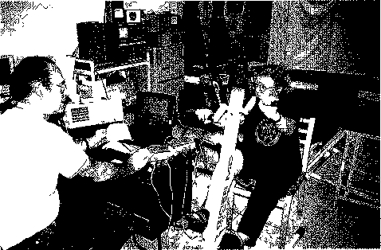
Fig 1 - Measuring layout for recording coordination dynamics with the coordination dynamics recording method and by sur-face electromyography: A 75-year-old Parkinson's disease patient is exercising on the special coordination dynamics therapy device and mechanical coordination dynamics are recorded and displayed on a laptop The display is showing the frequency and the changing coordination dynamics. Plots of the display are used in Figs. 2, 3. Electromyographic activity was recorded simul-taneously from up to 4 muscles (4 channels), the results are not used in this report.
Results
Eight patients in whom Parkinson's disease had set on 5 to 10 years earlier underwent low intensity coordination dynamics therapy on average for 4 hours per week for 2.5 months. The average age of the patients was 69 years (range 63 to 75 years). The progress achieved was measured in terms of the improvement of the organization of the lesioned CNS, i.e. by measuring the (mechanical) coordination dynamics and partly by a dexterity test (Minnesota Manual Dexterity Test) to quantify tremor reduction on the long-term.
In a previous work the low-load coordination dynamics of Parkinson patients (5 females, 3 males) were measured at the beginning of the therapy for forward and backward turning; the values obtained were Δ_{forward} = 8.4 ± 4.2 s⁻² and Δ_{backward}=16.9±13.2s⁻²
respectively. The values of low-load coordination dynamics for normal subjects of the same age for forward and backward turning were 5.4±2.2 and 11.8 ± 8.1 s⁻² (mean age = 73) respectively. The Parkin-son's disease patients thus showed, as expected in diseased CNS, larger (poorer) coordination dynamics values. But the intra-group differences were larger than the inter-group differences, making improvement measurements of the coordination dynamics of single patients with ongoing therapy necessary.
Improvement of Parkinson's disease patients due to coordination dynamics therapy quantified by low-load coordination dynamics
Original recordings suggesting the improvement achieved in one Parkinson's disease patient by coor-

68

_dination dynamics therapy are shown in Fig 2A-I. On the left panel a recording from 20min (A), 1 min forward (C) and 1min backward turning (E) are shown at the beginning of the coordination dynamics therapy. The frequency (upper trace) and the coordination dynamics (lower trace) show large variations, i.e. the arrhythmicity of turning was large The middle panel of Fig 2 (B, D, F) shows coordi-nation dynamics at the end of the therapy after 2.5 months. The improvement of the frequency of turning on the special coordination dynamics therapy device and the arrhythmicity of turning (coordination dynamics) can be clearly seen from the 20min recording (B), the 1min recording from forward turning (D) and the 1min recording from backward turning (F). The improvement of coordination dynamics for
forward turning from Δ_{forward} = 13.1 s⁻² to Δ_{forward} = 7.8 s⁻² (D) amounts in this case to 40% The coordination dynamics for backward turning improved from Δ_{backward} = 31.7 to 10.0 s⁻² (F), which represents 68%. The improvement of the numerical values of coordination dynamics of all the 8 patients varied quite much.
In 5 patients coordination dynamics Δ = Δ(df/dt)/f improved strongly for forward and backward turning
(Δ_{forward} (5) = 43% ± 7%; Δ_{backward} (5) = 60% ± 7%). In 3 patients coordination dynamics improved only little or very little, resulting in an improvement of the values of 8 patients or Δ_{forward} (8) = 32% ± 18%; Δ_{backward} (8) = 38% ± 30% (mean for both directions = 35%). The actually achieved group coordination dynamics values for forward and backward turning

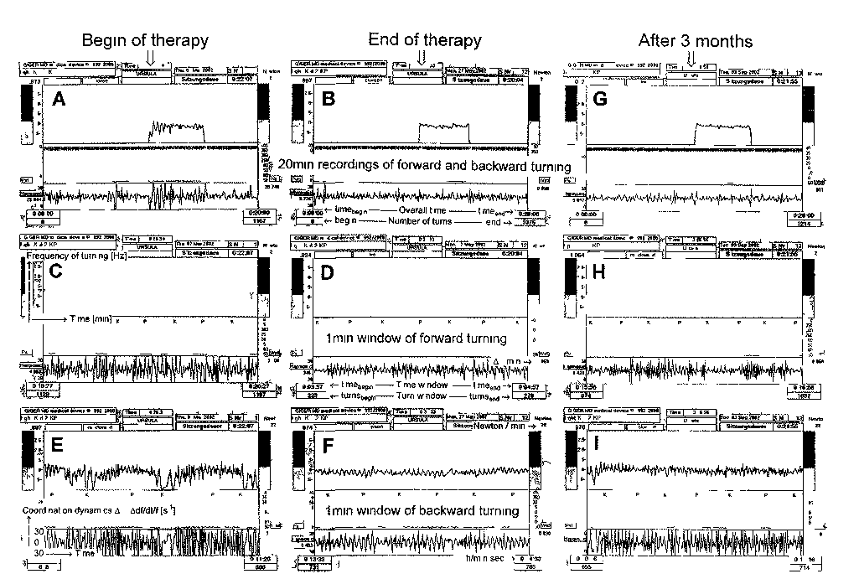
Fig 2 Low-load coordination dynamics recordings from a 70-year old Parkinson’s disease patient at the begin of coordination dynamics therapy (A, C, E) and at the end of the therapy after 2.5 months (B, D, F) and 3 months after the completion of the therapy (G, H, I). A, B, G. Overall recording of 20 min; first 10min forwards, followed by 5min backwards (blue frequency (upper) trace) and 5min forwards turning again. Note the reduction of frequency variation in A for backwards turning suggesting motor learning in the short-term memory. C, D, H. 1min time windows for best forwards turning E, F, I. 1min time window for backward turning; Improvement and worsening of coordination dynamics Δ/min can be judged upon easily from the coordination dynamics trace (large arrhythmicity (E), small (F), larger (I)) and from the coordination dynamics values (31.7, 10.8, 17.7 s⁻²).
69

were Δ_{forward} = 5.5 ± 2.5 s⁻² and Δ_{backward} = 9.1 ± 5.2 s⁻² and thus similar to those of the control group (Δ_{forward} = 5.4 ± 2.2 s⁻² and Δ_{backward} = 11.8 ± s⁻²).
pharmaco-therapy and fitness training alone cannot prevent a worsening of the CNS functioning in Parkinson's disease patients.

Low-load coordination dynamics 3 months after completion of the therapy
Three months after the completion of the coor-dination dynamics therapy measurements were repeated to see whether the Parkinson's disease patients were able to maintain their improved coor-dination dynamics. From the original recordings of Fig. 2G, H, I it can be seen that the coordination dynamics worsened again. In this presented case the coordination dynamics for forward turning worsened from 7.9 to 9.1 s⁻² (Fig. 2H) and that for backward turning from 10.0 to 17.7 s⁻² (Fig. 21). The whole group of Parkinson patients achieved worse results: by 22% for forward turning and 20% for backward turning. The mean values of coordination dynamics for 7 patients worsened due to the discontinued coordi-nation dynamics therapy were Δ_{forward} = 6.0 ±2.4 s⁻² and Δ_{backward} = 9.3 ±6.0 s⁻². The improved CNS functioning (by ~ 35%) achieved previously was partly lost again (= 21%) (Fig. 4). As can be seen from the comparison of the mean worsened coordination dynamics values, the mean values do not reflect group changes as well as the mean changes for single patients expressed as percentages. A single patient with very poor coordination dynamics (high values) and little changes can reduce the changes of the whole group.
Conclusion
Since pharmaco-therapy and conventional fitness training for 1 to 2 hours per week remained unchanged the important conclusion is that coordi-nation dynamics therapy could improve the CNS functioning in Parkinson's disease patients, whereas
High-load coordination dynamics in Parkinson’s disease patients
At the beginning of the therapy the patients could not cope with loads above 20N. Because of the age they were also not pushed strongly to try. After 2.5 months of the therapy, being more fit than at the beginning of the therapy, the patients were pushed to exercise at higher loads.
Only one patient was able to turn on the special coordination dynamics therapy device at 200N. In Fig. 3A, B ideal coordination dynamics are shown, taken from a female athlete. With increasing load up to 200N the coordination dynamics increased only little (Fig. 3B, Fig. 3A lower trace). Original coordination dynamics recordings for 3 patients are shown in Fig. 3C, E, G. In all the three cases the patients could not maintain the frequency of turning (load escape). These 3 patients could turn under higher loads (Fig. 3D, F, H). The best patient could reach 150N (Fig. 3C, D), but the arrhythmicity of turning increased strongly. The patient in Fig. 3E, F turned under higher loads so slowly that the coor-dination dynamics could not be measured safely any more. The third patient (Fig. 3G, I, H) could reach a load of 100N. But his CNS became exhausted (the dashed line is above the solid line, Fig. 3H). Inter-estingly, that particular patient could turn well for trot gait (K) but not for pace gait coordination (P); see Fig. 31 - increasing and decreasing arrhythmicity of turning. This phenomenon will be discussed in the Discussion section with respect to the lack of dopamine.
In conclusion, apart from one patient all had problems to move arms and legs in coordination for higher loads. Even though the low-load coordina-

Fig. 3 - High-load coordination dynamics in a 19-year-old athlete (A, B) and in 3 Parkinson's disease patients (C-I) A, C, E, G. Overall recordings for load increase and decrease. Note that the healthy person can maintain the frequency (upper trace) for increasing load whereas the patients cannot, the load dependence in Watts (middle trace) shows a nice stepwise shape m the recording from the athlete but not in that for the patients B, D, F, H. Hysteresis-like graphs of coordination dynamics values for load increase and decrease. Note that the curves for the patients (D, F, H) reach higher values of arrhythmicity (coordination dynamics) and that they are unable to exercise at higher loads. I. 1 min time window of "G" showing that the coordination dynamics are good for trot gait coordination (K) and poor for pace gait coordination (P).
70

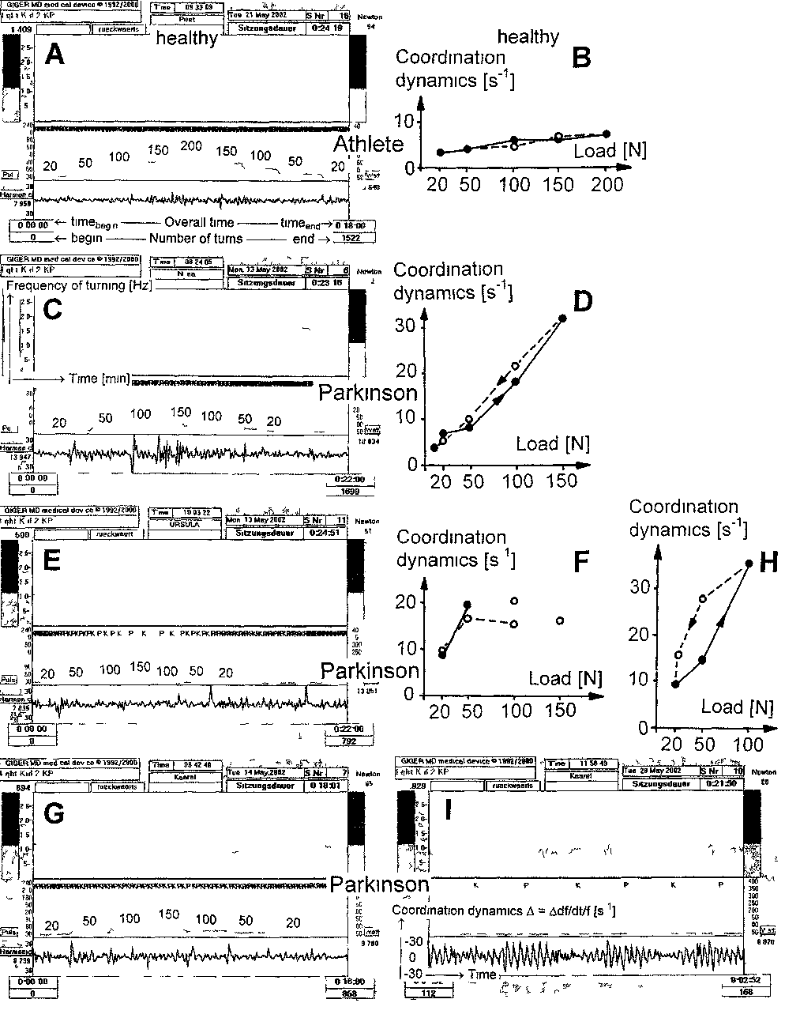
71

tion dynamics improved much, the high-load coor-dination dynamics were still poor, but better than at the beginning of the therapy.
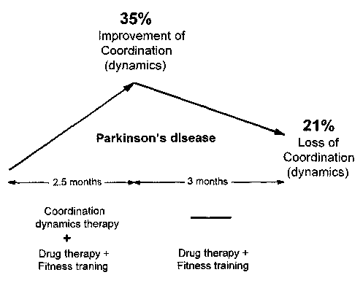
No heart problems during exercising at high loads
Three of the 8 patients had slight heart problems. Upon overloading, as during climbing many stairs, they experienced heart problems. The patients were thus instructed to stop exercising as soon as experi-encing any heart problems upon exercising at high load. After high-load testing, the patients complained about having not enough power when exercising at the highest load but not about heart problems. This could mean that the patients could be fitness trained without overloading their heart.
Improvement of tremor as quantified by a dexterity test (Minnesota Manual Dexterity Test)
It could be shown in the previous work (13) that hand and finger coordination improved in the short-term memory after exercising on the special coordi-nation dynamics therapy and recording device as quantified by a dexterity test. The question arose, whether this improved hand and finger coordination gets also retained in the longer-term memory. When repeating the dexterity tests one months later during the therapy under the same conditions, 3% ± 2% better results were obtained for the dexterity parameter.
Discussion
The only therapy known so far that can improve CNS functioning in Parkinson's disease patients is coordination dynamics therapy
It could be shown that low intensity coordina-tion dynamics therapy (for 4 hours per week) dur-ing 2.5 months, in combination with pharmaco-ther-apy and conventional fitness training improved CNS functioning by 35%. When the coordination dynamics therapy was stopped after 2.5 months, the CNS worsened 21% even though pharmaco-therapy and fitness training were continued (Fig. 4). It is con-cluded that the only therapy known so far that can
improve CNS functioning in Parkinson's disease patients is the coordination dynamics therapy. The usefulness of a combination of pharmaco-therapy and coordination dynamics therapy, has to be inves-tigated. Because of the substantial side effects of anti-Parkinson drugs that subside after some time on the drugs, we did not try to discontinue drug administration. One patient did not take anti-Parkin-sonic drugs at all. He improved by 42% due to the therapy and his condition became worse by 37% after stopping the therapy. It is therefore likely that the improvement of CNS functioning in Parkinson's disease patients was mainly due to a functional reor-ganization of the CNS achieved by the coordination dynamics therapy.
Two other elderly patients with strongly progres-sive degenerative diseases (unpublished observation) who recieved intensive coordination dynamics ther-apy (20 hours per week) lived longer as forecasted by school medicine, but they died soon after the termi-nation of coordination dynamics therapy. Coordi-nation dynamics therapy may optimise the func-tioning of damaged neuronal networks or optimise them even if the damage to the networks is perma-nently increasing because of the progressing neu-rodegenerative disease with loss of neurons and con-nectivity.
Fig. 4. - Improvement of coordination dynamics with coordina-tion dynamics therapy and loss of good coordination dynamics after the termination of coordination dynamics therapy.

72

Functional and structural CNS repair
References

A 4 hour coordination dynamics therapy was applied to the patients because they did not want to exercise more often and longer. Since a patient who suffered severe poliomyelitis (due to which the motoneurons are destroyed) substantially improved upon the application of an intensive and long-lasting (more than a year) coor-dination dynamics therapy (10), long-lasting intensive coordination dynamics therapy seems to induce neuro-genesis. As further a very severely affected cerebral palsy patients rather suddenly improved after approximately 5 months of therapy, neurogenesis seems to be induced by intensive coordination dynamics therapy lasting longer than 5 months.
Consequently neurogenesis is unlikely to have sub-stantially contributed to the improvements observed in the Parkinson's disease patients as the therapy was not intensive and not long enough. Growing of neurites without neurogenesis may have slightly contributed to structural repair. But the major part of the improve-ment was probably due to a functional reorganisation, including activation of non-active neurons.
It would be important to apply intensive coordi-nation dynamics therapy (20 hours per week) for longer than 6 months to Parkinson's disease patients and to measure how much CNS functioning can be improved and maintained in the long-term memory.
Pace and trot gait and lack of inhibition
It can be seen from the frequency and coordination dynamics traces in Fig. 3I that this particular Parkinson's disease patient was able to turn quite rhythmically for the trot gait coordination (K) but not for the pace gait coordination (P). This is astonishing since with CNS degeneration one would expect that the patient could perform better for the easier pace gait coordination than for the more difficult trot gait coordination. In other patients the easy and difficult coordinations (small and large arrhythmicity) seemed to vary. Probably, the neu-ronal network states that can be better organized than others will depend on the actual CNS degeneration.
Acknowledgement
This study was partly supported by the Estonian Science Foundation, grant no. 5278.
1. schalow, G.: Conduction velocities and nerve fibre diameters of touch, pain, urinary bladder and anal canal afferents and α and γ-motoneurons in human dorsal sacral nerve roots Electromyogr. Clin. Neurophysiol. 31: 265-296, 1991.
2. Schalow, G.: Oscillatory firing of single human sphincteric α₂ and α₃-motoneurons reflexly activated for the continence of urinary bladder and rectum. Restoration of bladder function in paraplegia.Electrormyogr.Clin.Neurophysiol. 31:323-355,1991.
3. schalow, G.: Impulse patterns of single encoding sites of human secondary muscle spindle afferents. Electromyogr. Clin. Neurophysiol. 33: 451-464, 1993.
4. schAlow, G.: Spinal oscillators in man under normal and pathologic conditions. Electromyogr. Clin. Neurophysiol. 33: 409-426, 1993.
5. schalow, G.: Phase-correlated adequate afferent action potentials as a drive of human spinal oscillators. Electromyogr. Clin. Neurophysiol. 33: 465-476, 1993.
6. schaiow, G.: Action potential patterns of intrafusal γ and parasympathetic motoneurons secondary muscle spindle afferents and an oscillatory firing α₂-motoneuron, and the phase relations among them in humans. Electromyogr. Clin. Neurophysiol. 33: 477-503, 1993.
7. schalow, G., bersch, U., gocking, K. and zach, G.A.: Interspike intervals of secondary muscle spindle and urinary bladder afferents in relation to the oscillation periods of sacral spinal oscillators for continence in man. Physiol. Res. 43: 7-18, 1994.
8. schAlow, G., bersch, U., michel, D. and koch, H.G.: Detrusor-sphincteric dyssynergia in humans with spinal cord lesions may be caused by a loss of stable phase relations between and within oscillatory firing neuronal networks. J. Auton. Nerv. Syst., 52: 181-202, 1995.
9. schalow, G. and zach, G.A.: External loops of human premotor spinal oscillators identified by simultaneous measurements of interspike intervals and phase relations Gen. Physiol. Biophys., 15 Suppl 1: 95-119,1996.
10. schalow, G.: Koordinationsdynamik-Therapie (Teil IV) Physiotherapie 1999.
11. schalow, G.: On-line measurement of human CNS organization Electromyogr. Clin. Neurophysiol. 41: 225-242, 2001.
12. schalow, G.: Time axis calibration in human CNS organization for judging dysfunction. Electromyogr. Clin. Neuro-physiol. 41: 485-505, 2001.
13. schalow, g., paasuke, m.., ereline, j. and gapeyeva, H.: Coordination dynamics in Parkinson disease patients and healthy subjects quantified by the coordination dynamics recording method and EMG. Electromyogr. Clin. Neuro-physiol. 43: 473-485, 2003.
Address reprint requests to:
Prof. Giselher Schalow
Dr.med.habil.,Dr.rer.nat.,Dipl.Ing.
Untere Kirchmatte 6
CH-6207 Nottwil
Switzerland
www.cdt.host.sk

73

